“No Way” Places
The Story of El Rancho del Rey
God’s Open Door in Monterrey, Mexico

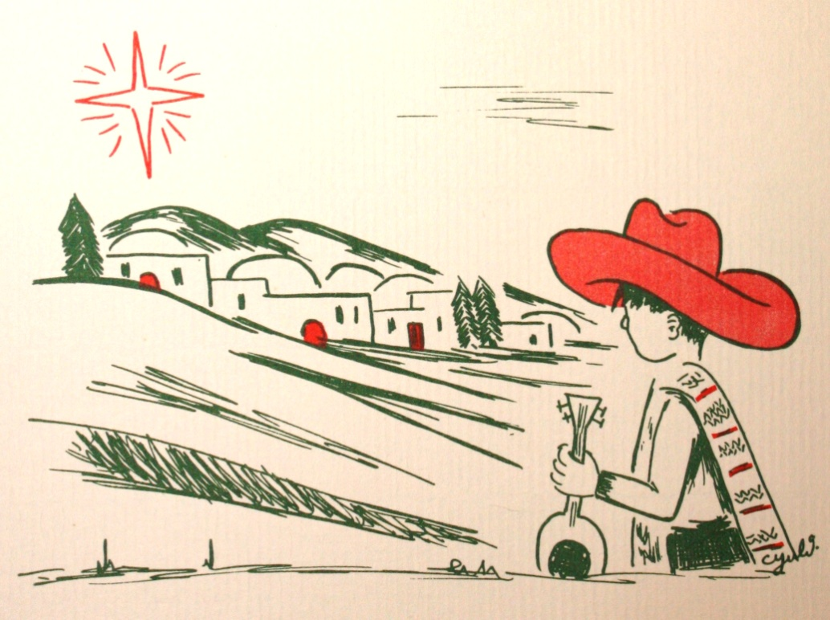

By Anne L. Moller

Edited by Charles H. Lewis
“No Way” Places

By Anne L. Moller

Edited by Charles H. Lewis

Published 2013 by
Del Rey Missions, Inc./El Rancho Del Rey
P.O. Box 1827
McAllen, TX 78505-1827

COPYRIGHT © 2013 by Del Rey Missions, Inc.

All rights reserved. No part of this book may be reproduced or transmitted in any form or by any means, electronic or mechanical, including photocopying, recording or by any information storage and retrieval system without written permission from Del Rey Missions Inc., except for the inclusion of brief quotations in a review.

Cover by Anne L. Moller
Christmas newsletter, Dec. 1982

Contents

Forward Page 1
Introduction 3

Chapter 1 Mexicali Stars 9
Chapter 2 The First Star 13
Chapter 3 Mexicali Joe 17
Chapter 4 Eduardo 21
Chapter 5 The Sleeping Lady 25
Chapter 6 Shadows 29
Chapter 7 Arches & Triumph 31
Chapter 8 Bruno’s Prayer 35
Chapter 9 A Way Through the Fire 39
Chapter 10 A Way Out 43
Chapter 11 Little Ishmaels 47
Chapter 12 El Medico 51
Chapter 13 El Salvaje (Part One) 55
Chapter 14 El Salvaje (Part Two) 63
Chapter 15 La Venida 69
Chapter 16 Choco’s Angel 73
Chapter 17 The Real Orphans 77
Chapter 18 Wallpaper 81
Chapter 19 The Dormitory Walls 85
Chapter 20 The Way to Win 89
Chapter 21 His Way 93
Chapter 23 Tears of Joy 97
Chapter 24 Chiapas 101
Chapter 25 David’s Sons 105
Chapter 26 The Wide Wide World 109
Chapter 27 The Other Side of Love 113
Chapter 28 Let’s Fly 119
Chapter 29 Thou Shalt Laugh 125
Chapter 30 Kings and Queens 129
Chapter 31 Open Doors…? 133
Chapter 32 Image of God or?? 137
Chapter 33 Worshippers 139
Chapter 34 A Song 143
Chapter 35 Another Chance 145
Chapter 36 The Kingdom 149
Chapter 37 Fishing 153
Chapter 38 Pioneer 157
Chapter 39 Bread Upon the Waters 161
Chapter 40 Father’s Business 165
Chapter 41 Morning Glories…Or Entanglements? 169
Chapter 42 Stay the Course 173

Epilogue 177

Forward

It has been a great privilege to have personally witnessed God’s work at El Rancho del Rey in Monterrey, Mexico. El Rancho del Rey is both a Christian group home for at-risk Mexican boys, and a “forward operating base” for the spread of the Gospel of Jesus Christ in northern Mexico. It was founded by the American missionary couple, Hank and Anne Moller, in 1956. After nearly six decades, El Rancho del Rey continues to fulfill its original purposes, but the work is now in the capable, and God-fearing hands of the Moller’s son, Danny, who is the current Executive Director.
More than 1,000 boys have been rescued from life on the streets of Monterrey and other surrounding towns in Mexico by El Rancho del Rey. Many of these boys are now fathers and grandfathers who return to visit El Rancho to bear witness in their lives to the saving grace of their Lord and Savior, whom they came to know first at El Rancho del Rey. Where they might have been human fodder for the drug gangs so prevalent in the area, many of them have become pastors, or have otherwise established successful careers and become stable fathers and spiritual leaders in their families and communities.
For some time, I pondered how I might write a history of the Moller’s work in Mexico, until discovering that it had already been done. Anne Moller considered herself to be, first and foremost, a missionary, but she was also a gifted writer and poet who, over the course of her service, wrote monthly newsletters to the supporters of the Moller’s work in the United States. Each newsletter was a beautiful self-contained story, with an occasional poem thrown in, about God’s work through El Rancho del Rey. She never took credit for any of the great things that happened in the lives of the children of El Rancho and her beloved people of Mexico, it was always God’s gracious, redemptive, and powerful – if not actually miraculous - work.
Anne tells us here that, after some years, her American friends convinced her that she needed to write a history of El Rancho del Rey. In 1979, what had simply been a newsletter became “No Way” Places, the history of El Rancho del Rey, published in monthly installments.
Anne’s God-given talent as a poet infused everything she wrote, giving her a peculiar poetic style permeated with unbridled enthusiasm and passion for God’s work. In editing her writing, I have been reluctant to change a single word. In fact, I have not changed a single word in the body of Anne’s text, except to correct the very, very infrequent misspelling (she was a meticulous self-editor). I have also occasionally added a comma or two to a run-on sentence, but only when it was essential to its understanding.
I have also tried to use artwork and photographs that were original to each edition of “No Way” Places, although their formatting and placement in each chapter may not occur in the original position in relation to the text. Because there were no original negatives to work with, the quality of some of the images, as copied from the published “No Way” Places, were so poor that they could not be used. In those cases, other photographs from the collections at El Rancho del Rey, or photographs taken by this writer, may have been substituted.
Also, when she introduced the 22nd Chapter of “No Way” Places, Anne wrote that she felt it would have been more appropriate had it been the prologue to her history. Because of that, I have honored her wishes, and combined Chapter 22 with her introduction, where it fits perfectly into the chronological order of her story, with its original title, Where the Cloud Led. Therefore, it is no mistake: there is no Chapter 22 between Chapters 21 & 23.
As will become apparent to the reader, Anne and Hank Moller held nothing of themselves back; their lives were fully surrendered to their Lord and Savior. This fact was made manifest in their unqualified commitment to their work and in the love they deeply felt for the people of Mexico. Once on the “mission field”, their home became Mexico, and the people of Mexico their family. There would be no long sabbaticals in the States, no retirement, no quitting – ever. They believed deeply that if they were fulfilling God’s command in the Great Commission, He would provide for their every need, and over and over again, He always has.

Charles H. Lewis Falls Village, CT
January, 2013

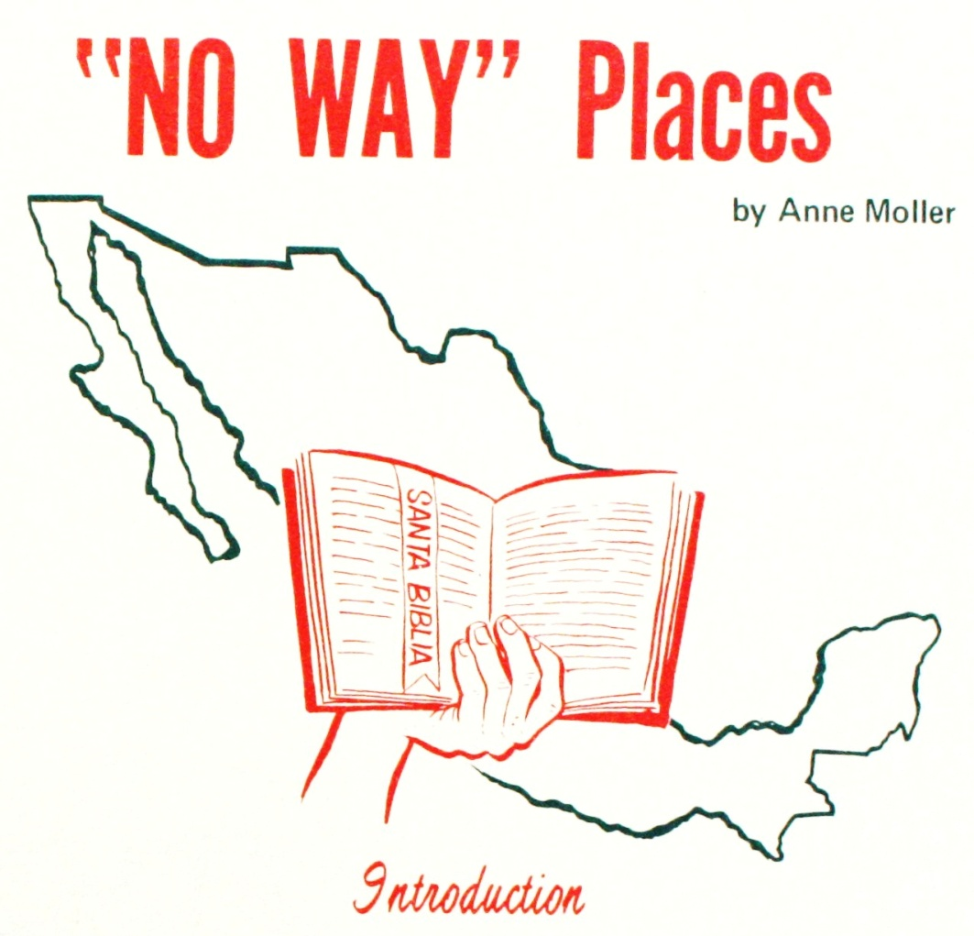

Friends who have followed our Missionary efforts at El Rancho del Rey in Monterrey, Mexico, have encouraged us to write a book relating our “South of the Border” experiences.
Because of these requests I am writing a book of short stories that will be called “NO WAY” PLACES. The first chapter takes place in Mexicali along the Baja California Border, beneath the “Mexicali Stars.”
So many times during our first twenty five years in Mexico [this was written April, 1979, ed.] we have come to places where, like the children of Israel by the Red Sea, there was no way – no way out; no way back, no way through. Yet God brought us over on the other side just as miraculously as He took the children of Israel across the Red Sea. He who rules the winds and waves, still backs up the waters when His children call upon Him in their distresses.
In this series of short stories I have recalled many trying and blessed times which all worked together for our good and God’s glory. These experiences have made Mexico a significant part of our lives, confirming our belief that we are here because we were called here by God.

Where the Cloud Led
(Originally Chapter 22)

A short time after graduating from Bible School (1949), while seeking the Lord’s will concerning our place of service, we began corresponding with a missionary in Ecuador. He was an Englishman associated with groups known as the “Plymouth Brethren”. They are fundamental Christians so named “Plymouth Brethren” by other Christians because of first having come into prominence in Plymouth, England, though they prefer to simply be called “brethren” and that with a small “b”.
Both Hank and I were saved while fellowshipping with a local group of brethren in the Hatboro, Pa. area. Under some fine teachers, we received our early basic spiritual training. However, it was during our four years of evening study at Philadelphia School of the Bible that we had been challenged concerning the mission field. We particularly felt called to the Latin American people.
Our English Missionary friend, Dr. Wilfred Tidmarsh, wrote letters to us concerning his work among the Quichua Indians of the Eastern Ecuadorian lowland jungles and of his need for helpers. We found the correspondence fascinating because, he particularly requested help for a boys’ school at Shandia in the jungles of the Oriente. We had been very active in Bible Club and Bible Camp work, therefore, we were attracted to the possibility of also working on the field among the youth.
Mrs. Tidmarsh had been injured in an airplane accident on take-off from Quito en route to the Eastern jungle. A related back problem and a poorly set broken foot now made it almost impossible for her to travel the many miles and torturous days of jungle trails when the missionary plane was not available. Dr. Tidmarsh was appealing for young men to take over this strenuous jungle work so that he could principally minister in other parts of Ecuador.
During World War II Hank had allied himself with other Christian servicemen who foresaw the usefulness of the airplane in postwar missionary work. This group became the Missionary Aviation Fellowship who now provide air service for missions worldwide [written Sept. 1981, ed].
After an early trial in Southern Mexico, Missionary Aviation Fellowship blossomed and began to service mission groups operating in western South America. Principally, the Wycliffe Bible Translators in Peru and assorted groups in Ecuador. In the Eastern jungle they had their base air strip at Shell Mera, an early site of exploration for oil in the Oriente Basin. The M.A.F. pilot in the area was Nate Saint, a friend of Hank’s through M.A.F. and a native of a town near Hatboro.
Hank already had his pilots’ license and had been an aircraft mechanic in the Marines. The less than half hour flight time between Shandia and Shell Mera, combined with our association with the brethren, seemed like the Lord’s leading to a place of service using the talents and experiences that the Lord had entrusted us with. We could be at the boys’ school at Shandia and help out with aircraft work when that was needed.
Our correspondence with Dr. Tidmarsh continued as he was in accord with our plans. We were thrilled to hear that he would be visiting us on the way back from his furlough in England. When he arrived we had the joy of going to his meetings and seeing the slides repeatedly as he spoke of the Lord’s leading in his life plus the great need for laborers on the field. The burden on our hearts increased; surely this must be “THE” place.
We prayed about this need and our desire to fill it. We had Bible training and other necessary talents and abilities. We were in fellowship with a group of brethren that could recommend us to the work and stand behind us in loving concern. All doors seemed open but we lacked permission from the DOORKEEPER to pass through! We continued to pray; more earnestly and definitely than we ever had before in our lives, but we could not get a “Go-ahead”. It seemed that there was a cloud hovering over us. For all that time period it never lifted. It stayed right there while we, with heavy hearts, wondered WHY?
The cloud didn’t move. There was no promise from the Word, no opening up, no still small voice, no way.
We wondered if perhaps we were not close enough to the Lord to hear His Voice even if He were speaking. Perhaps He couldn’t use us; we weren’t worthy. We knew that there was still a great deal lacking in our lives but we were baffled by His Silence. Should we just get up and go anyway? Since learning of the need, had not we wanted to be missionaries? Didn’t that constitute a CALL? Here was an open door! From where we were it looked right!
But we DARED NOT move without a word from the Lord!
Then I began to blame myself. I wondered if I was at fault. In my heart I was afraid of flying and of jungles! In my mind they seemed so DARK! I had a sense of failure. Perhaps I was holding Hank back from his call! Did I really have what it takes to be a missionary?
With, seemingly, still no answer we had to tell Dr. Tidmarsh that we could not now accept the post. He left for the Midwest and west coast on his route back to Ecuador.
Finally, the way to Shandia was obviously closed to us as we heard from Dr. Tidmarsh that two young men, then another, were going to take up the work at Shandia. Jim Elliot, Pete Fleming and Ed McCully were those that the Lord of Harvest had earmarked for that part of the vineyard. Small wonder then that OUR cloud hadn’t moved! Perhaps we could be used in a small measure as we continued in our youth work. For a while our desire to serve on a foreign field had to be put on “HOLD”.
A few years later (1953-’54) the Lord led us to cross the continent. While living in the Los Angeles area Hank was working at North American Aviation. On a daily radio broadcast from a missionary training school we heard an invitation to interested Christians to join the students on a three day trip to the Mexican border town of Mexicali for what they called a Gospel Invasion. This would consist of practical Christian witnessing and preaching through student interpreters. They badly needed transportation. They had the language; we had the wheels!
We phoned and offered to take our station wagon. The call seemed clear. Promises started to leap out of the Word and “Cloud” lifted!
Suddenly it all began happening! In Mexicali we met Tony and Carmen Aldapha, Mexican-Americans who were ministering in the area. They encouraged us to come down to help them. The rest is told in Chapter One. NOW we heard “Permission Granted” to walk through THIS open Door! We cashed Hank’s life insurance policy for starting funds. Friends in a small church group we fellowshipped with, loaned a down payment on a small travel trailer. Then the church filled it with a food shower. By July of 1954 we were in Mexico, bridges burned behind but the goodness of the Lord ever present.
In January of 1956, we were in Monterrey, Mexico, working among the little sons of the street and the people of the poor areas of the sprawling city. Upon retiring one night, we heard a Spanish language newscast announce the tragic deaths of the five American missionaries at the hands of the spear wielding Auca Indians in the jungle of Ecuador. Jim Elliot, Pete Fleming, Ed McCully, Rodger Youderian and Nate Saint had left their bodies, pierced and awash in a remote tropical river, planted as seed corn for the gospel’s sake to yet another tribe.
One moonlit night, sometime later, I looked out across the beautiful Rancho del Rey landscape; the nearby towering mountains were so picturesque and strong. I loved them. I loved the tall water tank silhouetted against the bright night sky. I loved the big dining hall with its tower. I loved the long dormitories and the dear children in their bunk beds. My heart was flooded with Love and praise for all that the Lord had done but especially for these Mexican children who were so open-heartedly receptive to the Word of God.
Out beyond the dormitories stretching up toward the mountains on the left was the rough, rustic landing strip where Hank had taken off from and landed countless times while bringing in supplies, ferrying people or dropping gospel literature in remote areas; thru the clouds, in the rain or bathed in the sunlight of 100 plus degrees heat; in incident and accident God had protected him. Seemingly he loved to fly more than most other things in life! He was still alive, fulfilling his dream, his call, using his talent. My heart swelled with gratitude. God was so good. “In Him is LIFE…”
THEN I more fully understood why back in Pennsylvania the cloud had stayed down. It hadn’t moved because there was no way to Ecuador for us. If we had gone on our own Hank might be dead. He might have been (or surely tried to be) one of those who had flown down to “Palm Beach, that sand bar in the Curaray river, to await the coming of the Aucas.”
When we had read the beautiful story “Through the Gates of Splendor” by Betty Elliot telling of the dedication of those men we felt very unworthy indeed. They were chosen vessels for that task. Perhaps in eternity we will hear them tell more thrilling things of their earth exit.
Meanwhile, we trust that God will allow us to continue to labor where the call has been so clear, where He has blessed, where the harvest has been a joy; where the cloud led. --Anne Moller

Give of thy sons to bear the message glorious,
Give of your wealth to speed them on their way,

Pour out thy soul for them in prayer victorious
And all thou spendest JESUS will repay!
(from O Zion Haste! M.A. Thompson)



NO WAY PLACES CHAPTER 1

Mexicali Stars

Years after having heard the little tune, “Mexicali Rose, I’ll come back to you some sunny day…”, I found myself going on a trip to this quaint little border town. There I was introduced to the “Country of the Aztecas,” which I loved at once, and very soon my heart was saying, like the little song, “Mexicali, I’ll come back!”
We had gotten up with the break of dawn to meet other young people in Los Angeles with whom we were to be traveling to do a three day missionary invasion in Mexicali. Some of the young Bible School Students could speak Spanish. We would have to count on them to talk for us once we crossed the border. Otherwise how could we even ask for a drink of water? We laughed carefree and delighted as we anticipated the adventures that awaited us.
It began to get warmer as we neared the Imperial Valley and the Salton Sea. The air was dry and pleasant and the soft, warm breezes, almost devoid of humidity, were intoxicating.
The date palms were majestic and little places along the highway sold delicious date-milk drinks.
Although we were still in the States, the closer we got to Mexico, the more we encountered Mexican people. Spanish began to flow in conversations in restaurants and gasoline stops. We tried to learn words like “Amor…(Love)…Salvador…(Saviour)…Como esta usted?...(How are you?)” We tried to memorize texts in Spanish, putting the accents where they didn’t belong, without knowing how to sound the Spanish vowels.
Crossing the border and entering Mexicali we were ushered into a merry-go-round of push carts, taco selling venders, and shoe shine boys. The atmosphere was charged with loud music, clashing colors, people calling us into their little shops.
The houses and street markets of this little push cart world were very quaint and fascinating. Everyone seemed to have time to be friendly and to make us feel that we were welcome and important.
The Spanish style homes in the nice colonies had fantastically designed gardens inside walls. One had to get inside the walls though, to see this. The outside walls were drab.
But this drabness was not to be compared with the adobe huts, the cardboard and tin can houses where the poor lived. This was a total contrast. It was here that my heart stood still and listened to the Spirit’s Call.
At the age of thirteen I had already started to dream that one day I would go to the Mission Field. There I would labor in the hot sun in the Great Harvest where there were grass roofed huts, among the people that God would show me! It was my joy to find before my very eyes, the Field of my Dreams!
We were never once bored, there was always so much going on around us! Mexican curios are bright and colorful and inexpensive. It was fun to have our shoes shined by the bright eyed little shoe shine boys. Soft stringed instruments and Latin voices, held us spellbound. We loved listening to the “Mariachis” (the street minstrels) sing.
As we went down the streets giving out the precious tracts we had brought along, there was a flowing out inside of me. Had not the Scripture promised… “Out of thy innermost being shall flow rivers of Living Water?”
A picture we had brought along of the Good Shepherd holding a lamb in His arms helped me to get a message across. I NEVER ONCE wanted the young people with us who spoke Spanish to translate for me. I wanted to do it myself. I wanted to TALK to the little street children, the women with their babies on their backs, the barefoot girls with braids, men with sombreros and the Señoritas. Talking to them and telling them about Jesus seemed sweeter and more satisfying than anything I had ever tried to do!
That morning I could not have asked for a drink of water in Spanish. There was “NO WAY”! Yet , somehow, here I was, walking in and out of the little groups of people, without inhibitions, talking to them in broken Spanish words. My stumbling mixed up phrases, were streams of joy.
As night settled down upon us, we found shelter in a third class hotel in the center of Mexicali. The cement floor and walls of our room were very plain and bare. The bed was hard, but sleep was unimportant. Late at night we could still hear street noises and early in the “mañana” music and voices floated in through the open window and once again, sleep was banished.
Spanish, Spanish, everywhere! I TRIED to DRINK it in! But all the words seemed to be running together and coming out so fast!
We stayed in Mexicali three days. It was in this crude little hotel room, the “Call” to Mexico seemed to get through to us, “I have set before you an open door,” the Spirit said, “that no man can shut.”
Nights found us outside of town helping in an outdoor mission service among the laborers on large cotton farms. As we worshipped together there with these humble people beneath the stars, it seemed that the very stars were telling us to stay.
Because of the clear desert atmosphere, Mexicali stars seem bigger and brighter than in other areas. They seem so CLOSE! You feel as though you could reach up and TOUCH them. Were they not the same stars that had spoken to Abraham so long ago? It seemed that these Mexicali Stars were singing. It was strangely enchanting out there underneath that Mexicali sky. The Scripture speaks of the “Morning Stars” singing together, and this is exactly what they seemed to be doing. Their song was rapturous and beautiful. It seemed as though, behind the stars, were a host of Angels sounding forth the “Call” again. “Come to Mexico!”
We had to go back to Los Angeles and pick up life where we had left off. But when we did, we began to make plans at once to return as soon as possible to Mexicali. Hank sold his Life Insurance Policy so we would have some money to start out on. In a few months he resigned his job at North American Aviation. We ventured forth in a small house trailer with the prayers and blessings of Christian friends behind us. We were on our way with our three small children, Joanne, Linda and Clifford; on our way back to the Mexicali “Stars”.
We drove down through Indio, past the Salton Sea, through Calexico, across the border. We had come back this time to live by faith. We would need to learn to trust God for ourselves, our children, and many others! This was something we had never done before. Fears were brushed aside, for now. At long last, I was going to do the one thing in life that I really wanted to do.
We would be learning many things in the days ahead about Mexico’s beautiful close to nature way of life, about the Aztecas, and the Niños Heroes”; about great men like Benito Juarez and Hidalgo; about a way of playing guitars that is sweeter than any other; about burros and sombreros and chile and Español! But above all, God would teach us many precious and important lessons by His Spirit as we labored with the “Sons of the Street” who are the real STARS of my story.
We would also learn about hundreds of “NO WAY” places that were out there, like wide rivers with washed out bridges, about rock strewn paths and fallen tree clogged roads, which were never able to block our way to… “The STARS”.

Faithful is he that calleth you who also will do it.
1 Thess. 5:24

“…Summer and Winter
and Springtime and harvest
Sun, Moon and Stars
in their courses above

Join with all nature
In manifold witness
To thy Great Faithfulness
Mercy and Love

GREAT IS THY FAITHFULNESS
LORD UNTO ME…!

[From the hymn, Great is Thy Faithfulness;
words by Thomas Chisholm, 1866-1960;
music by William M. Runyan, 1870- 1957]

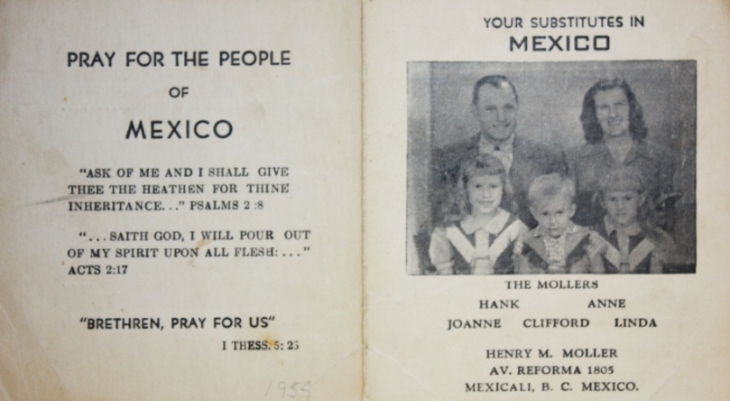

NO WAY PLACES CHAPTER 2

The First Star

The quaint small city of Mexicali was like a training ground for us in those early days of our missionary life.
Yet we seemed to sense that we would eventually go into the interior. Since there was much “across the border” work being done for the Lord in the border towns, the need for the gospel was so much greater further in. As we listened to reports of missionary work in Chihuahua, in Sonora, in Cholula, and other places, our interest grew day by day.

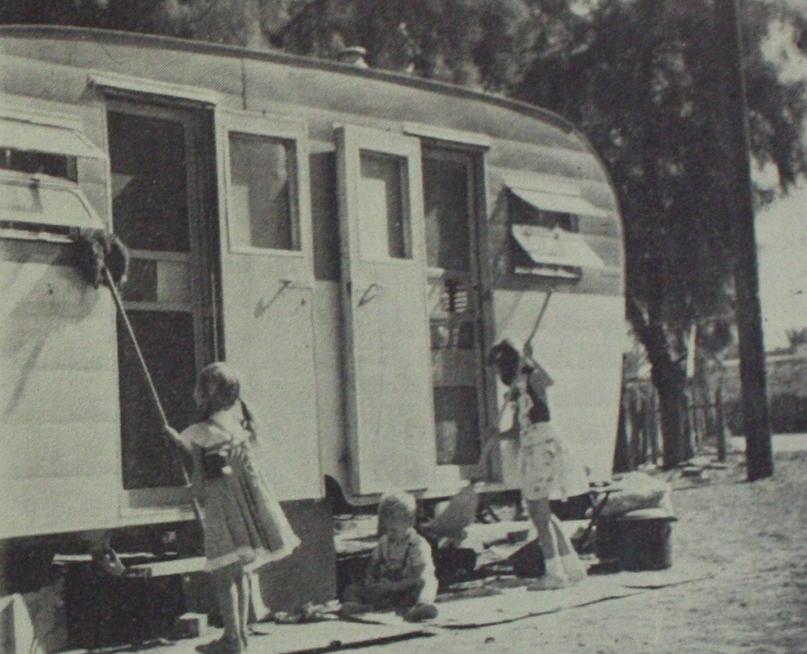

Meanwhile, our trailer was parked on a lot close to town by a canal. It was mid-summer and the heat at high noon forced us to abandon the trailer and take refuge beneath the trees in the shade.
Picking tunes on the mandolin and trying to learn choruses and hymns was my favorite pastime while the children played beside me.
On one such occasion, a little Mexican boy came running toward us, shouting and gesturing excitedly. His words were indistinguishable, but I got the message! Clifford, our three year old, had fallen into the canal and was being swept downstream! He had not cried out and was doing his best to keep from going under.
Dropping the mandolin and slipping hastily into the water, I managed to reach him. Frightened beyond words, and losing my shoes in the muddy waters, I lifted Clifford up on the bank, climbing out beside him.
Dripping wet, and trembling with emotion, we stood beneath a scorching sun, a bit confused but deeply grateful that Cliffie was alive and safe.
Cliffie made up for not having cried out while floating downstream. He had gotten his breath by now and was sobbing huskily. The village Señoras came running to the scene.
“Que pasó?” (What happened?), they wanted to know. They were all so kind and tried to console us. They brought towels and hurried us into a “Tiendita”, and offered us anything that our hearts desired from that which the small store contained.
Drying Cliffie’s tears, I wished that I could wipe away the guilt I felt for what had taken place as easily as I wiped away his tears.
“Your Mom fiddles while you drown!” I confessed.
I might have brooded over the event, but there was no time! Life moved along very quickly in this so called “Land of Mañana!” There were services to go to; tracts to give out; people to visit and pray with; songs to learn; our three children to care for and Spanish to master. There was no looking back. Our hand was on the plow.
Clifford forgot the frightening event easily and when my mind reverted to it, I praised the Lord for HIS deliverance. Had not God proven to me that HE was near, inasmuch as He had sent the little Mexican lad along at the RIGHT time? This was another proof of HIS love.
The little hero’s name was Francisco. We much appreciated the alertness of this child who acted so quickly and wisely.
Francisco’s dark eyes flashed a great big “Gracias” (Thank you!) when he got a bow and arrow set as a reward for his help in making a happy ending to a story which might have been a tragic one.
Francisco taught us something that we were later to notice over and over again as we labored among the little sons of the street at El Rancho del Rey. In a crisis, Mexican boys are fantastically clever and dependable. Many times, some of the older, better swimmers among our boys have rescued some of the younger, unskilled ones who were just beginning to learn and had gotten in over their heads. How gracious God has been to them; to all of us through the years in preserving all their lives.
Here I would like to add another tribute to our Rancho del Rey boys. There have been times without number when we have been overwhelmed with things to do; a desk full of envelopes to stuff; a painting job; some digging for a foundation or a cesspool; or kitchen work and dishes. You knew you would never get it cleared away! Then suddenly they came! The boys were home from school or from play! You were so glad to see their smiling faces! Would they help? No, it’s not like that. It is they who ask the question, “MAY we help?”
“Ah, sí, con todo gusto!” (Ah, yes, with pleasure!) And the work seems to vanish away because they are there.
Even I have to admit that this zealousness makes up for the other side of the coin…the times when, for instance, they act like they did just the other night. I was annoyed because all the High School boys wanted to ride along in the Pick-up after the Service when I made the rounds to take the people home. I gave them an emphatic “No, the Pick-up is too crowded!”
So those unpredictable youngsters RAN the mile to where I was going. While I was driving slow over the bumpy roads, THEY were able to outrun me.
Driving back over the same bumps, the unpredictables were with me. How could I refuse them? I laughed and called them “Los Increibles!” (The Unbelievables).
They say they like to ride along with me so that I will not have to come back alone in the dark and they want to be there just in case I should have a flat tire or something. I suspect they mainly like the excitement of “going”, but how can I help but love them?
This spirit of helpfulness is found not only among our Rancho del Rey boys but among the humble village people. You may find yourself stranded with a flat or needing a push. You thought you were out there all alone along the road and you were wondering what in the world you would do!
All at once you notice that there are people appearing on the scene. They pop up out of nowhere. You wonder where they came from. You thought it was a lonely deserted spot. But here come barefoot boys, girls with pigtails, women with shawls; out from behind the trees they come; from over the hills. They offer to push the car; are quick to bring up a team of oxen or mules or to get what you need in the next village. They tell you where you are and how far you are away from the next gas stop. They invite you into “su casa” (Your house”, though really theirs).
We are sorry to say that we have lost track of our first little “Star” (Francisco), but we are happy to say, that on the Rancho del Rey, we have found many more “Stars”.
Sometimes, over the twenty five years, we have lost the vision of that beautiful Mexicali sky. There have been some spiritually dark times, when it seemed like the “very stars had fled…”, but even in the darkness, the NO WAY places opened up.

NO WAY PLACES CHAPTER 3

Mexicali Joe

We stayed by a mission out in the “campo” near Mexicali for about a year while Hank helped build a little church.

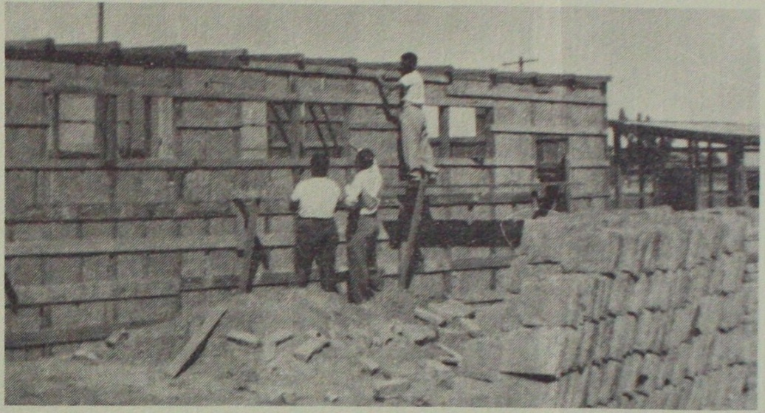
Colonia Palacio Church – Mexicali- 1954

We were learning some Spanish. We had begun to like eating tortillas, chile, frijoles and even soup made from fish heads.
One of the hardest things for me to get used to that year was bathing in the nearby broad irrigation canal with my clothes on. I insisted on knowing why this was necessary.
“The village people would be shocked if you wore a bathing suit!” Carmen, the wife of the mission’s pastor informed me.
Carmen was beautiful and shapely as was her husband Tony handsome. Their love for Christ was constant and inspiring. Carmen played a tambourine and her strong Mexican alto voice was instrumental in leading the humble peasants in ardent worship. I admired and respected her. Nevertheless, I tried to reason with her a little in the hope that she would relent. “I have always worn a bathing suit when swimming…
“These people are not used to that idea, and we are trying to win them to Christ.” Carmen tried to help me to understand. She was kind and nonchalant. “We must be all things to all men so that we may win some.”
Reluctantly I submitted, though rebelling inside as I walked dripping wet, my clothes clinging to me, on the dusty path from the canal to the trailer. At the trailer door I sponged the mud off my feet in a bucket.
God saw and perhaps He pitied. At any rate, He has graciously made up for those little frustrations by allowing us to live on El Rancho del Rey and to enjoy the long summers and swimming seasons with the Rancho del Rey children.
How well do I remember the first time I looked in through the fence at the beautiful swimming pools in El Alamo and dreamed of being able to take the children for a swim! How impossible it seemed, and then, it was suddenly happening! God made it possible! We have had the privilege of watching the boys learn from the smallest to the biggest. They have made good swimmers. Yes—bathing suits are allowed at Rancho del Rey!
We were feeling like real missionaries now. We were also feeding the mission people who were quite poor. Often they would drift in for the evening meal at Tony and Carmen’s before the evening service. Our little supply of cash was dwindling…but some of those around us were receiving Christ as Savior…surely God would supply.
We asked only for the bare necessities in those early days. The tortillas cooked on an iron sheet for the griddle over the open fire tasted all the better. The salsa de chile and refried beans made a “fiesta”.
It was a joy for me after a few months of trying to talk through an interpreter to finally be able to teach a little on my own in Spanish. Quoting Scripture that I had memorized I shared the gospel with some of the people in what my friends called a “Pennsylvania accent Spanish”.
One day while Hank was in town with Tony, my little world blew up around me. It was my turn to cook for the group that was out witnessing. The oven in our trailer exploded and my face and arms were bathed for a brief moment in searing flames. The trailer caught fire and most of our clothes were burned before we were able to get the fire under control.
The children screamed when they heard and saw what had happened. I grabbed the cooking oil and poured it over my scorched face and arms, praying for God to help me as I tried to put out the flames which were spreading quickly.
It was God’s provision that we had brought a wash tub of water from the canal that very morning and I was able to throw it into the flames with a pail and beat the rest out with a broom. God was there! The fire was smothered; the trailer was saved.
As I walked outside the trailer, my heart still thumping wildly, hair singed, arms and face blistered…who should be coming down the dusty trail…?
It was old Brother Jose, “Old Joe,” who loved to pray for the sick and claimed a gift of healing!
“The Lord, He tell me come here,” Jose said in broken English. “Did you know about the fire?” I asked.
“No,” he said, “But HE tell me. He say, ‘You go! You pray for La Americana.’”
As Jose laid his hands upon me, I wept and sobbed. The Lord’s love and comfort flowed in. God KNEW! He cared! He had sent His servant, Jose, to me!
When Hank came home, we drove across the border to buy olive oil. All that week I anointed myself with oil in the name of the Lord, liberally bathing the burn areas with oil. In a few weeks all the ugly red blisters were gone. My face and arms were restored and whole.
The weekend following the fire friends came from Los Angeles with clothes. Not only did we have things for ourselves to replace those that had been burned, but we had boxes full for the poor field workers in cotton fields who were attending the services. What a joy it was to share these lovely gifts with the needy believers.
A brand new word of testimony was mine; one that all were able to witness. God had healed me from the terrible burns without a scar!
The services were still being held out underneath the Mexicali stars. Mexicali Joe was always there playing his guitar and praying for the sick.
Mexicali Joe? We have lost track of him too. But wherever he is, we hope he is still praying for the people like he prayed for me that day when I was hurting so and when it seemed like there was NO WAY through the fire.

Who Tore The Vail?

“It is finished,” Jesus said,
And those who watched him die.
Little did they understand
The reason why…

What had He “finished” on the Cross?
Who tore the veil in twain?
What made the Mountains tremble?

We are the finished product…
We emerged, the BUTTERFLY,
Out of His pain and travail,
To LIVE and not to die!

No one else could have done it…
God, the Father knew…
The miracle of our redemption
Only Christ could do!

Who then, can condemn us?
God’s wrath is satisfied!
We are a new creation…
In Christ, the Crucified!

…Anne L. Moller

NO WAY PLACES CHAPTER 4

Eduardo

While still in Mexicali we were informed that there was much need for the gospel in the interior, also that there was a great deal of opposition and prejudice against the preaching of the Cross in some places.
We heard stories such as the following: A certain Brother Juan had been working in Zacatecas preaching the gospel and had built a little church. He was receiving help from an American in New Jersey who was interested in visiting the work in Zacatecas. Juan was happy to have him visit and when the New Jersey man arrived in the village the people who had been coming out to the services gathered to hear him.
This, however, seemed to arouse suspicion and the little church was suddenly surrounded by men on horses, “If you hold a service,” they said, “you will not leave here alive!”
The service was held anyway, in fear and trembling, behind locked doors. No one dared to leave the Church when it was over. All night long the Christians prayed while horsemen trotted around outside yelling threats.
Early in the morning there was silence; no more sound of horse’s hooves. The brethren opened the door stealthily and ventured forth. As the New Jersey man and his Mexican Pastor friend drove away, they were fired upon, horsemen charged after them; shouts filled the air, but they came out of it safe and still alive. They never returned to that little town.
We could not help but wonder what happened to the believers in that village when they waited in vain for the Pastor to return.
We were young and zealous and we believed very much that “greater is HE that is within than he that is in the world.” Such stories as these quickened our desire to find out what it was really like in the interior. We knew we must “GO” further in.

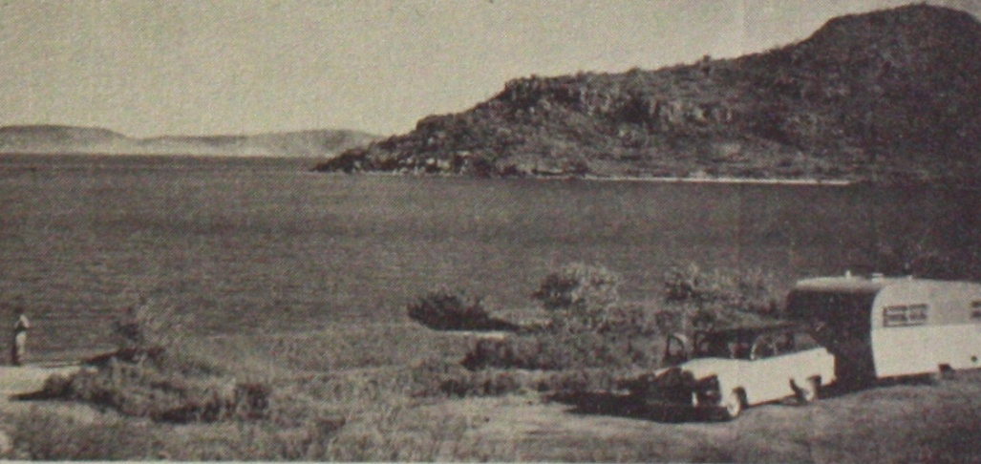
Our trailer by the sea in Guaymas, June 1955

It would be hard to describe the beauty of this land of the Aztecs as we drove along the narrow highways making our way farther and farther away from the border and the Mexicali stars. The soft, sunny breezes were filled with the scent of blossoms and the tropical fruits were a delight. Pineapples were so sweet. Mangos, guayavas and bananas grew on the side of the road as well as in large haciendas.
How beautiful everything was! The small villages, the lonely mountains and the green valleys, the big cities, such as Guadalajara and Mexico City; the seaports, Mazatlan and Guaymas!
We pulled our trailer up hills; stopped by the side of the sea; held spontaneous meetings by the side of the road; handed out tracts in gasoline stations, in seemingly deserted places where there were only a few shepherd lads or children and mothers standing in the doorways of bamboo huts. The market places in the busy sections of the cities were quaint and enchanting, assailing the nostrils with every possible scent.
Far from the stories we had heard about persecution and opposition, the people were kind and receptive. They listened politely and never threw down a gospel tract. They often gathered around asking for “Mas!” (more). Although we knew such stories as the New Jersey man’s adventure in Zacatecas were true, we were learning that such episodes were rare. The overall picture was quite different. We began to lose our fears and felt a deep love growing in our hearts for these simple, courteous and gracious people.
EDUARDO went along with us from Mexicali to act as a guide and to help us with our Spanish. We had happy fellowship with him. We loved to listen as he played the guitar and sang. He never tired of trying to help us learn more of his beautiful native tongue.
We were elated over the good times we had, witnessing and giving our tracts. “Esta es su casa!” (this is your house) was a familiar expression. We could not help but feel every time someone would say this that God was literally fulfilling His promise to us. “He that forsaketh houses and lands and father and mother and children for my sake and the gospel shall receive a hundredfold..”
YES! There were hundreds of little “Casas” that were OURS. Not because we owned them, but because we claimed them for Christ and their doors were open to us. Here were our brothers and sisters for we were at home with them in heart.
Eduardo’s guitar was a beautiful instrument which taught us a deep spiritual lesson as we were learning that there were times when our efforts in preaching the gospel did not have the desired effect.
From the jolts of traveling, moisture or temperature changes, the guitar would get out of tune. The strings had to be tuned to make the chords sound correct and the instrument useful.
We too, needed to tighten up the strings of prayer; to be saturated with the Word; to be anointed with holiness and power. This is what would help the people’s hearts to be softened and make them willing to acknowledge their spiritual need.
Eduardo had given out tracts and as a group gathered, he sang and played. He knew his voice was good and could attract a crowd. He preached with great “gusto”.
But suddenly…! As quickly and as spontaneously as the crowd gathered, they LEFT! Eduardo was standing there holding his guitar dejectedly all alone wondering what happened.
He grinned a little sheepishly as he joined us in the trailer house. “Se fueron!” (they left), he said. He repeated this little phrase several times, laughed at himself, sat down and began to tighten up the strings of his guitar.
Spiritually the people with their religion were as hard to reach as the mountain villages beyond the rock strewn paths or fallen tree clogged roads. Although seemingly receptive and quick to give a mental assent to the gospel, it was so hard for them to be a disciple for Christ. They could not be won by Might, nor by Power, nor by Talents alone.
Next time he witnessed he would pray more before he started out. The WAY had to be… “By my SPIRIT, saith the Lord!

If I Had Known

A beggar came to a little town
Seeking a place to stay
Almost everyone in that little town
Turned the beggar man away.

Later, the people of that little town
Learned to their surprise
That the “beggar” was a millionaire
Coming in disguise.

Those who rejected him
Began to wail and moan
“We never would have turned him down”
If we had only known!”

Hungry, thirst, naked…
Jesus comes today…
Do I receive, “The least of these”
…Or turn them all away?”

When he returns in majesty
Will I be one to moan
“I never would have turned him down
If I had only known?”

Anne L. Moller

NO WAY PLACES CHAPTER 5

The Sleeping Lady

Looming high on Mexico City’s southeastern horizon are two 18,000 feet high snow capped volcanoes known familiarly as the “Sleeping Lady” and the “Warrior”. To some they are more than a tribute to God’s grandeur and superb artistic power.
We listened fascinated to the Indian legend about these two neighboring mountains, Ixtaccihuatl and Popocatepetl.
The Aztec story goes that an early Indian chieftain would not permit his daughter, Ixtaccihuatl, who was deeply in love with a commoner, Popo, to marry until he proved himself in battle.
The warrior, Popocatepetl, went away to fight distant tribes to bring tribute and captives to prove his prowess. Ixta desperately waited in the despair that only the love sick can know. Her father repeatedly told her that Popo was dead; Ixta died of a broken heart.
The very next day, Popo returned. Now he was a hero, a conqueror, and eager to be granted the privilege of marrying his beautiful beloved.
Popocatepetl’s love drove him to desperate efforts to revive his Sleeping Lady. He carried her to the highest mountain close to the powerful Sun God. Popo shot an arrow into the sun, then sat down at Ixta’s feet, determined to wait for her to arise. He believed that one day she would be restored to life.

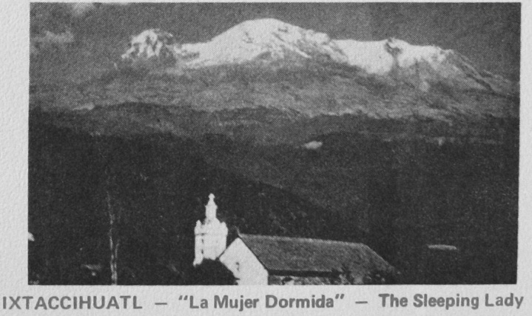

He sat there until both were covered with snow. There they remain to this day. The smoke of his watch fire still ascends skyward for Popocatepetl. “The Mountain that Smokes” still has its heart burning within. Popo and Ixta are together as the ages roll on.

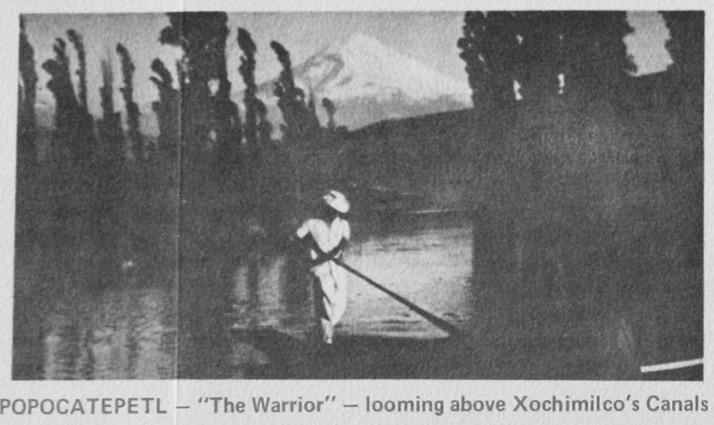

I could not help but compare the Aztec Legend with the Resurrection Story. In the account, Christ, the “Warrior” also goes forth to battle to win His Bride. The great conqueror of all ages, He was the one and only who could prevail against Satanic tribes.
In the legend, Ixta died. In the Resurrection Story, the “Bride” was also dead… “dead in trespasses and sins”. The “Warrior”, Christ, carries her on His back up Mount Calvary! For it was for Her He stumbled up this hill beneath the cross. What “arrow” was this that had been shot by the “Warrior”, Christ that made the sun grow dark at noonday? And yet, in the darkness of this NO WAY place, light shines forth to all the world.
What force of love was this that goes to the death and then beyond…? This “Warrior” does not “sit down” in defeat and hopelessness. Up from the grave He arose! Victor o’er the dark domain!
Rocks were rent; the earth trembled and shook; a chaotic change was taking place. Death was being swallowed up in victory! Popocatepetl! The TIME has come! Love has found a way! The hope in your heart was not in vain. The long wait has ended! The “Sleeping Lady ”, the BRIDE of Christ, has risen up in strength and beauty! The “Warrior”, Christ the Lord, is seated on a throne more dazzling in brightness than the snow capped Twin Mountains sparkling in the splendor of the tropical sun.
In Mexico City, Joanne and Linda studied in first and third grade. I tried to improve my Spanish by taking a course with the Soul Clinic Missionary Group.
We had many adventures with these young people going on invasions with them in villages and witnessing from house to house. We experienced the deep joy of complete dependence upon the Holy Spirit to make Christ known. What a thrill to give out a tract, then to begin to tell the Gospel Story in its simplicity and power from house to house, from villager to villager, on down the little narrow streets, in and out of the winding trails. As it had been in the beginning, in our first few days in Mexicali, so it was now, the people were receptive, friendly, and easy to talk with. Many agreed: Christ was the only Saviour, the only hope, the only way. Words flowed. It was like a drink of cool water. Our hearts sang!
Santa Barbara, Chihuahua, was one of the places we went to on Caravans for Christ during our stay in Mexico City. What happened in the town still lingers in our thoughts. Once again, God preserved the life of our little son.
We had had a full day and all went well, when suddenly a young “Ranchero” wanting to be friendly with Clifford, lifted him up on his big horse. The horse jerked the reins out of the Ranchero’s hands and sped up a stony hill. Cliffie, hanging on for dear life, looked back frightened, crying for help; but there was no way to stop that horse! All day we had gone forth taking the name of JESUS to the people. Now we called upon HIM in our despair, and he heard!
In a few seconds, the plunging animal reared up and Cliffie went crashing down head first on the rocks. He gashed his head, and we thought he would surely be trampled to death beneath the horse’s hoofs which pounded down around him hard as the rocks beneath. But NO! When we picked Clifford up and wiped the blood away, he was alright!
The Apostle Paul said, “What shall I say more? For the time would fail me to tell of Gideon and of Barak and Samson and of Japhthae, of David and Samuel and of the prophets; who through FAITH subdued kingdoms, wrought righteousness, obtained promises, stopped the mouths of lions, quenched the violence of fire, escaped the edge of the sword, out of weakness were made strong, waxed valiant in flight, turned to flight the armies of aliens. Women received their dead raised to life again…”
God by His Spirit is still “subduing,” “obtaining,” “stopping”… and the time fails us too, for we cannot begin to tell all that God has done for us in Mexico.

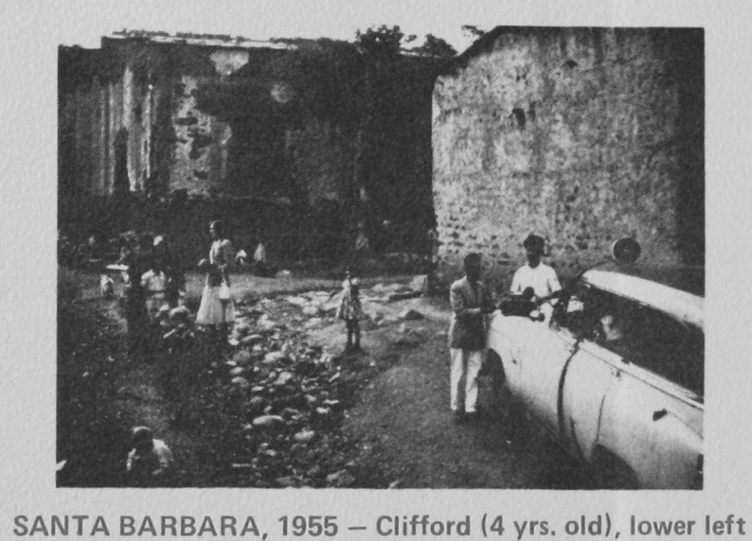

NO WAY PLACES CHAPTER 6

Shadows

In Mexico City we were trying hard to make a go of it in our little seventeen foot house trailer with our three children. During the rainy season life became an ordeal. To make matters worse, Hank had picked up amoebas in the village work and due to the fact that we were not aware of what was wrong with him, he developed hepatitis. He got very thin, grew so weak he had to stay in bed most of the time. His appetite was poor and food only agitated his distress. His yellow skin and sunken eyes spelled out the seriousness of his condition.
As the days dragged by, discouragement overwhelmed us, and the trailer seemed to be getting smaller and smaller.
I have one outstanding recollection of this unhappy time which may have been the turning point, changing defeat into victory.
Because of Hank’s illness, I was hard pressed trying to keep the three children quiet in the little trailer kitchen all day while it continued raining outside. It seemed that there was no way to keep things running smoothly.
Toward evening, the rain cleared off, and just as it was turning dusk, I slipped outdoors, hoping the children would not follow me and hoping that they would be quiet so as not to disturb Hank’s rest.
There was a tennis court next to the trailer court and it was vacant. No one was around and it was a good time to pray. Down on my knees in the wet grass I cried out to my Heavenly Father in utter and complete despair.
I told Him that I wanted to still serve Him but that there was no way that I could with Hank lying at death’s door and the children locked up in one tiny room while it rained all day.
Where had the joy gone? Where were the bright promises? Where was the God who led His people into a broad land and the Lord who healed the sick with a touch? Why was I so all alone? Hank, always so strong, couldn’t help me now. My children were too small to understand. I was in a foreign land, far away from family and friends. To whom could I go but to God?
As I look back on that moment of calling upon the Lord, I realize how God really did hear and answer prayer by sending another missionary to see how Hank was doing. It was he who suggested that Hank had the amoebas and needed to be hospitalized.
After being interned, Hank began to improve. His color returned, his appetite improved, his strength was restored. Praise God! The Lord Jesus Christ Himself was standing in the shadows of the rain drenched trailer court that night when all seemed so dark. He CARED. He sent help. He made a way.
Another big event in our lives in Mexico City was the selling of our trailer house. We had been cooped up for so many months that sometimes we actually felt claustrophobia symptoms.
We had discussed trying to sell our trailer before leaving Mexico City to go north to the border to renew our visas again. If we could sell our trailer, we would not have the long trip pulling it over the mountains. We would be free to look for an apartment when we decided where we should continue our missionary endeavors.
Hank was feeling like himself again and he was able to make contact with a large car dealer who advertised over TV. So our little trailer home was advertised and quickly we found ourselves without a house. Somehow though, we never regretted being set free from trailer life. As soon as the trailer was sold, we knew that the time had come for us to leave Mexico City.
God had made us to know that we were to go to a “fruitful valley”, but we had no idea where this would be. However, we felt that we would not be returning to live in Mexico City. In Mexicali we had been happy in the work, but God did not seem to be leading us back. He had told us in Mexicali that He had set before us an “open door.” We believe that Mexicali was only a door. God was leading us along and letting things happen. He was moving things around until He got us where He wanted.
We enjoyed the trip north (without the trailer), through many little quaint villages. We loved the variety of fruits we saw growing by the side of the road… pineapples, bananas, oranges. There were fields of ixtle for making twine or rope and ever so many cacti for making “pulque”. We drove out of the mountains on to Mante, Linares, Montemorelos and then… there it was… the city of the Saddle Back Mountain… “Mountain King”… MONTERREY.
Little did we know when we stopped by to visit with some missionary friends who were busy working for the Lord in the colonies around the city, in the churches and the jail, that very soon, not too far from MONTERREY, we would find our “Fruitful Valley”.

NO WAY PLACES CHAPTER 7

Arches & Triumph

Late in 1955, we contacted the Alarids in Monterrey. They were Spanish speaking Americans from Albuquerque; missionaries with whom we had worked on occasion while in Mexico City.
The Alarids welcomed us to share the apartment over theirs in the colony of Las Mitras. We got acquainted through the Alarids with other missionaries such as Sister Owida Baker. We went with her to the villages, to the churches, and to the prison services.

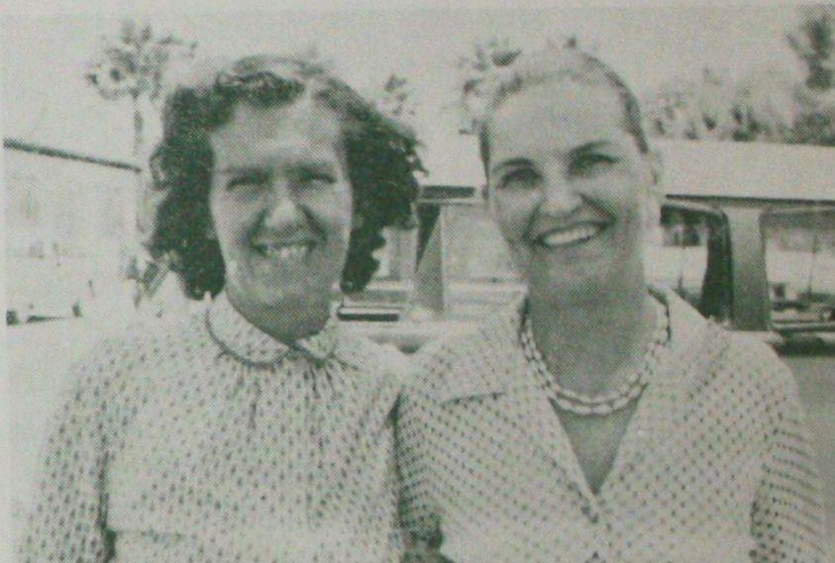
Anne Moller & Owida Baker, Spring 1956

Owida and I became good friends soon after we met. Although she laughingly admitted one day that her first impression of me was not very good, she had been well impressed by Hank. She said that she had remarked to someone, “I wonder what a handsome man like Brother Moller could see in such a plain person like Sister Moller?” But after we got better acquainted, she loved me in the Lord and let me interpret for her in the jail services as she ministered under the Lord’s anointing. We began to flow together in the Spirit and have had a beautiful friendship.
We were getting more fluent now and were able to make out fairly well with our Spanish. However, we would still have to admit that our accent was not what it should have been. We didn’t mind a bit when Bob Alarid said one time when Hank was using the best Spanish he knew, “Brother Moller, your Spanish sounds more like French to me!”
Sometimes when driving we would be stopped by “transito” who hawkishly watched for slight infractions, real or imagined, which gave them opportunity for the “mordida” (bite). If Bob happened to be along, he would grin and say, “Try your ‘French’ out on him, Hank!” Sometimes Hank’s “French” worked wonders. The cop was so busy trying to figure out what this “gringo” was saying that he forgot about the “mordida”.
We were especially interested in working among the children in the poor colonies and there were opportunities everywhere. We started little classes, told Bible stories, had contests, and gave out candy to the ones who gathered around. Week after week, they came back for another “story”. Our little apartment on the second floor over the Alarid’s place always had children going up and down the steps.
Many of these children were very destitute and ate wherever they could get a crumb of bread and slept in doorways. Some of these children asked if they could come and stay with us. The thought began to “take” and I began to toy with the idea. Why not? I had grown up near Christ Home [orphanage] in Warminster, Pennsylvania. I was thrilled with the fact that God had provided such a beautiful spot. The faith and courage of the Christ Home founders and those who carried on for years was deeply impressed upon my heart. Perhaps God had allowed me to see and feel this and then had sent us to a place where the need was much greater, so that we could reproduce what He had begun years before.
We were led to a Ranch out in the mountains, twenty-five miles southeast of Monterrey near a little town called El Alamo. The Ranch was for rent with an option to buy after a two year lease.
The house was beautiful with a brick color Spanish tile roof, large graceful arches supporting the front terrazzo roof, a long hallway, cypress trees out front, and an orange grove spreading down over the forty-five acres of land. What a wonderful place for children to run and play.
The Lord gave a Word of Promise when I went before Him concerning His will in this matter. He said, “Dwell in the land and do good and verily thou shalt be fed.” I was excited and thrilled. I shared what I had gotten from the Lord with Hank.
But Hank wanted to be sure. When he did arrive at the conclusion that it was the will of the Lord for us to have the Ranch, he went to make the final arrangements with the Señora who owned the Rancho. She told him to come back at 4:00 p.m. to sign the lease.
Upon his arrival, she informed him that in the interim she had rented the ranch to a man who was going to put in an egg producing operation. It seems that she preferred her property to be use for chickens rather than children.
This was disappointment beyond words. Hank and I had both felt that it was the will of the Lord for us to have the Ranch. How could we have been so misguided?
As it was, we continued with our work in the out-lying villages and the colonies until school was out. Then we left to go east [USA] to itinerate. While we traveled, we noticed that God was providing things for our “orphanage” which had not yet materialized. We were getting showered with sheets, towels and clothes for children.
On our way back to Mexico when the summer was ended, we went to a missionary overnight stop in the rear of a church. The room where we stayed was cluttered with old clothes which smelled musty. We had to push them off the bed onto the floor before we could lie down.
I remember complaining to the Lord as I lay in the warm room wishing for a fan to move the stifling air. We had to leave the ceiling light on and the top sheet off to keep the bedbugs in hiding. “Lord,” I sighed, “Aren’t we ever going to have a home again?” Our children had fallen asleep huddled together in a small bed. Theirs had been a rough summer traveling from place to place. They would be glad to get back to Mexico, but that sparsely furnished apartment on the second floor was not really all that inviting to come home to.
Weariness induced slumber in spite of the heat. Hank and I both fell asleep. I do not know how long I slept, but when I awoke, a cool breeze was blowing in the small window. How delightful it was! I felt so refreshed! I had had a beautiful dream! It was like an answer to my prayer. God had heard and had wanted to comfort me.
In my dream I saw El Rancho, the arches on the front terrazzo, the front lawn, the white fence. I heard children’s voices playing happily; laughter rang out with sounds of joy. Camels were coming down the road in front of the white fence. They were loaded with good things for the children.

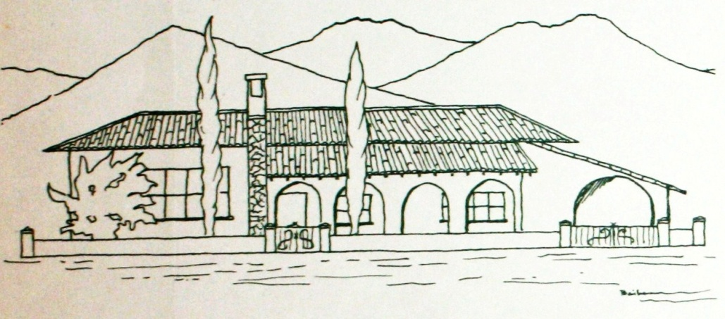

I somehow knew that this was meaningful. God was speaking to me. He was opening up the way. The children WOULD have a home. I didn’t know how this would be, but I believed and took heart.
A few weeks after we had gotten back to Monterrey where we were living in the upstairs apartment, the Señora happened to be in the “tienda” [store] at the same time Hank was. She told Hank the Ranch was now available.
What had happened? The man had broken his lease and left here with equipment debts. NOW it was open to the CHILDREN.
I have often wondered… what did the camels loaded down with good things mean? They are not native to Mexico; our beasts of burden are oxen and burros. I don’t know, but I do know that camels are BIG BURDEN BEARERS.
During our first twenty-five years in Mexico, many of our friends from far away places have carried heavy burdens for us. Some have come visiting loaded down with good things for the Rancho del Rey children. In the heat of the day or in the gloaming some have sat beneath those arches as we reminisced of the Lord’s triumphs.

NO WAY PLACES CHAPTER 8

Bruno’s Prayer

In mid September, 1956, we moved out of the upstairs apartment in Las Mitras to the Ranch near El Alamo where the arches and the oranges were.
We thought we would rename the property. The name it had at the time was “San Nicolas” which just honored a saint. We wanted to honor Jesus.
Hank remembered recent Mexican history of a popular uprising of the Catholic population in the late 20’s when the Mexican government seized church properties and held them in federal custody. The clergy, protesting, refused to officiate in church functions. For many months the Catholic rallying cry was “Cristo Rey”… “Christ is King!”
Now we had a lead on a name we and our neighbors could both feel comfortable about. Christ is indeed the King of Kings. The Ranch would be to honor Him… the Ranch of the King… EL RANCHO DEL REY; a place where the sons of the street could become sons of the King.
It was the fall of the year. In Mexico there is not the riotous coloring or the falling of the leaves to the extent that I had been used to all my life. However, I hardly noticed the lack of this gorgeous display of nature due to the delightful satisfaction derived from the warmth of the Mexican sun. It seemed more reluctant here to give up its glory than it had back home.
But life was not all sitting in the sun and eating tree ripened oranges. We had already begun the task for which we had been entrusted, the Rancho. Jose and Guillermo were our first two little sons of the street. Guillermo came down with malaria a few days after he arrived. We were not familiar with this sickness. We were quite upset when he took uncontrollable chills and fever every day at the same intervals. Hank and I looked at each other. “Now, what next?” I began to wonder what we would do with a whole house full of kids!
Like it or not, capable or not, it wasn’t long before more boys came, and then more and more. The need was overwhelming! We were falling over children at night in the dark trying to light lanterns and get everyone settled down to sleep. We were going to need some help; someone who could talk better Mexican lingo and cook better Mexican meals.
We went to look for help in the gospel preaching church in the town of El Cercado. We found out that Brother Antonio’s people were in Cristina’s home. They were having a funeral. Cristina’s husband had died.
Dead people get buried quickly in Mexico; the very day they die, or the next day. However, the mourning lasts a long time. Sometimes close relatives wear black for a whole year.
Benjamin, a young man from the Church who had some experience as a cook, and Cristina soon became part of our Rancho del Rey family, helping with the cooking and meals. The boys began to notice a big improvement. I began to TRY to cook Mexican style.
Before Benjamin came with us, he had worked with Bruno, Cristina’s husband who died. Bruno’s story fascinated us and I would like to share it with you.
Benjamin and Bruno had been preaching in the “Sierra”. They were very poor having very few earthly possessions. Their shoes were just crude sandals made out of old tires. But they had been called to preach the gospel and it didn’t matter about fine styles. They went from village to village. Sometimes they were invited to stay in a place for a few days or a week. Other times they would preach and move on trudging over the mountains until they were welcomed in another town.
Often they would sleep on the dirt floor; they would be happy to eat tortillas and chile del monte or the aguacates which grew in the area. They hunted for talajotes or cactus which is delicious and nourishing; a substantial food for a wholesome appetite.
Bruno and Benjamin had good results and many believers still worship God today in those mountain villages as a result of their efforts. They went preaching, singing, and praying and believing God for the healing of the sick. Many prayers were answered. Sometimes they fasted for God’s glory, sometimes they fasted because they had to. They walked and preached in heat, cold, and rain. The summers were long and sometimes very dry. Water would be hard to get. The winters, although only three months of severe cold, seemed longer because of the thin jackets, sandals, and too few blankets which always had to be shared.
But it was a time of joy because many precious people from Las Sabinas, Laguna y Sanchez and numberless other villages accepted Christ. Bruno and Benjamin were following the Master. Cristina too, was happy when they returned to tell what God had done.
Then a sad thing happened. Bruno got very sick. The cold winters and exposure took its toll. The lack of proper foods and long fasts had sapped his strength. He was too thin; his appetite was poor; Cristina was frightened. “Don’t go the Sierra anymore!” she begged.
But Bruno kept going back to preach, returning to Cristina more spent each time he went. When finally he was no longer able to return to the field, Benjamin stayed with Bruno and cared for him, helping Cristina to prolong his life.
Bruno did not feel it was right for Benjamin to waste his time helping Cristina to care for him. “Go back to the villages, I am fine. You must preach the Word. The people need you.
But Benjamin stayed by Bruno until the end. One morning Bruno said, “Benjamin, what do you want more than anything from the Lord?”
I would like to work with American missionaries in the villages,” Benjamin said.
“I will ask God to grant you this desire, Benjamin,” Bruno said. Not long after this, Bruno was called Home. The battle had ended for Bruno. He had entered into the LORD’S Holy Mountain.
It was the day Bruno was being buried that we arrived in the town of El Cercado looking for help, and that very day we found Cristina and Benjamin.
The ANGELS had carried BRUNO to his new home. Had they sent us to answer his last request and PERHAPS his FIRST request in heaven?

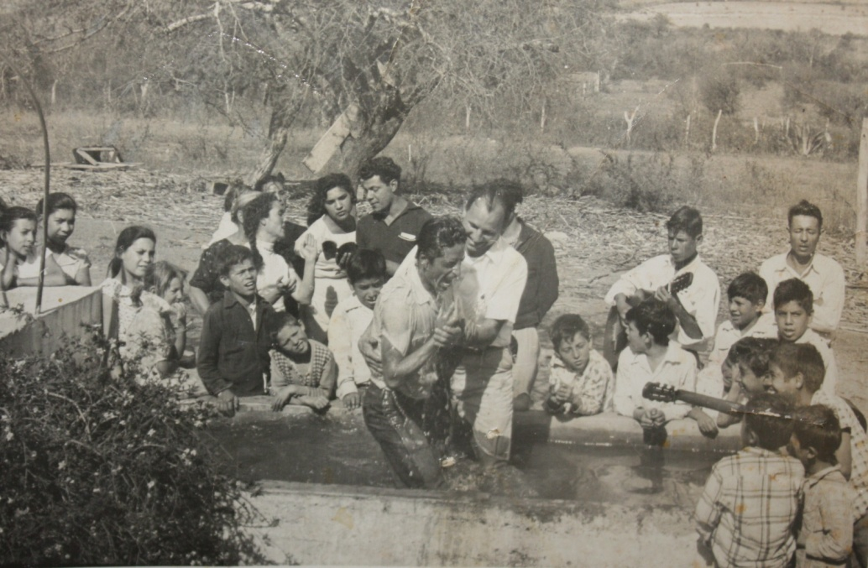
Hank baptizing in the stock tank at El Rancho in1957.
Benjamin is behind Hank’s right shoulder.
Cristina has the pigtail in the left center.

NO WAY PLACES CHAPTER 9

A Way Through the Fire

We were kept very busy with our little children of the street. Sometimes we were filled with joy, sometimes with despair. We often wept and prayed quite loud, as though we thought God was very far away and deaf. We were very much involved with the children, and we felt the boys’ waywardness as though they were our very own.

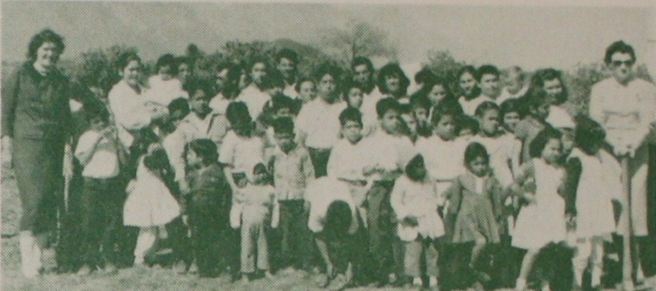

A sense of guilt would come over us when one of the boys would lie, steal or get on drugs. This had been their way of life on the street, but we felt that we had failed. Was it because we had not prayed enough for them? Hadn’t we given them enough discipline or love? Perhaps we had not given them enough of the WORD, or we weren’t yielding to the Holy Spirit.
We knew that Christ could set the worst of them free, yet some of them still rebelled and went their own way. We wanted them to be changed from Sauls to Pauls, but it was not happening fast enough.
There was a conflict going on within our hearts: which was the way to handle the problem of their waywardness? Should we send the difficult boys back to the street so that the rest could be spare? Or should we go all out and try harder to save them?
Along with the spiritual battles, there were physical and material challenges which slowed us down spiritually. Perhaps this was because we were not putting first things first. We were so busy trying to raise finances to meet the daily needs; we HAD to keep food on the table, pay the rent, keep up with school expenses. Piled up on this were legal expenses as we sought to arrange our immigration papers. There was the expense and daily trip back and forth to Monterrey to take our children to study in English at the Pan American School. Although we have always held services right from the beginning on the Rancho three or four times each week, we were missing out in the midst of the activities on our private prayer life.
Yet, in spite of this, God was there and we knew that His mercy was following us. Our work in the mountains had been started even before we went to El Rancho, and we tried to continue with this. Off we went several nights a week in the jeep with some of the boys, singing along the way. The trail was rugged going back to Las Sabinas where we held open air services. The joy of taking the gospel to these humble village people made us forget the weary, bumpy ride and the flat tire threat.

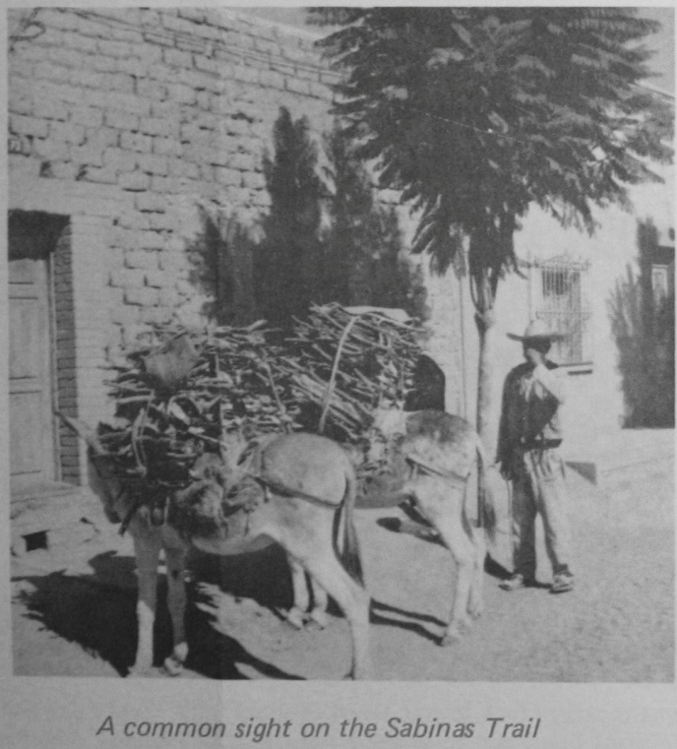

On one occasion, we had picked up some young boys on the way who rode along to be in our service in Las Sabinas. We were a bit concerned about overloading the jeep, but in Mexico there is always room for one more! We went and returned, the jeep swinging and swaying along the treacherous trail (I would close my eyes when we reached a certain place that had a deep drop off down to the river that fed the dam). On the way back, someone had piled brush in the narrow pathway and set it on fire. We wondered what might happen if we stopped along the dark trail. While we were pondering this, the boys we had picked up jumped out and worked courageously to beat out the fire with branches, water from the creek, and their stamping feet. We never saw such valiant fire fighters! As it was, we were able to keep moving right along over the smoking trail. We held our breath and prayed! “Some through the fire, some through the flood… but all through the blood…”
Often we were tempted to give up the Sabinas work when upon arriving back at El Rancho we learned that the boys that had not gone along with us had been fighting or had stolen supplies out of the closet. Finding out who was guilty was time consuming and discouraging.
The boys were rugged physically and seldom ill, but at times we were faced with illnesses which we were not familiar with. There was one insignificant little sickness which passed around among most all of the boys which frightened me and almost made we want to leave the field.
All the children were getting sore eyes. They were bulging and watery. One after another had the same complaint. We tried all sorts of remedies: we prayed; we used the doctor’s medicines. Nothing worked.
In the middle of the night, I would wake up paralyzed with fear. I saw big, swollen, red eyes in my dreams. I convinced myself that this was too much for me. I couldn’t take it anymore. I was not capable of handling this. Physically, financially, spiritually, there was NO WAY.
My thoughts were being invaded by the Enemy. “You better watch out!” he said. “Some of these days your own children are going to get sick and die down here and it will be your fault. You better go home! You better take [care of] your own children first! You aren’t getting anywhere with the rest anyway!
I listened until I was hopelessly depressed and I went through the motions of trying to pray and be a missionary, without any sense of accomplishment or joy. I did not discuss the way I felt with Hank as he is NEVER afraid and I knew that he would just laugh at me.
In the midst of my fears. I cried to the Lord and “He delivered me out of all my fears…” As always he used the Word. “There was a certain rich man,” He said, “which was clothed in purple and fine linen and fared sumptuously every day” (Luke 16).
The Word was not consoling me by any means, but it was SPEAKING. “If you go back to Pennsylvania and devote your life to your own children after I have called you to the field, YOU are like the RICH man.”
I hung my head as He said, “There was a certain beggar named Lazarus, which was laid at the gate full of sores.” I knew the boy with their sore eyes were like Lazarus.
The Spirit continued softly, “Lazarus wanted to be fed with the CRUMBS that fell from the rich man’s table.” The Lord made this clear to me too. “The boys are looking to you, to your table to be fed.” This was spiritual as well as physical. They were starving for the Bread of Life.
But Lazarus got nothing from the rich man. Just the dogs licked his sores. The rich man did not want to contaminate himself with the sores.
“Is that the way I look to you, Lord?” I asked sadly. “Is MY heart like the rich man’s?” Yes! I did want to go away from the little Lazaruses with the sore eyes!
I couldn’t escape the ending: “The beggar died and was carried by the ANGELS into Abraham’s bosom.”
And the rich man? Did he just go on faring sumptuously every day? Ah, no! “The rich man ALSO died.” He didn’t contaminate himself with Lazarus’ sores, but he still had to die. And in eternity, he was judged for the way he dealt with Lazarus. “In Hell he lifted up his eyes being in torment.” He wanted Lazarus to dip the tip of his finger in water and quench his thirst, but there was NO WAY.
I decided I didn’t want to be the rich man. In eternity I wanted to be with Lazarus. God gave me courage and love as I yielded to His will and stayed by the little sore eyed ones, and soon we had the right remedy and the sore eyes disappeared.

NO WAY PLACES CHAPTER 10

A Way Out
(For a Son of the Street)

This month we pause in our story to tell the story of Oscar Garza as it was related to me during the early days of El Rancho del Rey… Anne Moller

In the little mud floor hut in Cerralvo, Mexico, I was happy as a little boy because I was close to those who loved me.
But my father became paralyzed and my mother struggled with us children. It was hard for her to try to support and care for all of us.
I remember she tried to make us children obey her, but she seemed tired all the time. When I was only small, I became unruly and I can remember throwing stones at my mother. Sometimes I cried because I was hungry, and I wanted her to give me something to eat. My father suffered a lot. They had to give him his food because he was too weak to hold a spoon, and he had more than one year of this sickness when my mother fell ill also.
I was seven years old; my brothers were younger, and my father and mother were there helpless. We boys made the food which sometimes had no salt and was burned; sometimes we did not eat. My mother had to sell the clothes and dishes that papa had bought when he was working.
After that, my mother went to live with my grandmother, and my father went with his brother. But do not think that papa had a happy life. His brother and his nephews did not love papa and he had to try to work in spite of his crippled condition and paralysis. He had to draw water from the well using his one good hand and his mouth, because the other hand was asleep. My cousins said that they wished that papa would die.
When Mama was feeling good, she played with us, and we loved her. Then I remember how thin she was getting and she did not play with us anymore. My uncle started to give her blood. That helped her a lot and one day she said, “Look, I am gaining weight!”
But one night the doctor came and gave her a blood transfusion and that night Mama died. I do not know why except that my uncle says the doctor waited too long to give her the transfusion after taking it from him. Sabe Dios!
When Mama was in pain that night she talked to us and said, “Be good, and don’t do wrong things.” And we said, “Yes, Mama, yes.”
And when it was near morning, she said to my grandmother, “Mama, I am going on a journey soon.” After that she did not talk. Then we knew that she was going to leave us.
We left Papa after Mama died and we went out and wandered like sons of the street for a long time. Sometimes we did not eat, and sometimes, yes, we ate mangos and melons we had stolen in the market, tacos we had begged, and hard tortillas.
My brother said to me when we walked in the streets and wondered where to go to sleep at night, “I want to see Mama again.” And I would say to him, “Don’t cry, Hermanito. What do we gain by being sad?”
Another day dawned and we struggled through it again. We had hunger. We wanted to have fun. We began to learn the ways of the street and anyway it didn’t matter about being good anymore because Mama was dead.
One day I got malaria with chills and fever. I got very thin and weak and could not go with my brother when he walked and went to the market. My brother brought me mangos and bananas. Sometimes he would forget to come. Sometimes he would laugh at me when I told him I was cold and my teeth would be chattering as I lay in the sun.
But one day he came with medicine. “Where did you get this?” I asked. He had begged for it. The medicine helped a lot and I began to get well. But I did not remember the favor very long. I was bigger than my brother and I would force him to give me things he had. He always had more than I did because he was not ashamed to beg. Too, he was quick! Which is always a help when you are a son of the street.
As we grew older, every little while we fought and because of this we separated one from another. I had months of not seeing my brother. I thought that he was lost or picked up by the police.
What happened was my brother was not lost, but he was found. He was no longer a son of the street. He had gone to El Rancho del Rey where orphan children are received and loved and cared for. I decided to go there too, and pretty soon I was praying with the rest of the children and listening to the wonderful Bible stories. I am grateful for a place like El Rancho del Rey.
It would be hard to tell all about the lives of the sons of the street. There are many dark, sad, stories that I would be ashamed to tell. A boy who has always had breakfast waiting for him and clothes to wear might never want to do some of the things we did. There is always a way out for the boys on the street. Sometimes it is not a good way, but hunger and cold and loneliness are schools. And the sons of the street go to these schools every day.

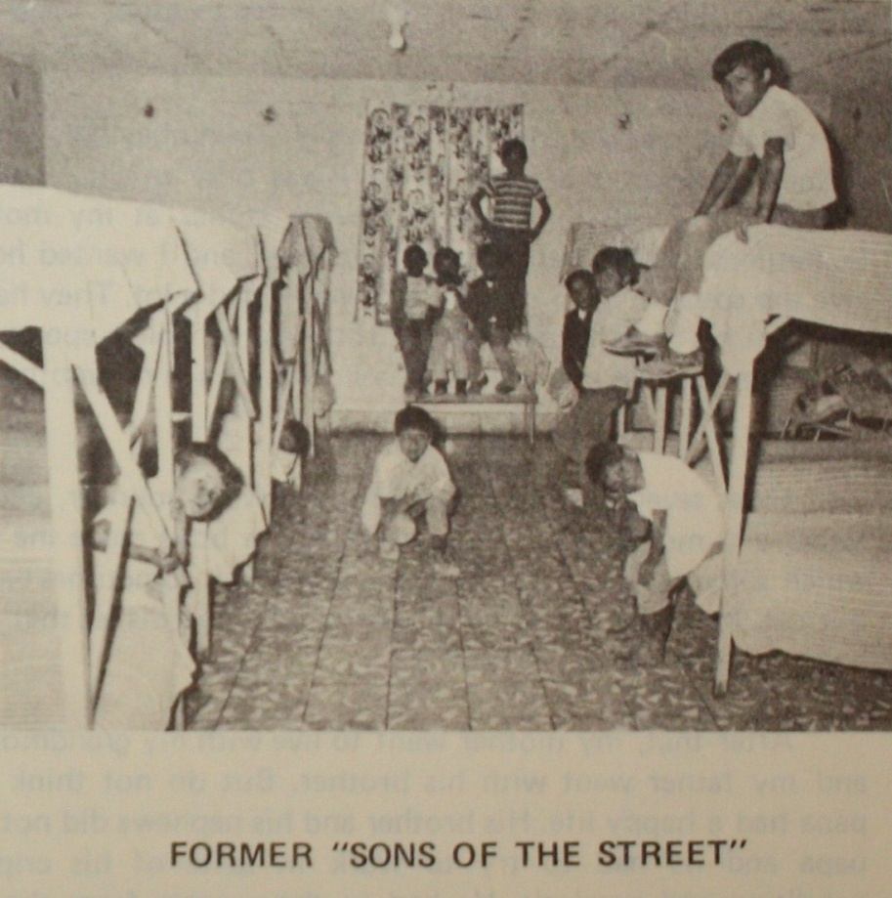

Loose the Colt

“Only a little Colt…”
Said the owner with a frown.
“Why do you loose the colt,
And take him from this town?”

“The Lord hath need of him,”
The disciples stoutly said,
And the little, untamed colt,
Down the street they led.

Only a little BOY…
All bound up and TIED…
Only a little boy…
Untamed, untaught, untried…

The Lord hath need of the BOY…
Set HIM also free!
LOOSE him, Lead him…
FORTH Majestically.

…Anne L. Moller

NO WAY PLACES CHAPTER 11

Little Ishmaels

As the time on our lease on the Ranch was ending, we had no idea as to what we could do about our purchase option. The owner wanted to sell, not to rent again, so it was a matter of either raising the amount needed to buy or looking for some place else that would be suitable to rent.
Buying seemed to be out of the question. We had no financial reserves and were living by faith from day to day. The expenses of providing food and supplies for the seemingly ever hungry “muchachos,” keeping clothing and shoes repaired, and paying utilities and the endless list of items required by a “large family” for daily living consumed the available income.

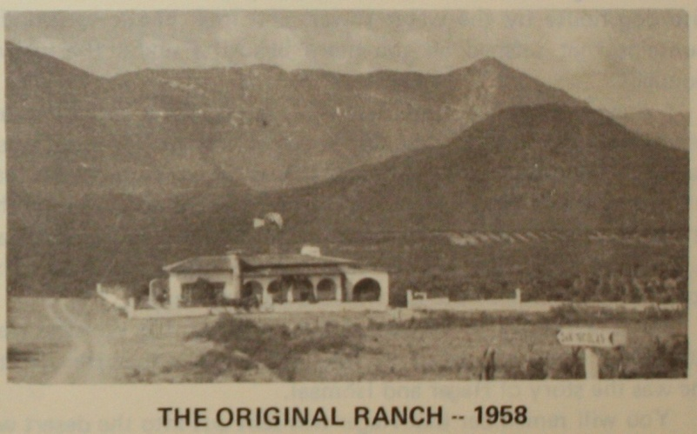

The Señora wanted to sell. She reminded us that if we didn’t buy, there were those who would. Frequently prospective buyers arrived to look over the Ranch. Each time she came, our pulses increased. Was our dream of a red roofed arch-wayed Haven for the sons of the street going to come to a quick end?
In Mexico, at that time, there were no long term mortgages. Even today, eight to ten years is an unusually long contract. In our case, the whole amount would have to be paid within three years at one per cent per month interest on the unpaid balance. It seemed impossible! Of course, now as we look back, it was quite reasonable. Think of buying a ranch house, plumbed and wired, 46 acres with hundreds of orange trees for $12, 800. Yet to us at that time it WAS a large amount and the $2,000 down payment appeared HUGE!
There were just a few more months left before our lease would be up and we must exercise our option or the Ranch would be sold. Hank felt that he must do something about trying to raise the $2,000, so he left for a speaking trip to the States.
This was the first time that I had to stay alone on the Ranch without Hank. I have never been a very brave person. I was frightened about the responsibilities and quite concerned about the prospective buyers that kept coming to look over the Rancho. Each time one came, the children would come running up to me to ask if we were going to have to leave the Ranch soon.
“No!” I told them, “The Lord will take care of us. He wants us to be here. He will make a way. Let’s pray about it.”
Some nights I would sit, “Snoopy” like, on the roof of the big white dog house by the water tower, and look at the surrounding mountains that seemed all the more beautiful under the lustrous moonlight.
I prayed earnestly for I felt very much alone and burdened. There was so much work to be done here in Mexico. The need was so great. The children needed a home. It was an opportunity to teach them the Word of God, to trust and believe in His Son Jesus. If they went back to the streets they would return to poverty, darkness and sin. They would grapple with cursing, immorality and injustice. Their opportunity to learn of the Lord would be very limited.
The Lord spoke to me at that time through His Word as He so often has at times of trial or trouble. The portion that He used this time was the story of Hagar and Ishmael.
You will remember that Hagar was sent out into the desert with Ishmael. Ishmael was the little unwanted one, a child of the flesh, like most of the boys we were taking care of.
Hagar thought that she and the boy would die of thirst out there in that wilderness. I felt somewhat like Hagar did as the little boys came around me wanting to know if we were going to have to leave.
The Angel of God spoke to Hagar telling her that HE had heard the cry of the child. Then her eyes were opened to see a well of water she hadn’t seen before. God had provided! Their lives were saved by the Angel’s voice. Would God send an Angel to help us, I wondered?
I wrote these thoughts down and sent them out in our little monthly newsletter. Perhaps many of these letters were never read, but those that did read them must have PRAYED. Their prayers must have moved an Angel in our direction because things began to happen for our little Ishmaels.
Mr. Bennet consulted with a Mr. Wilson who in turn knew Mr. Raymond Hueckstra, a Christian public relations man who had previously made a trip to Monterrey. (Mr. Hueckstra is now better known as Chaplain Ray from his radio work on behalf of his very extensive prison ministries.)
Mr. Wilson and Mr. Hueckstra flew down to Monterrey and started the search for us in a city that then had about one million people. They went everywhere asking for El Rancho del Rey. Since we are located about 28 miles south east of Monterrey in a rural area, how would they ever find us? All they had to start with was a post office box number in the Monterrey Post Office where we went about once a week.
Yes, it was like looking for a needle in a hay stack, BUT that “Angel” knew where we were. After a while someone suggested contacting the American Consulate. Sure enough, we were registered there and a friend, very informally, told them how to find El Rancho del Rey. Was I ever surprised to see our Sunday School class teacher from Portland, Oregon, Mr. Hueckstra and to meet Mr. Wilson. We had never kept in touch with Mr. Hueckstra and now he was standing at El Rancho del Rey on a mission for the Lord.
The boys did what they always do when visitors arrive. They gathered around and showed their love. Pineapples were peeled; papayas were cut up, and were brought out in trays of tropical fruit. They provided a great audience for Mr. Wilson, who was a large man with an equally large and tremendous voice. He had been soloist for some famous evangelists in the 50’s – 60’s era. The boys were impressed, and the visitors were equally impressed with all those who made up El Rancho del Rey.
They promised that when September rolled around and the lease was up, we would be assured of the $2,000 down payment. Through Juanita Coe they kept their word!
The Angel of God had heard these Ishmaels as they cried out to the Lord. Eyes were opened and the little Ishmaels were provided for and blessed.

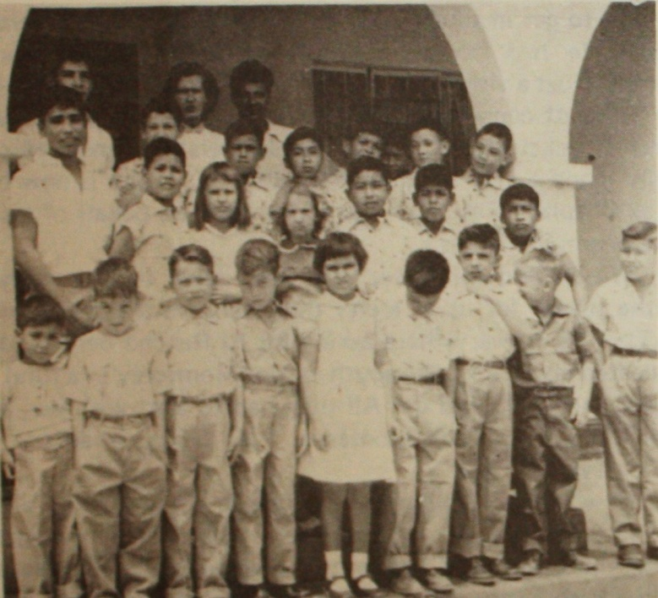

El Rancho del Rey Staff,
Boys, and Moller Children About 1958
NO WAY PLACES CHAPTER 12

El Medico

Youth has no time for reminiscence. Its days pass slowly and everything of value or importance seems to be just beyond reach – in the tomorrow of their lives. How thin the balance, how fine the thread that ties them to life they never seem to fathom.
While looking again at the picture of the “Sons of the Street” in Chapter 10, I remember an important experience of the big boy on the top bunk.
It was the height of our fiesta. Everything had gone over triumphantly. The children had learned their parts as never before. The Spirit of the Lord was in our midst. The play, Saul of Tarsus, was the main event. It had preached the gospel message all the way through from the stoning of Stephen until Saul was let down over the wall and went forth to preach Christ whom he had once persecuted.
Don Alfonso, the most important “personage” in the village, and his family, had come out, along with many of the other village folk. For the well-off and the poor to meet together in an evangelical way in this pueblo where Catholicism had held sway since the beginning of its existence was a leap over the wall of prejudice.
But at the height of it all, when the children were preparing the piñata and there were shouts of joy and laughter and they were blowing whistles merrily, little Angelito groaned again with pain. We had brought him home from the hospital just a week before that. His operation on the ulcerated liver had been a difficult one; his incision had not healed properly. He was not able to retain his food, and his eyes were looking bigger and more listless, and his skinny little legs and arms were like “popotes” (straws).
So that night, before the piñata was broken, before the little bags of peanuts and “dulces” were given out, before the guests were dismissed, we were rushing Angelito away again to “El Hospital” in Montemorelos. Satan had walked in on the scene to wage a battle against us. We were claiming territory that was his, and there would have to be a fight. But God was God to the ends of the earth, and these little sons of the street belonged to Him.
The miracles that had been performed for El Rancho del Rey children had been spread abroad, and were a testimony of the Lord’s power and love. But would we lose Angelito? Would our festivity be turned to mourning and sadness?
I think that it would have been like that except for the children’s faith and prayers and for the prayers of all those who were holding up the work and sharing faithfully.
For that night a miracle was performed. There was no doctor available in the mission hospital. There would be none until the “Manana.”
Rosa was staying with Angelito and was sleeping beside his bed on the floor. He called her early in the morning and said, “Did you see El Medico?”
Rosa had seen no one. The nurse insisted that no doctor had come in during the night.
Angelito was excited. “El Medico said I was going to get well and that I would go back to El Rancho, and he said to tell La Hermana Anita not to worry anymore, that He was going to send “muchas cosas buenas” to El Rancho.
Angelito said that he had never seen this medico before in the hospital and that He had a beautiful smile and that His face shone.
The very night that the “Medico” appeared at Angelito’s side the incision burst open, and the infection which was causing the pain was released. Relief came at once. The next day Angelito was able to take food, and his incision began to heal.
God had restored him to us again. Back at El Rancho del Rey, all the children believed that “El Medico” who had come to Angelito that night was the Lord.

Our summers were usually spent in the States, visiting churches and friends, telling about the work in Mexico. Many times, due to lack of help, we could not travel together. One of us would travel and the other stayed at the Ranch to continue the work.
I remember one of these trips was coming up. I had planned to go with our children to the east coast. The trip promised to be an ordeal for me because I had developed a lump on my breast. Fear began to grip me. The lump was not only annoying, it was painful. At the end of each day I felt weary and exhausted. Hank was concerned and advised me to see a good doctor upon arriving in Pennsylvania.
While in Bible School, I had had a similar problem with a group of small scattered lumps. I stopped using strong antiperspirants and the problem disappeared.
Perhaps this was more serious, but I felt inclined to believe that healing might come in a natural way if I would keep cool and not panic.
I began to think about the possible things I had been doing that could have brought about this painful condition, I had been using nylons and light foam bras. I would cut holes in these—pores need to breathe. I had gone back to using antiperspirants again. I would stop that at once, even at the expense of the extra time needed for more frequent bathing. It is natural and necessary to perspire. The body needs to get rid of wastes. If this natural process is interfered with, the body poisons back up and cause trouble.
Ever since my children were small, I have used onion poultices on their sore throats, a lot of fresh lemon juice for fevers, and warm olive oil for earaches. Hank would kid me and say I used lemon juice on lemons and that he lived in an onion storehouse.
For years the boys on the Ranch have made up jokes about the onions, lemons, and olive oil. However, they gladly let me wrap up their throats with onions, treat their burns with olive oil or give them lemon juice on a cold winter night when they are coughing and feverish.
Does it work? Yes! It has worked on hundreds of little boys. Because I had seen these simple cures do marvelous things, I felt that I would try applying olive oil and onions on my breast at night. During the day I went about my business with bras with holes cut in them and without antiperspirants. Always I breathed a prayer for help to my Heavenly Father in His Son’s name, “JESUS!”
When I arrived in the east, I still had pain. The lump was still there, but—was I imagining it?—it seemed smaller. At night, though, after driving a lot during the day, it would hurt.
I didn’t go to a doctor. I KNEW one thing and believed it will all my heart—I was NOT going to have my breast removed nor accept any advice to do so. I would pray and trust the Lord, using simple remedies persistently, and just keep on going by faith doing the things I had scheduled.
As the months went by, I became more sure, more convinced that God had heard my prayers and honored my faith, and the simple remedies worked. The growth was getting smaller. It finally disappeared.
That was about 20 years ago. Since then I have given birth to another child (Danny) and had no related problems.
I want to add that I appreciate doctors because they are dedicated to bringing healing to people who suffer. For myself, I do not approve of extreme surgery such as mastectomy. We live in a cut now, pay forever, and think later age. Much of this is unnecessary. Seek a second opinion and the mind of the Lord. I believe that if most women would pray and think it out for themselves, they could find healing in a natural way.
I appreciate doctors who believe in simple remedies and trust in God for their wisdom. I know just such a doctor: a fine born-again Presbyterian man in Monterrey who has been very gracious to our Rancho del Rey boys for twenty-four years. He has always been uncomplicated and sincere, and his faith in God has made him humble and wise.
Just the other day Hank’s mother was in his office. He has helped her now as well as on her previous visits to Mexico even with things New York doctors failed to relieve. I told him the other day “Mom thinks you are a wonderful doctor.”
He raised his hand in objection and pointed up. “No,” he said, “we have a DOCTOR!”
Thank you, Doctor Rodriguez, for reminding me. Yes, indeed, we HAVE a DOCTOR!

[Angelito]

NO WAY PLACES CHAPTER 13

El Salvaje
(Part One)

Amongst the many faces of any group picture from the early years of Rancho del Rey, it would be hard to find ONE that did not stir memories and bring forth a story to tell.
We called them all “sons of the street”, for this is what they were, or at least most of them. It seemed that those who had really come from the street were the hardest, the most unbroken, the most cruel. Yet it was to them we were drawn the most. There was something about this one that was forceful, though he was only a boy. He seemed so knowing, so indifferent to the opinion of others, so mocking and strong.
He, and the others that were with him, came at one o’clock in the morning. There were no beds yet for them, so they slept on the terrazza. The pastor who had directed them to the Rancho told us in the morning. “Watch out for those two – they are the worst.” One of them was our dark boy. His eyes were piercing and black. He seemed to know that he was being pointed out and accused of something.
That was the beginning. Had he heard what the pastor had said, I wondered? I was sorry, if he had, so I smiled at him. He must not think that we had been warned to mistrust him. He must feel at home and wanted.
Underneath his torn shirt and ragged clothes, he was poised and graceful. He walked with a muscular, rugged nonchalance.
A haircut and clean clothes did it. All of the boys looked so different. They were not just ragged urchins. They were little princes to whom we had opened our doors.
Time passed. We were living with our little sons. The dark boy was the worst as we had been warned. Fighting, stealing, swearing, jealousy were part of life. Restraint was an unknown quality.
Alvaro was fourteen and had only gone as far as the second grade, but he had knocked around on the street long enough to learn a lot of things. He put himself in the fourth grade and held his own.
He had said when he first came. “I will stay a few days here and then I will go away”. But something seemed to be holding him. Was it the 46 acres of wide open spaces in which he could roam, the orange trees that were loaded with fruit, or the mountains that were calling to the heart of a boy who was half Indian and who was tired of the city streets? Could it possibly be that he was willing now at last to settle down to the routine of school and combing his hair and wearing clean clothes because meals were good and there was always an open closet door? No one seemed to care too much if the bananas disappeared and the crate of mangos was used up in a day. This was easier than roaming the market place and begging for food or having to steal where you might run the change of having a cantaloupe hurled at your head.
Or could it be that “El Salvaje”, or “The Wild One”, as they had nicknamed him, had other unspoken reasons for staying overtime?

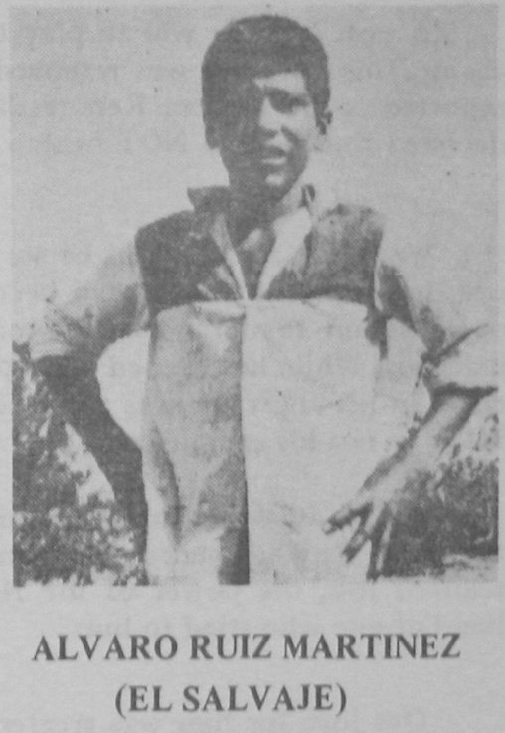
The days passed. There were personality conflicts among the older boys. Feuds! Counseling was hard! The counselor was having trouble with El Salvaje. The counselor was steady, demanding. Rules meant a lot to him. To El Salvaje, rules were meant to be broken. He was openly defiant. One thing I learned quickly as I dealt with him: force was out! He would never be subdued that way. Force was all he had ever known thus far in life and he had learned to fight force with force and win. There was another way! It was the way of the Cross. It was God’s way. It was the way of love.
There were times when he obeyed rules so willingly! He would be called upon for some of the hardest jobs: lifting digging, shoveling loads of dirt on the old jeep. Our wild boy would get the job done. If you praised him and let him know he had done it well, his dark eyes would flash and smile. His glory was his strength.
The long talks we had together enlightened me. I began to understand. I weighed every action now, every vulgarity, in the light of the things that I had learned concerning his life in the past.
For his mother he said he had no love. Yet I wondered. He talked about her at times as though he was proud of her. She was beautiful he said, shapely and fair. This was surprising, since he was so dark. He received letters occasionally from her and he would write. She was married again now for her third time.
He could remember vividly the beatings that he had received from her. The beatings that he had received were during the time when his mother had been deserted and was alone. He had seen her crying many times after his father had wandered off. There was just him and his brother then. There were constant duels between them he said. His mother would become angry and frustrated. Love for her children seemed to be lost in the mad struggle to survive. Very young, El Salvaje began to take refuge in the street.
The second marriage did not help the wild boy’s life nor make it any more endurable. More children came which lessened the feeling that she had for him. He was accused of hurting them. There was less food to go around. Never enough beds. El Salvaje came home from the street every once in a while, dirty and barefooted. He would crawl under the bed and go to sleep. On one such occasion, his brother threw a bucket of water on him. “Take a bath!” he yelled. There was murder in El Salvaje’s heart that day and his brother received the worst beating he had ever had. Once again the wild boy took refuge in the street where he could bathe when he pleased.
The truth of what really happened when his little step-sister got burned remains to be read off on the judgment day. But that was one of the final climaxes in his life at home.
“My mother had gone out and my little sister and I were there alone. I was playing and not paying any attention to her,” he said. “She was sitting on the chair by the fire. Suddenly, I heard her scream and saw that she had fallen off the chair into the fire! I grabbed her and pulled her out. When my mother came home she blamed me. She said that I had pushed her in. She beat me and I ran away again.”
At eight years old he was told officially to leave. It was one thing to go away because you got mad and felt like it. It was another thing not to be wanted. Perhaps he had been unbearable, perhaps he had stolen many things, perhaps he had been so wild that the smaller ones were not safe. Yet it is quite hard to understand. Even so, except as one realizes the suffering and the poverty that there is among the poorer people of Mexico, how a mother could say to her own son, “My husband does not want you to live here anymore.”
She probably knew that he could beg and steal and survive. She probably thought of him as much older than his eight years. He seemed so much older than fourteen in many ways when he came to the Rancho. There were times when we felt a strange power that we could not describe working, laughing, knowing, playing, in the flash of his black eyes. Perhaps she saw in her son something that she had seen in the boy’s father. Something that had won her, yet had hurt her, had left her to weep alone nights on end. Now she was facing life again, trying to make a go of it. Her wild son of the man who had left her was causing friction. Would she let him destroy her life twice? He had gone away but he had given her his son. The image of himself. The same forceful, passionate, unruled spirit. Dark, savage, wild. Handsome, cruel, unrestrained. A little “devil” who seemed so defiant, so unafraid.
Cruel words! “My husband does not want you in this house anymore!” He had already lived on his own most of the time, but had gloried in coming back and walking in again. It was “home”. His brother was his brother even if he did love to beat him up. Now he was being told to leave. The truth was he was not a “devil”, but just a little boy.
He said, “I felt like I was tied around the neck like an animal. I went out of the house like I was walking in a dream and went down to the schoolhouse. I threw myself down on the steps and cried. After that I did not go back for a long time. I stayed out on the street. I could steal better than most of the other kids and I was never afraid to get into a fight. The kids on the street learned to laugh at my jokes and to do what I said.”
From eight to fourteen years old was not all spent on the street. There were intervals where efforts were made to help him. In the Ciudad de los Niños there were many other homeless boys like himself. But El Salvaje is remembered there only as being one of the most wild. Then out on the street again and picked up by police and to the “Correccional.” This is the place for boys who have gotten into trouble or who have been found sleeping on the street. Once entering the “Correccional” they are not permitted to leave there on their own.
A half a year spent behind those walls was like an eternity to a restless boy who had the call of the wild in his soul and in his arms and in his feet. Three times he climbed the wall and almost escaped. Three times he was caught and brought back. Each time the determination to escape grew. Walls could not hold him. Laws could not force him to obey. He was his father’s son. And one day he waited until the time was right. The guards were smart, but he was smarter. The walls were high, but not nearly so high as the spirit within him that demanded liberty. He was up over the wall that was too high to climb, and down over the other side. No one saw him this time! In a moment, he was free again and back to his beloved street.
Soon after leaving there he felt the urge to see his brother again who was still living at home. He had been told to leave, but time had passed since then. When he arrived, he caught his brother in a fight with another kid. “Coco” they called him. Coco was giving his brother the worst of it.
“Borrati!” Literally, “Erase yourself out!” shouted the Salvaje and joined in on his brother’s behalf. He was more than a match for Coco and the tide was turned in a moment. The Salvaje turned around a conqueror with a triumphant smile. White straight teeth made his smile beautiful, except Coco did not in the moment appreciate it.
“Who are you?” his brother asked, a bit dubiously. He had grown so since he went away! He did not remember him! What surprise he got when the realization dawned on him and the Salvaje said, “Soy tu hermano.” “I am your brother.” His brother might have in that moment nicknamed him “Salva Vida.” “Lifesaver” instead of “El Salvaje”.
Such was the life of the Salvaje and the radical changes. Such were some of the struggles and escapades that helped to form his thinking and were so much a part of him when he came to El Rancho del Rey.
But there was more. There was another part of the interwoven fabric of this young life that was forcibly formed.
If the Salvaje was proud of his mother, he was equally proud of his father, though he told the bare facts when discussing them.
He knew very little about his father from having lived under the same roof with him. Most of the things that he had gathered concerning him were told by his grandmother, or his aunt or friends.
He describes one brief encounter. His father approached him with his head down since that was the way he usually walked. He slouched over on the weighted side of his gun belt. Even at that he was well built and strong.
He spoke abruptly. “How is your mother?” The Salvaje knew very little by this time about her himself, but he must have felt a bit of loyalty to her.
“Bien,” he said. “Tiene muy bonitas curvas! She is well. She is beautiful!” He walked away from his father as though he had no interest in talking further. He yelled his answer over his shoulder indifferently.
“Come back here, little Devil,” His father called after him.
“Yo no tengo nada que ver con usted,” “I do not have anything to do with you,” was the answer that the boy flung back. He kept walking.
“Come back here or I’ll shoot you in the pants.”
“Andale,” “Go ahead”. The boy kept walking and the threat was repeated. This time louder, more demanding, but he was his father’s son and he did not turn back. There was no shot.
“My father lives high up in the Sierra most of the time where there are outlaws,” he said. “Sometimes I think that maybe he is dead now. There were people who hated him and would have liked revenge.”
However, other conversations revealed that El Salvaje had other dealings with his father. Such dealings that were like early chapters in the life of our wild boy, and had a part to play and instill into him the strange powers that were working behind the black flash of his eyes and the cunning humility and defiance which seemed to be combined within the spirit of this son of the street who had come to us.
The last thing that El Salvaje wanted to ever do was go to school, but he was doing it. Fourth grade did not seem so hard at all in spite of the fact that he had only spent a half year in the first and another half a year in second. The people in the village all knew him in a short while. He was the biggest one in the school and the most difficult. The professor gave him many warnings. There were days when he did not appear in the escuela, and times when it looked as though the Salvage would be expelled.
But at the end of the fourth year he was promised that he could now enter sixth grade and so pass out of grade school. This was a real triumph, but even in the sixth grade there seemed to be moments when he lost sight of the certificate tied in a ribbon, and almost drove the professor mad. Were it not for the interest that the professor had in the Americanos and their efforts to do something for these little street kids, he would have given up in despair and Salvaje would have gone forever from the portals of San Pedro’s humble school.
There was something in the depths of his soul that I could see that caused me to rise to his defense though all the world was opposed to him. He read me and knew instinctively that I could not condemn him, he knew that he could fight or disobey and that when the accusations were being hurled at him, I would stand silent listening, knowing that it was all true, but doing nothing apparently to condemn him. Not that we approved of fighting or disobedience. But I saw something else! He was still obeying the laws of the street, the laws of the wild, the laws of the untamed. He had a set of rules of his own that he obeyed, that were superior in some ways. For one thing he was not hypocrite. When I asked him why he did certain things, “I am no good,” he said.
The worse he got, the more I was determined to believe for a miracle. Even if he had been sent to us by the devil, I knew God would win even as He won over his people when they were not just bad, but their sins were increased and they cried by reason of them.
I knew God was looking down at the Salvaje and searching him. Searching his heart and felling the throb and the pulsebeat of the emotions and desires that He had created him with. The Salvaje was His product. God must love him even as we did. He would not lose the Salvaje, He had paid a price too great.
He would not lose El Salvaje even as He would not lose His people in Jeremiah’s day who had failed so many times. He loved them so much that He was jealous of them and said, “For I will restore health to thee and I will heal thee of thy wounds, saith the Lord, BECAUSE THEY CALLED THEE AN OUTCAST.”
“Because they called thee an outcast!” Here were His reasons… “because” they were “no good”; “because” their sins were increased…”
Just “BECAUSE” God LOVED them!
(TO BE CONTINUED)

NO WAY PLACES CHAPTER 14

El Salvaje
(Part Two)

While Salvaje was rough and hard and the bigger boys often clashed with him, the littler ones followed him around. They picked up his remarks and repeated them. They pretended that they were little “Salvajes”. Yet, there was no one who was as gentle and loving and capable of entertaining a new baby! He was a strange combination of hardness and tenderness, of rashness and persistence.
In services when the message of the love of Christ went out, his dark eyes betrayed mingled emotions. He was convinced, he said, that it was “not for him”; that he could never be a “Christian”. He kept coming in late to the services, but in time to hear the message. If there was a message without power he would be restless and unruly. He would talk or joke with the one nearest him. If the message had weight, his eyes would rest on the speaker and he would listen as though detained for that brief moment by a greater force than that which seemed always to be driving him.
In the midst of our frustrations with his making raids on the food supply, skipping school, laughing when we thought he should have been quiet and serious, we found that it was he we always called upon for the hard jobs like carrying heavy bags, crates of melons and jugs of water. It was he who dared to climb up on the water tank and flush it out so that our water supply could be clear again. It was he who was smart enough to catch on to how to operate the pump or the power plant. It was El Salvaje, in spite of his unruliness, who could get the others to quiet down and get in line.
The tenderness Salvaje expressed when Linda was so ill…carrying her in and out of the car; standing by when she seemed not to have any interest in getting better; she was so weak with fever. He did everything he could think of to make her smile. It was one of these hours, sitting by Linda’s bedside, that we learned many of the events that took place in Alvaro’s life on the street. Linda’s fever seemed to slacken while she listened and her interest was awakened. At a time of heartsickness and despair, so many miles away from home and loved ones, the Salvaje seemed to be the one who brought cheer and comfort and meaning into the darkness.
Strange, unruly, yet beloved son of the street he was; with Samson powers and Samson weakness combined. To send him away to maintain law and order or to save the rest might mean that we would lose more than we would save. None of the better behaved boys had the same potentialities.
When Salvaje practiced the part of Cain in our Christmas play on Cain and Abel, he would come in late for practice, refuse to repeat his act, declare he was bored to death with the whole thing, and influence the other performers. We threatened to take him out of the play to no avail. He did not seem to care. Yet who could we find to play Cain as well as him?
We lived through the practices and when the play was put on it was the talk of our little town. It was Salvaje’s part that made it good. With all his heart he performed when the lights were dimmed and all eyes were turned to him. His dark eyes flashed and filled with horror when the voice of the Lord came rebuking him for having slain his brother Abel.
A year later he was to play the part of King Solomon and practice times were hard again. This time he was removed from his part and the boy who took his place was reported to be beaten. Reports had it that it was El Salvaje who had beaten him. He declared that he had NOT beaten the boy and yet we felt he had. The boy wouldn’t say.
We never really could be sure about whether he had or hadn’t, but after it was all over, he admitted that he had been standing upon the roof of the dorms listening to our conversation (Señora Tomasa and myself) about the way we felt about El Salvahe’s behavior. While he listened he happened to notice a centipede there on the roof near the edge. In his anger, he was tempted to slide it off and make sure it landed on one of us. Were we not his enemies now?
But he admitted that something restrained him and we realized as we looked into his hurt eyes that he needed deliverance from this force of darkness that was driving him. We realized too, the power of the Holy Spirit to protect us, His children, and restrain the hand of one who tried to hurt.
Our love for him was greater than our frustrations and there were bright days that followed when El Salvaje was carefree and helpful again.
Then one night we were in Allende trying to hold a service near a Carnival. There were mostly young people there who were out for a good time. They were drinking and hilarious. When they found out we were singing gospel songs they thought it was a joke. The crowd pushed in on us, laughing, making fun.
I wondered where the Salvaje had disappeared to. Would he help us if we needed it?
I learned later what had happened. Judy was singing, but her voice and guitar seemed to fade in the out-of-doors. But suddenly, there was a hush. We were preaching, and the words were coming easily about a lonesome dark trail we all were walking; of spiritual midnight skies and starless nights; of holding hands and finding the way together with Jesus Christ who was the WAY to the end of the trail and God. They received us! It ended with clasped hands and “Adios Amigos!”
In the strange quieting down when we were able to really preach we had noticed El Salvaje standing in the midst of the crowd. His face told us he was on our side. He later informed us that he and Paul had gone around among the roughest ones during the pushing and said roughly, “Quiet down! Back up ! Quit pushing! Go home if you don’t like it!”
One day when Salvaje was contemplating having to soon leave the Rancho he said sadly, “If someone offered me a million pesos or five years on El Rancho I would choose the five years on El Rancho;” a childish exaggeration? Perhaps, but it showed where his heart was!
There is much more to tell about this son of the street, El Salvaje, but we must leave much untold for lack of space. One of the outstanding things that happened to him was in Iowa where he had gone to visit with our friends, Carol and Linda Fries, on their farm. What happened was printed in the Spencer, Iowa, Sunday Times:

Mexican ‘Wild One’ Feted for
Saving Linn Grove Girl’s Life

By Jolene Stevens

LINN GROVE—Eight years ago he was “El Salvaje,”the wild one, a son of the street followed by trouble.
This month Alvaro Ruiz Martinez, the 23-year-old Mexican youth who has captured the hearts of residents here, won something else as well: an Iowa Farm Safety Council award for saving the life of his adopted “sister,” Elaine Fries, daughter of Mr. and Mrs. Carol Fries.
Council members hope to bring Alvaro’s action to the attention of Washington officials in behalf of international understanding between Mexico and the United States.
Alvaro was unable to attend the award presentation Dec. 4 in Des Moines. He had returned before Thanksgiving to his home at the Rancho Del Rey in Monterrey, Mexico.
But his Iowa farm family, the Frieses, accepted the impressive bronze and walnut plaque for him and the award is to be sent to the Rancho where it will hang on the dining room wall for all to see.
The inscription, “To Alvaro Ruiz Martinez, this expression of appreciation for saving the life of Elaine Fries of Linn Grove, Iowa, June 7, 1964,” is written in both Spanish as well as English.
“We couldn’t be any prouder,” Mrs. Fries said. “Alvaro is like a brother to us, and when he leaves, the house seems terribly empty. But he’ll be back again next year.”
And Elaine’s admiration for Alvaro is evident in her expressioin as she talks of how he saved her that day in June.
She had gone with her father and Alvaro to the hog lot and was standing near the metal gate. A hog, which had become caught in the wire, attempted to get loose and the gate went over on Elaine. Other hogs in the lot, aroused by the commotion surrounded Elaine […and raked her back and scalp with their tusks while they tromped her face down in the mud-Anne] Alvaro, standing nearby, heard the hogs and after running to the scene, beat them off with a wrench. Then he pulled Elaine from under the fallen gate.
The action reported in the Daily Reporter by Mrs. Edna Robbins, Linn Grove correspondent, came to the attention of Keith Kirkpatrick, WHO newsman and a member of the Farm Safety Council. The presentation was made Dec. 4.
Elaine’s life, however, was not the first he had saved. When he was eight, he had pulled his small sister from the fireplace in his home.
*************
Ironically, it was this act that put Alvaro out of his home and into the streets.
His step-father had ordered the youth to leave home accusing the boy of pushing his sister into the fire. The street became the home for a confused, reckless boy whose meals consisted of what he could steal or earn by working at small jobs in the city. He came to the Rancho, indifferent to the opinion of others, his dark eyes piercing and black as if he knew he was being pointed out and accused. He came when he was 14 to the Rancho, a Christian boys ranch operated by Mr. and Mrs. Henry Moller, two American missionaries.
The Mollers worked long and patiently with Alvaro and the youth responded. He now serves as a counselor for the other forty boys at the Ranch.
Two years ago, a dream came true for Alvaro and he had the chance to come to the United States. He spent five months working with a family in Arkansas. Here he learned English. He then returned to the Ranch.
The Fries who had heard of the remarkable work of the Ranch had written saying that any of the boys wanting to come to an Iowa farm were welcome to visit at the time.
Alvaro first came in October 1961 as a shy, quiet youth. He stayed until February 1964 and then returned to Rancho Del Rey to help on the ranch.
But he returned again on June 3, just in time to save the life of his little Iowa “sister.”
**********
The episode is one more chapter in this remarkable story of what understanding, friendship and love can do. The Fries’ home is filled with all these things as well as a special warmth that comes through interest in the welfare of others, an interest that has made them an active part of the Linn Grove community. Both Carol and his wife are active in Methodist Christian activities and carol serves as a scout master.
Nurtured by their understanding and friendship, Alvaro soon overcame his shyness and although shunning crowds whenever he can [sic], still consented in a number of local speaking appearances to tell about his Rancho Del Rey.
And so it was, as if planned, that it was Alvaro, of all the others, who came, to give to the Fries as others had given to him.

Our latest [January 1981] report on El Salvaje and his wife Amelia is that their five children all go to Sunday School and believe in Christ, and are even making gospel texts. El Salvaje does NOT allow his boys to drink or smoke.
Son of the street! Salvaje! We believe that God has chosen you. That the hills, where you have loved to roam shall speak to you of HIM every time your dark eyes rest upon them; that the great trees shall allow the wind whisper through their tresses that GOD is love; that the birds will sing until they encourage you to surrender wholly unto Him.
The world will fail you, yes! But then your heart will know that only HE can bring the freedom and the happiness you seek!

NO WAY PLACES CHAPTER 15

La Venida

Zertuche is the mission in the mountains many miles from El Rancho Del Rey where we have done some work on and off through the years. Benjamin went to this village years ago to take up a work which had been started by another missionary but which was dying out because the missionary had left and no one wanted to live in such a poor environment.

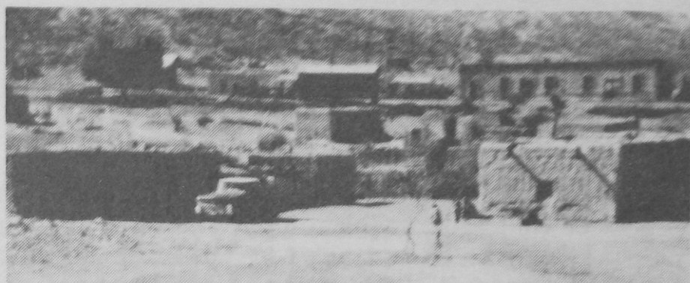

Zertuche is a very difficult place with no natural advantages. It is an arid, semi-desert, mountainous area; a water-stop and booster engine hook up point in the days of steam on the railroad. The people who do live there would do better to leave. But they were born there and most, no doubt, will die there. Some have left for Saltillo or Monterrey to find a livelihood elsewhere. Many of the people have never gone to school. They have a simple way of life herding goats and working with the Ixtle. From long fibrous threads harvested from this species of cacti they manufacture hemp ropes on hand spun homemade devises.
The Ixtle work is very hard and monotonous. The pay is very small and poverty rules. But there is something beautiful and gratifying about their lives in this dusty little village nestled in the mountains where the train stops once in the morning and once at night. The other way out or in requires hours on foot or burro. A “sort of” road is negotiable by high road clearance vehicles. We have ruptured oil pans and gas tanks by trying it in cars and station wagons. At times when it was not possible to drive in we have air dropped packages of used clothes sent from the States for the poor villagers.

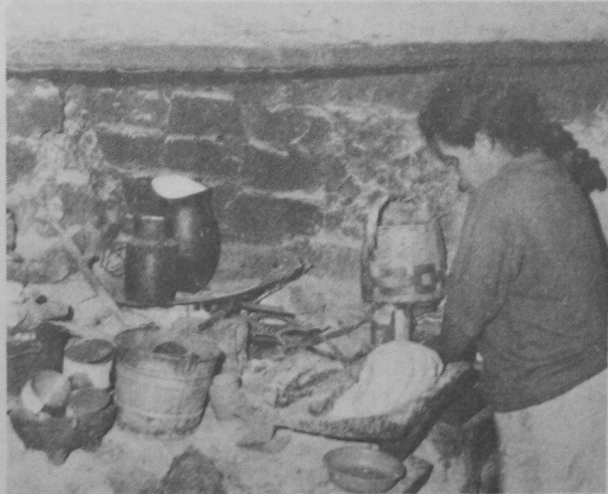
A Zertuche Kitchen

Benjamin had done a good job of bringing the gospel to these people before we had to bring him home after he contracted undulant fever. They love to sing and worship the Lord. However, they are like children and often have quarrels among themselves. The work of the Lord has not prospered too well since Benjamin is not staying with them permanently. Yet, like children, when we go again, they will forget their differences and come together to worship the Lord with us. They will beg us to come more often and some will tell us that when we do not visit, the services die out. In spite of the disappointment we feel because they do not stand on their own, we feel we need to encourage them whenever we are able.
It was during one of these visits that God worked in a wonderful way and sent the blessing that the people desperately needed. Here in this part of Mexico, we often have to pray for rain. Back home I remember we used to say, “Save for a rainy day.” Here the people never think of a rainy day as something bothersome. Rain is a blessing to them at all times. People will go out in the rain, even go to church in the rain although they have to walk all the way. Rain is not their usual portion so they have a saying which is quite different than ours. They say, “Save for the dry time,” because to them the time of need will most likely be caused by a long dry spell.
We went to Zertuche for a visit this particular time and we were loaded down with provisions, clothes, food, and other gifts which God had provided for the poor through friends who have shared with us so faithfully through the years. We sometimes take the morning train from Ramos Arispe to avoid the torturous drive over river beds, rocks and rough mountain trails. This time we decided to drive in with the pick-up as we had too many things to load and unload on the train.
When we arrived there the people greeted us warmly as we emptied the truck. After greetings, which usually get quite lengthy, the people began to tell us what a hard time they had been having because they’d had no rain. The “Lechugia” had not grown well and the river had dried up. The “Lechugia” was the plant they used to make their twine rope. This meant that their main livelihood was cut off. So their need was worse than usual. The conversation thereafter was about the weather, nothing else seemed to have the same importance.
We said that we would pray for rain as soon as we met together for our service. All the men were there since no one was going out to bring in the “Lechugia”. We decided not to wait until the afternoon, as we usually do, to hold the service. We would have it right away. In this way we would be able to finish up earlier and get an early start back on the rocky dusty road to the highway so we would get home to the Rancho before dark.
Benjamin went over to the little adobe building we had purchased to use as a church and started playing the accordion. In this way the meeting officially was announced. The children started coming. The young men, the mothers and the people from the other side of the railroad tracks were all there. The little “church” was crowded to the doors and many were standing outside.
Benjamin announced that we were going to pray for rain. After a few songs, a few specials and testimonies, we all began to pray together for God to open up the heavens and pour down rain upon the dry and thirsty ground. The people in Zertuche may be like children and may quickly forget to gather together to pray when there is no leader, but when they do gather together they make their little adobe church ring with joy. We were all in one accord that day as we prayed for RAIN!
There was not a cloud in the sky when we started to pray. It was dry and hot and parched. There was no sign of rain. There were no predictions of rain. The forecast was as dismal as the air around us was hot and dry. But God heard those simple prayers sent up in unison, and while Benjamin was still leading the singing and BEFORE he had a chance to preach, Pifanio stuck his head in the window on the side of the little church to tell us that we were going to have to hurry up and get the service over FAST!
“Why?” Benjamin wanted to know.
“Because ‘La Venida’ is coming,” he said.
I wondered what the “Venida” was anyway. But I found out quickly that it was caused by a downpour, or a hard rain like a cloud burst. He could “see” one coming by the way the sky looked.
Benjamin suggested that we just pray and leave at once.
“But why do we have to leave so soon,” I wanted to stay and finish the service. I did not understand why the big rush.
“Because when ‘La Venida’ comes, the river fills up within a short time and we will not be able to cross over,” he said.
If we did not leave at once we might not make it across the river out to the highway again. We would have to stay all night, or longer in ZERTUCHE!
So we prayed another short prayer of thanks and started on our way! With the wind in our faces and some rain spitting on the windshield, we bid the Zertuche people goodbye and started down the trail as fast as the pick-up would carry us, about eight miles an hour on that “road”.
We were rushing against time. If the Venida, the flash flooding, came too fast there would be NO WAY across the river! Danny was still quite small and he became frightened by the black clouds, the claps of thunder, and the down pouring rain that quickly followed. We kept on going as the dust turned to a quagmire of slippery mud. We prayed that God would help us cross in time!
It took about an hour for us to reach the river which was rising quickly. Could we make it across safely?
Yes! HE who had sent us to Zertuche to pray and who had answered our prayers, had made a WAY! All the rest of the trail, we enjoyed the rain rushing down the sides of the hills, into the little stream beds below. On they would rush and join together in the river we had already passed. In a little while there would be NO WAY, but we were past that place and safe. We sang and worshipped. Danny’s tears were dried and we felt that Zertuche had one more reason to BELIEVE GOD.
YES! JESUS is the one TRUE SAVIOR! He is the ROCK of all ages who provides water in the wilderness and a shelter in the time of storm!

NO WAY PLACES CHAPTER 16

“…instructed in the WAY
of the Lord…”

Keeping up with life on El Rancho is a busy, demanding, pressuring experience with so many little muchachos to be responsible for. I have found out over and over that there is no way to face the challenges and stay with it without committing myself consistently to the Lord. Early morning commitment is the best. And yet, there are those days when I rush off to my chores without taking the precious time that I need to revitalize my life with His wisdom and grace. I recall one of those days as I think again of:

Choco’s Angel

Arturo was only four years old when he first came to us. His Mexican mother was a deaf mute. His father was an American Negro whose brief visit to Mexico ended before Arturo was born.
Arturo’s mother had had a difficult time trying to care for him due to her handicap. When the little bushy-haired Arturo raced around a bit wildly, and when it seemed hard for us to get him to listen, we tried to remember that he had never had a mother’s voice to listen to.
When Arturo’s mother visited him at the Rancho she would try to communicate with us by signs. Arturo, who had learned her sign language from the cradle, would understand and interpret.
The boys nicknamed little Arturo, “Chocolate” (Cho-co-la-te), because of his brown skin and chocolate colored eyes. We all loved little “Choco” in spite of his mischievous ways. Even as he grew older he was so little compared to the others and at the same time so anxious to be “big” that he would work furiously on cleaning around orange trees or carrying heavy bags off the pick-up. He soon had bulging muscles which were quite unusual for such a little guy!
He was one of my favorites. I used to love to work with him in the orchard cultivating the orange trees. He would keep up easily with the bigger boys and his eyes would shine when I praised him. I always felt wells of joy within when he would greet me with a “Buenos Dias, Hermana Anita!” and a big smile.
But one morning Choco became too upset for a “Buenos Dias!” He had lost his shoes again! This was a problem because the little ones would often kick their shoes off as soon as the weather was nice; they like going barefoot! Then, when it is chilly they would be hunting for their shoes. Maybe they had left them down by the creek. Maybe they were in the orchard. If they were lucky, they might be underneath a bunk bed.
Choco had lost his sandals several weeks before that. There was only ONE sandal now. That one would keep showing up. The boys kept bringing it back from the trash pile thinking they were bringing the mate to the one that was lost.
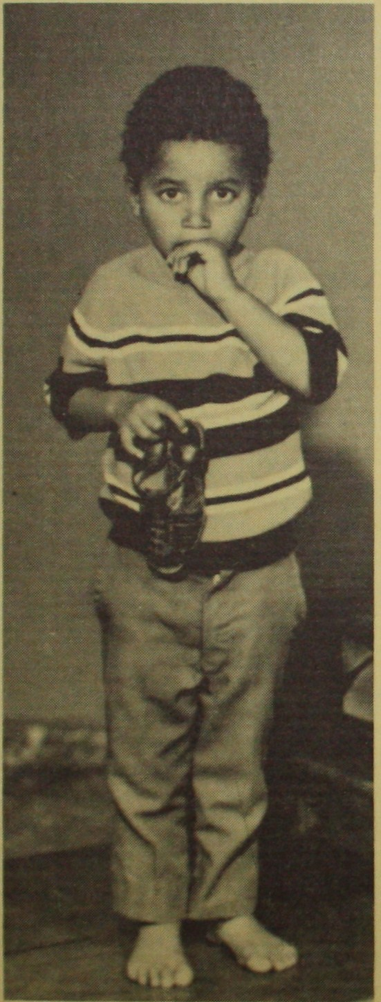
In the meantime, the Lord seemed to be taking care of Choco. Friends came to visit and brought shoes. One pair was just right for Choco! Now we could leave the one sandal in the trash pile and Choco’s feet could be warm on cold mornings.
What an exasperation it was for me that morning to find out that his shoes were gone again!
“Choco, where are your shoes!”
Choco’s startled eyes met mine. He must have wondered, “Oh me, oh my! What has happened to my friend, La Hermana Anita!” Up until now it had been easy to be nice to Choco. Now all I seemed to care about was finding a pair of shoes!
Choco ran back and forth to the trash can trying to find them. Once he came back with an old jar. The more I questioned him the more confused he became. First he said Julia, the house-mother, had the shoes, then he said I had them. He told Hank they were in the trash pile.
He finally disappeared after I told him, “you go find them right now, Choco!” The last he was seen after that was on his way to school barefoot with one sandal in his hand and a woe-begone look on his face!
I forgot about Choco and his shoes and started to get busy in the house. I cleared up some of my office work and began to sweep the office floor. Underneath one of the chairs my broom bumped into something! What WAS that?” I couldn’t believe my eyes! There they were! Choco’s shoes! Choco had taken them off the night before in the office and had left them with ME! He was trying to take care of them! We had both forgotten!
How ashamed I felt for my impatience. How anxious I was to tell Choco the good news and laugh and to say “Perdonami!”
The bell rang for lunch and the other boys were all there but not Choco! I waited a while as sometimes the little ones come in late. They loiter along the way; playing marbles, hunting chile. Choco never did show up for lunch.
One of the boys informed me that they had seen Choco sitting underneath an orange tree. Choco had said he didn’t want any lunch because he didn’t want ME to SEE him!
I remembered the Scripture, “Take heed that you despise not one of these little ones for I say unto you that in heaven their angels do always behold the face of the Father which is in heaven.” I began to think about that verse and I wished all the more that I could find Choco. I made up a sandwich and got a cookie bar and tangerine ready to go.
“Let’s go hunt for Choco!” There were always a bunch of boys around to go along. They jumped into the pick-up and off we went to the village. We were looking for a little, bushy-haired, barefoot boy.
We hadn’t gone very far when we spotted him. He was walking sadly along all alone. It was now too warm for the jacket that had felt good in the early morning. He still had it on all zippered up. He was willing to let me unzipper it and help him out of it and seemed happy to climb up on the seat beside us in the pick-up. He munched on the cookie first.
His bare feet didn’t seem to matter now and his shoes were still underneath the chair. He did not seem to care too much about finding out where his shoes were. That had never been important to him in the first place. But he did seem glad to be back on good terms.
I wondered about Choco’s Angel. He must have been very busy noticing what was happening that morning to his little charge. Since Angels behold the face of the FATHER, I wonder what message went between them while I was giving Choco such a bad time?
Choco’s Angel and the Father surely KNEW where Choco’s shoes were all the time. How glad I was he cared enough to “…instruct me in the WAY…” Could it have been Choco’s ANGEL who got me to sweep underneath the chair that day?

NO WAY PLACES CHAPTER 17

The Real Orphans

One time when Linda was telling about her life in Mexico and how she felt about growing up on the mission field, she made the remark, “Joanne, Clifford and I felt like the boys had our parents and we were the real orphans.”

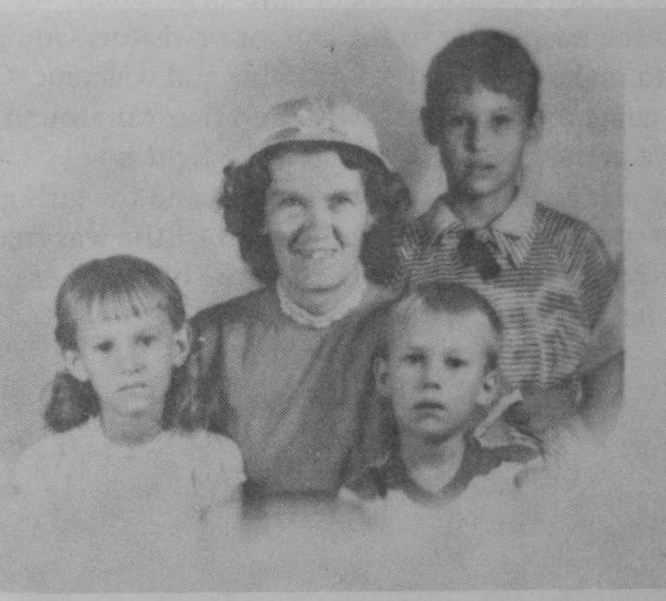

In some ways, Clifford had the most difficult time. His bedroom was down at the end of the long hall in the Ranch house when he was still quite small. It seemed so far away from our room, he says. He was often very frightened when he would wake up in the middle of the night. The boys told him stories about “brujas”, witches, and “bultes”, big bags which were supposed to be grotesque and which moved in the dark.
We would tell him that these were not true stories, but the boys who kept insisting that they had seen such creatures, spent more time with Clifford than we did. He felt small in his big room, and lonely, and preferred to sleep in the dorms on the little bunk beds with his Mexican story-telling “brothers”. That way, even if he went to sleep hearing another wild tale about witches, if they did happen to appear in the middle of the night, he would be well protected.
But this added to the many difficulties in getting him to settle down to homework at night. He played with the boys in Spanish all afternoon and English homework was part of another world. Notes came at time from his Pan-American School teachers. “Cliff is smart, but he doesn’t do his homework,” or “Cliff falls asleep in class!”
Cliff’s school problems and Linda’s and Joanne’s ideas which were different than our own were not all the result of a lack of caring and discipline on our part. We wanted with all of our hearts to give them the best within our reach; to help them where they needed it; to teach them the ways of the Lord and to share with them our love and our time. But there were always so many interruptions!
Sometimes, before we had electricity, it would be the power plant. The power plant broke down quite often and then there would be no lights, no ironing, no Bible reading. Sometimes a boy would get sick or have an accident. We would have to rush him to the hospital or to the doctor, or visitors would come and we would try to make them feel comfortable and welcome. Or a lady in the village was going to have a baby with no other car around except our pick-up to drive her to the clinic. It had to be right now!
If we had planned to study with Clifford and the girls and read the Word, we just didn’t get around to it again! Cliffie was free to run off again to play ball, which he loved, with the boys. When we got back later he might be sound asleep!
When I would come home from an errand of this sort, my first thought would be for Cliff. “Donde está Cliffie?” I asked the other boys.
The boys would always laugh at my fears and their favorite reply was “Me salio de la bolsa!”, “He got out of my pocket!”
“He got out of my pocket!” In a sense this is what happened to Cliffie. Not only was this a cute, funny, saying that the boys invented, but spiritually, Clifford and Joanne and Linda were “getting out of our pockets.” My heart ached, and I didn’t know what to do about it!
Often when I would get back from an errand and Clifford wouldn’t be around, I would go out to the airstrip, down to the creek, or out to the orchard, calling “Cliffie! Cliffie! Where ARE you?” I longed for the sight of the little blonde head of this uninhibited boy who liked to roam.
At times like these, I would feel crowded in upon. Especially if the lights were off and there were letters to write or feuds to settle among the boys. The burdens would seem intolerable midst the distresses and struggles of missionary life that seemed to be crushing me. I would cry to the Lord in despair for help!
Then, suddenly, he would be there! Cliffie was back. He was alright! He came barefooted and bright eyed, laughing from the fields! He always wondered why I would be so upset! There was nothing out there that could hurt him!
I felt dismayed and heartsick when the children grew older and went away to school. I KNEW that the opportunity to spend time with them now was gone!
Clifford and Linda and Joanne all did well in college. They deserve credit for their accomplishments in life. They are intelligent and successful. We are glad they have courage and self-sufficiency. However, there are times when one of our former Rancho del Rey boys come back to take part in our services, preaching the gospel with power and love; testifying about what CHRIST means to them. Then we feel that we have shared something with the Rancho BOYS that is greater than education or success.
With Joanne in Mexico City, Clifford in Houston and Linda in Denver or traveling, we don’t get to see them often. We desire for them a more consuming spiritual life; a real walk with the Lord. Often as I pray for them, I feel like I used to when Clifford was small and he had wandered off. At these times, I have asked myself the question, “Were Joanne, Linda and Clifford the REAL orphans?”
Danny is in another category, for his late arrival spared him the hardships of the early years when there was such a tremendous financial struggle of starting with nothing but the Lord and a vision, the incessant demands upon our time and strength, the insecurity of being young, inexperienced, and tempted to walk in the flesh instead of the Spirit. Now we have a better command of the language, an established work, many friends who back us up as prayer warriors as we learn to walk in faith and love. God has blessed us in such a way that there are more opportunities to share with Danny the things we would have liked to have given the others.
As I ask myself about Joanne, Linda and Clifford being the Real Orphans, a sense of guilt envelopes me. But it is then that by His Spirit I lay hold of His promises afresh. Has He not told me many times, and do I not KNOW that His promises are mine by faith? I listen to Him say again, “All thy children shall be taught of the LORD, great shall be the peace of thy children, in righteousness thou shalt be established, thou shalt be far from oppression and from terror, for it shall not come nigh thee.”
As part of His body, I speak words of faith and take authority and believe that the eyes of my children’s understanding SHALL be enlightened; that the power which raised CHRIST from the dead IS OPERATING on their behalf to bring them closer to the Lord. GOD will make a way!
Just as Cliffie, when he was a little boy would suddenly appear; bright eyed; laughing; saying there was nothing out there that would hurt them, so I believe, NOTHING can!

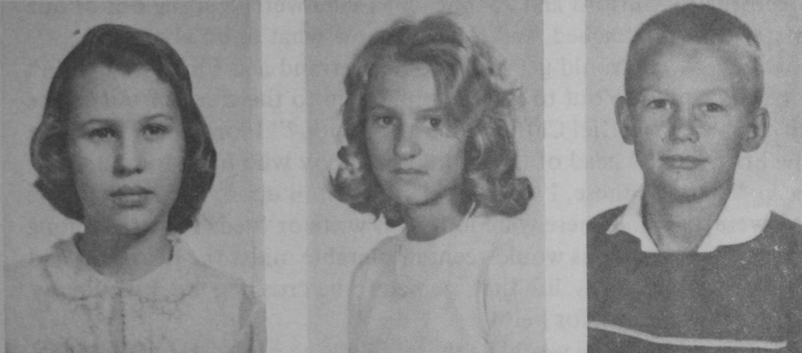

JOANNE LINDA CLIFFORD

NO WAY PLACES CHAPTER 18

Wallpaper

Was God interested in our wallpaper? He was interested in such things as curtains in the building of the tabernacle and even gave exact instructions. Then, as now, He sought to reveal Christ in His power and love even in little interior decorations and details.
Since moving to the Ranch, we had been living in the big rambling ranch house with its graceful arches, shaded verandas and red tile roof. During that time, we used one bedroom for our personal living quarters. The rest of the house was also home for 28 other boys and people, plus kitchen and dining room/chapel combination. This cozy situation soon generated the idea of fixing other buildings for dormitories while preparing to build some that were designed to be dormitories.
Meanwhile, that one room was our office, our living room and our sleeping quarters. At night when services were over and the last child was shooed off to bed there were two things we could do: sit at the desk to read or write, or retire for the night.
In the summer the ranch house was delightfully cool because it was made of adobe bricks 15” thick, plastered over with cement and whitewashed to resist water and heat penetration. It has 12’ high ceilings. These allow the heat that does get in to go upward and results in bearable temperatures.
The winters are something else! The sun didn’t get those walls heated and the house was cold and damp. The ceilings were too high for our butane gas heaters to effectually heat the rooms. The cold tile floors underfoot were an experience not conducive to barefoot midnight trips to the ---. Considering that the gas heaters used up the oxygen, the windows had to be opened. All in all, it left you very susceptible to colds. Perhaps it was better to live without heat as most of the village people do.
Yet in a sense the village people were warmer than we were because they had their wood fires going cooking beans and making tortillas. Also, the sun warmed the village huts up quickly in the middle of the day. But not so with the Ranch house. Its tile floors and plastered walls seemed to radiate the cold.
We lived through the early winters without thinking too much about what could be done. There were lots of warm days in between, but then a cold spell would strike unmercifully.
When Danny was born we struggled with the problem of the cold as he was born on the 22nd of December, a very cold part of the year. In the next few months he got the flu, the whooping cough, and bronchitis and we battled for his life.
By now, the boys had their dormitories and Hank had time to think about building an office with a low roof that we could heat. He ended up making it a whole, cozy little 20 X 40’ house with an office at one end of it. When we finally moved into it, Joanne called it our little “Doll House”. Now we no longer had to go to bed in the winter time to keep warm. Our little house was insulated and had hot water pumped through copper tubing set beneath the tile floors. The village people were amazed by it and would touch the floors with their hands. It was so different from their cold dirt or cement slab floors.
We had fun decorating, finishing it bit by bit. There were book shelves in Danny’s room, a nice closet for his clothes with built-in chest of drawers. There was a den for Hank where he could keep his books, flight planning charts and other maps. The house has big picture windows so you can observe lots of sky above the beautiful mountains to try to outguess the weather!
Our kitchen was small like a trailer, but it is an easy place to prepare a meal as everything is hands and easy to find. Now we could have our own family times together, rather than taking all our meals in the dining room. It had been a long time since we had a measure of privacy. It was nice to be a small family again.
We felt that our little house was going to make it easier for us to do things for Danny that we had missed out on doing for Joanne, Linda and Clifford. We would expect him to sleep in his own room every night. He would have a hard time escaping his homework. We’d be right there for devotions and prayer times.
All of the partition walls are wood paneled so we decided to put a nice wallpaper on the living room outside wall. The wallpaper we chose was a beautiful gold flecked, embossed paper that accented the light paneling, and was a warm cheerful color that would allow us to use other color combinations in the room later on.
We were anxious to get the wallpaper on the wall, but a little intimidated by a technique we had never put a hand to before. The paper was so beautiful and it couldn’t be matched if we made an error as we had bought the last of that particular pattern that the store had in stock. We kept putting it off. Maybe the fresh plaster wall should season a while? The routine of daily chores piled up as we got busy taking care of running the boys to school in the morning, picking them up in the afternoon, visiting the school to see about situations that arose, getting groceries, keeping things running, fixing up broken pumps, windows and other things, listening to boys’ problems and little feuds, praying with them, reading the Word, holding services, reaching out into the villages to the people. The wallpaper still lay on the shelf in the closet, the white plastered wall was getting dirty!
One day Linda came home to visit for a few days from school. She happened to notice the white wall was not white anymore!
“Why doesn’t somebody hang the wallpaper?” she wanted to know.
“Maybe it’s because nobody really knows how to do it, Linda,” I said. I said, “Can YOU do it Linda?
Linda admitted she didn’t know a thing about it, but she was willing to TRY!
Linda got out the wallpaper and the shears, was measuring and thinking about how to start cutting when somebody knocked on the door!
They were Americans! They had come to visit. They were friends from the Chicago area, who had been in touch with the Rancho work. They wanted to get acquainted with the work personally. They sat around talking and joking about the bumpy roads, and what a hard time they had had finding us while trying to speak Spanish. The life and contrasts in Mexico impressed them deeply.
When the conversation lulled a little, they noticed the wallpaper and the shears. “What are you going to do?” they said.
I’m going to paper that wall right there!” Linda motioned to the wall behind them. “I don’t really know what I’m doing,” she confessed and laughed.
“Would you like some help, young lady?” our visitor offered. “I happen to have been a paperhanger.”
We couldn’t BELIEVE IT. Between the two of them, Linda and our visitor, our gold embossed paper went up on the wall swiftly. It was a perfect job and looked beautiful! How often this little incident has reminded us of how much God cared for us. He even cared about our wallpaper!
I guess there was just NO WAY for Linda to have gotten it on by herself without errors, so God sent those dear people all the way from Chicago to do it for us. After He got them almost here, He put it into Linda’s heart to get the wallpaper out of the closet and to start thinking about how to cut it just about the very time they were knocking on the door! If they had come a few hours later, it might have been TOO late.

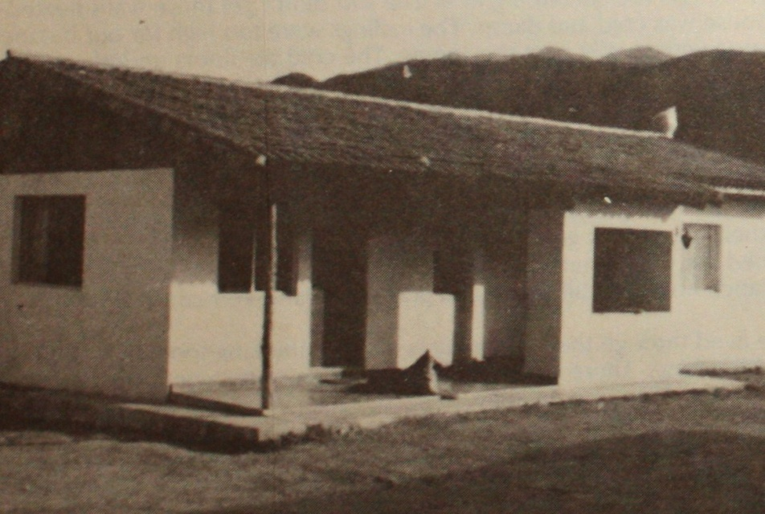
The “Little Doll House”
(Apartment/Office at El Rancho del Rey)

NO WAY PLACES CHAPTER 19

The Dormitory Walls

We were getting ahead of our story when we told about our “Little Doll House”. First came the dining room and dormitories for the boys. There seemed to be an ever increasing demand for admittance of new boys and an ever decreasing amount of space to put them into. Literally we were bursting at the seams.

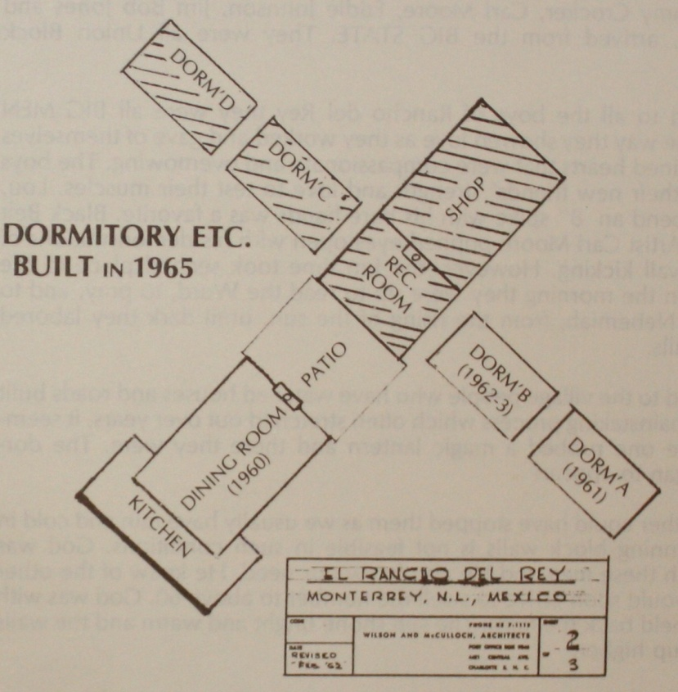

The Lord was challenging us! At the same time He set in motion, in various parts of the United States, people and forces to meet that need. A highly skilled Christian Architect in Charlotte provided the design and blueprints as he had for our whole complex. In Arlington, Texas, a prominent Veterinary Doctor persuaded a building contractor friend to take them both to Mexico in his plane along with surveying equipment to lay out the lines and establish bench marks.
Meanwhile, in the New York area the Lord was speaking to carpenters, plumbers, blockmen and other talented people who would take three to four weeks off from their regular work. From Arlington, a masonry contractor decided to bring a crew of six masons for the week between Christmas and New Year’s 1965 at his own expense, while other Christians in the area helped raise the airfare.
Mid-December came with its usual routine of preparing for the holidays for the boys. Along with sufficient funds for the boys’ needs, the believers in the States sent sacrificially for the stockpiling of construction material awaiting the arrival of the volunteers.
Soon we were shuttling people from the airport. Six of the men: Jim Keleher; carpenter/contractor, Lou Radzieski; N.Y.C. fireman, Joe Caron; Rescue Mission Director, Don Hollman; machinist, James Dougherty, and Jim McKeever, plumber, arrived from the BIG CITY. Six other men: James Crocker, Sammy Crocker, Carl Moore, Eddie Johnson, Jim Bob Jones and Walter Allen, arrived from the BIG STATE. They were all union block masons.
To us, and to all the boys of Rancho del Rey, they were all BIG MEN because of the way they showed love as they worked and gave of themselves out of disciplined hearts that were compassionate and overflowing. The boys marveled at their new friends’ strength and love to test their muscles. Lou, who could bend an 8” spike with his bare hands was a favorite. Black Belt judo Karate Artist Carl Moore popped eyes open with his demonstrations of barefooted wall kicking. However, the fun time took second place to the work. As in Nehemiah, from the rising of the sun until dark they labored upon the walls.
To us, and to the village people who have watched houses and roads built with a slow painstaking process which often stretched out over years, it seemed like someone rubbed a magic lantern and there they were. The dormitories began to appear!
The weather could have stopped them as we usually have rain and cold in January. Running block walls is not feasible in such conditions. God was working with these men and He also knew our need. He knew of the other boys who would soon arrive to swell the number to above 60. God was with us and He held back the rains. The sun shone bright and warm and the walls kept going up higher.
We never saw men work together with greater joy and devotion. The BIG CITY fellows liked the Texan drawl, their big hats and boots, while the BIG STATE boys feigned not understanding those northerners’ talk. Both groups were outspoken, relaxed and at home with each other and the Ranch kids. They laughed and joked with the boys, shared their coffee breaks with whoever happened to be standing by, and ate their simple meals along with the beans and tortillas. They must have longed for chewable beef, but put up with the local supply while strengthening their jaw muscles. Pulling ripe oranges from a nearby tree was a delight to them. They never complained about the many inconveniences, nor the lack of things. The language was no barrier. They picked up Spanish words or made up their own by adding an “O” to the end of the English words. Thus a fly became “El Flyo”, the bread, “El Breado”, etc. They laughed their way into the Mexican’s hearts.
Before the masons’ week was finished they had all corners laid and the walls run up to the window opening height so that it would be easy for the others to follow their lines to completion. The BIG STATE fellows KNEW how to get those blocks up. They kept the rest running to keep up with the mortar demands and supply of blocks.
Now the remaining volunteers pushed themselves relentlessly to get as much done as possible in their remaining time. As they built the new dorms, the Recreation Room and Shop, they hammered hard at all of our hearts for God. They were so talented, versatile craftsmen, so surrendered to serve. After three weeks on the walls they were ready to work on the roof. It must be on before they would have to leave for New York. It WAS! Don Hollman stayed on for several months to help Hank finish up.
Among the many blessings we have had throughout the years have been visits like these of people who have come to give of themselves to further the work of the Lord. They were positive men and women. They shrugged off negative things and believed for the positive ones. They had believed God for Salvation through Christ and had surrendered their lives to Him. They had believed and made the decision to come to Mexico to bless others at great cost of their own time, finances and comforts.
Those that came have always taken part in the spiritual part of the activities of Rancho del Rey. In our services they have share experiences they have had with the Lord telling our boys how much He meant to them. Each of them could testify of the NO WAY places in their lives that just dissolved away before the Provision of the Lord.
Sometimes as I have translated their testimonies, I have watched our boys’ faces and could read deep down inside of their beings. They KNEW that these people were speaking out of deep convictions. This salvation of Christ and knowing Him as Savior and Lord that was constantly being mentioned was more than words, for here were people of many types who backed up their words with living testimonies. They have heard it over and over again in so many different ways. “There is only one life that is worthwhile. That life is the one that is lived for Christ. There is only one way to have joy. There is only one Person who can give joy and peace. It’s all wrapped up in JESUS.”
Our boys have watched friends like this and have been impressed. Their lives have been molded by those who have Christ as Lord. Some visitors have left thinking they had just been building walls, but they have been Building Boys.

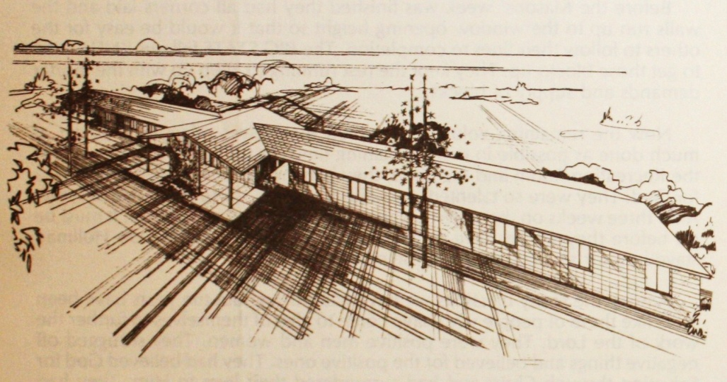

NO WAY PLACES CHAPTER 20

The Way to Win

Wednesday night is prayer meeting time at El Rancho del Rey. Our boys have always taken part and have learned that prayer is the way to wonderful things.
One of these prayer meetings will long be remembered. It ended in an attack of the enemy leaving us in confusion and despair; but it didn’t really end there.
Many years ago, on a Wednesday night, we had gathered together and the singing had already begun when a car pulled into our driveway and, as though familiar with our layout, parked in front of our Dining Hall where we hold our services.
The men who disembarked came into the service slipping into the rear rows of seats. They were strangers to us except for one man. We knew him as “Polo”, having met him selling Mexican curios in a Monterrey curio shop. He had visited on a few occasions and seemed interested in the things of the Lord. We classified him at least a “sympathizer”.
However, we sensed that he was not a good influence for our boys and did not approve of his insistent invitation for our boys to visit his “Ranch,” which was located in the nearby village of El Cercado.
We paused in the singing to welcome the latecomers. “Polo” announced that the tourists who were with him were “Hermanos” – “Brothers” who wanted to be in our service to worship the Lord with us.
Of course we are always happy to welcome others whether they are believers or not. Whenever we think someone is a believer, we like to give them an opportunity to share their faith with us, to sing, testify, or preach. We invited the newcomers to take their liberty.
To our surprise not one of them had a thing to offer. They declined to take any part. We thought perhaps they weren’t accustomed to this and a little embarrassed.
The service resumed. We had prayer requests and prayer, special songs and choruses, and gospel text quoted by the boys in rapid succession. Now it was time for the message.
Before the message could get started, suddenly, “Polo,” our visitor, stood up and indicated he had something urgent to say.
What he said shattered the rest of the service. “My friend here has just been robbed!” Polo said, “His wallet with three hundred dollars has disappeared!”
Benjamin, sensing that this was an accusation aimed against all of us said, “Let’s pray!” We all began to voice our concern to the Lord. Our visitors just sat like statues watching us. We wondered if they were such good “Hermanos,” why they couldn’t at least help us to pray about THEIR loss?



After the prayer and after a time of reflection, Hank talked to the visitors. Although there had been a little moving around by some it hardly seemed possible that one of the boys could be guilty of the supposed crime. However, some action had to be taken to mollify the visitors, so Hank announced that no one was to leave until he was first searched. As each boy went out, pockets were emptied and shoes removed while “Polo” and Company kept a close watch. No money and no wallet were found anywhere. Hank, who had extended the courtesy of the search, now suggested that our visitors may have lost the money somewhere else.
However, Polo and his friends, becoming quite hostile, insisted that it was here that they had lost it. They said they were very put out with all of us and that this was a very un-Christian way for us to act! They finally left vowing to bring back the police.
Our hearts were heavy and we leaned again upon the Lord in prayer. We couldn’t believe that our boys were guilty and circumstances seemed so unusual. Our visitors did not really convince us that they were genuine “Hermanos”. Although introduced as Christians they had not wanted to testify, did not even share a scripture text, nor were they seen to pray. They did not know the Christian songs. Their companion, “Polo, was a “Hanger-on” to English speaking people. Perhaps we looked “ripe for the plucking”!
Later, “Polo” and his friends came back. They now insisted that Benjamin had been the guilty one; that the wallet had been slipped to Benjamin who had carried it out in his accordion case. He had not been searched since he was way up front near the platform.
They kept accusing, threatening to take the older boys and Benjamin to the authorities if we did not come across with the money they alleged was stolen. Frightening stories were told about what the police would do to those charged with theft. “They will beat you until you confess (true!), and pull out your nails (unlikely!)” they warned.
The next day Benjamin was desperate and refused to eat. He was on his knees praying except for the times he was working for the boys. The boys were upset and also frightened. We now knew that it was a set up but we weren’t sure we could prove this if the law were involved, as Mexican law assumes you guilty until you prove your innocence. Try that from the inside of a Mexican cell!
During those early days money was tight and a scarce item. We often struggled just to keep the food supply adequate and to have the necessities for the boys. Yet this was what it was all about. These men wanted money. “Why don’t we just give them something,” I said. “We can say we are sorry this happened and want to show that we are trying to help out a little.”
But Hank realized that this was not the way through this NO WAY PLACE. “No”, he said. “We are not paying them off. We are not guilty. Why should we act like we are?”
“But they say tomorrow they are coming with the police to take Benjamin and the big boys to the authorities!”
“Let them come!” Hank said, like he didn’t care.
That night I could hardly sleep and the day dawned too soon. I had to go to Monterrey for supplies. I left with great concern over what might happen while I was gone.
When I got back, Benjamin seemed to be his old self. He helped unload the groceries and I asked him if “Polo” hadn’t come.
“Yes, he came without the police and wanted to take us with him to the Villa, but Enrique (Hank) said he didn’t dare. He said NOBODY has any right to take anybody off their property without a WRITTEN ORDER from the ALCALDE (Mayor) which he didn’t have!
Hank had read in a Mexican law book and had come across this bit of information which served very well to end the little game that Polo and his friends were playing to frame us for $300.00. Benjamin’s accusers left that day and never returned. We NEVER saw any of them again!
Not many months after that we were shocked to hear that POLO had died of a heart attack! “Vengeance is mine, saith the Lord, I will repay!”
Friends of ours from North Stonington, Connecticut, visited later and informed us that their whole church prays for us every Wednesday night. No wonder there was NO WAY for Polo and his friends to win!

NO WAY PLACES CHAPTER 21

His Way

Jesus Espinoza was one of the many boys we have had on El Rancho del Rey who had what it took to stay with us from first grade on until he graduated from High School. He was one of the most outstanding of all the boys we have been privileged to share with.
He was a rugged, little, husky, intelligent child right from the start. You wanted to be his friend because you liked him without having to try.
He got the nickname of “Pelon” almost right away. He fell asleep in the barber’s chair and just for a joke they shaved him bald. All through his school years he was known as “Pelon” – “Baldy”.
I got better acquainted with “Pelon” the summer I took him to the States along with his friend Abram to help me to itinerate. I felt that it would be a blessing to have two of our little Rancho del Rey boys along when telling about the work, as it is much easier to get people to feel close to a child when they can see him face to face and hear him sing and see him smile. Also, I know how winsome our boys are, and to this day [August 1981, ed.] many of our friends back East still remember the two little Mexican boys who sang in our services.
Having Jesus and Abram with Danny and me was a great help, while on the road, yet there were some surprises that awaited me. I thought that the muchachos would be overwhelmed with the good food and the beautiful places. I found out that they honestly did not like all of our rich foods as much as I thought they would. Oh, they would eat ice cream but for most other things they would just as soon have beans, tortillas and chile sauce (hot!). This was simply not available in most places where we stopped. I consider pork and sauerkraut a real treat as we rarely have it in Mexico (partially because we stay away from pork in this hot climate and marketing conditions). The time friends tried it on Abram and Pelon, it was hot dogs and sauerkraut. As for the boys, that meal was not for them. They were usually polite, and most of the time acted like little gentlemen, but they just couldn’t go for sauerkraut.
The part of the summer that Pelon and Abram enjoyed most was the week at Camp Lou San in Linglestown, Pa. It was girl’s camp and I was missionary speaker. Abram and Pelon really helped me to present the missionary work in Mexico. They had fun showing the different expressions that Mexicans use with just finger signs, and letting the children guess what their meaning could be. When our week was up, and it was time to leave, all the girls were in tears. It was hard to believe that at the age of 12 these two little Mexicanos were already breaking hearts. I’m sure the girls recovered!

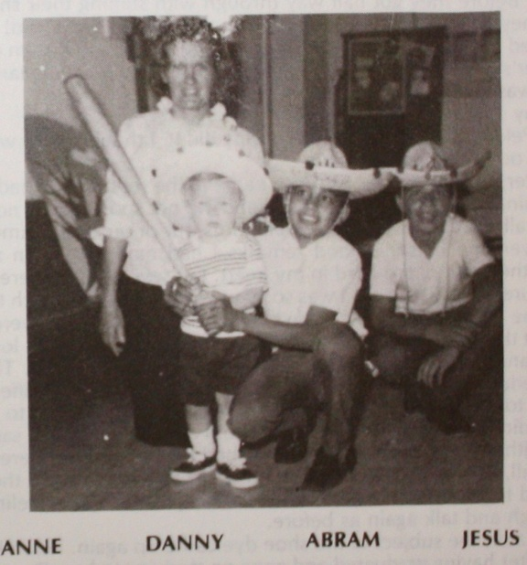

We had a good time, but there was one thing that happened during our stay in the East which marred our good relationship for a few days.
Pelon and Abram decided to shine their shoes in my mother’s living room. Because they are used to tile floors on the Rancho, it did not occur to them that it might not be the proper thing to risk spilling shoe dye on my mother’s good rug. Before they got half way through with shining their shoes, it happened! They called me to come quick to see what DANNY did!
I hurried into the living room and to my dismay I saw brown dye all over my mother’s orange rug and on her piano stool! Her beautiful piano stool and rug! She was so terribly unhappy with us!
“Danny spilled it!” Pelon said.
I told Pelon I didn’t believe that Danny did it. I thought they were just trying to get out of taking the blame.
My sister, Gladys, who is an artist, came to the rescue. She had some kind of paint thinner which would get it up and did not spoil the rug nor the stool. We were all so relieved after she helped us out of our predicament.
However, the harsh, unkind remarks I had made to Pelon and Abram hindered the Spirit of the Lord in my heart. For several days there was a feeling of failure and frustration. I was sorry we had caused so much trouble and at the same time I was sorry for the boys. I realized that they were in an environment that was difficult for them. They had to contend with long hours of traveling and many different standards everywhere we went. They had to meet schedules and be dressed and ready to go again at all different hours. They had to meet a lot of different types of people and listen to a language that they did not understand. They had to try to eat things like sauerkraut or else do without part of a meal. They wished for chile when there was none. And after all, they WERE only BOYS! My heart softened toward them greatly; we prayed together and the Lord melted away the strained feelings and we could laugh and talk again as before.
Years later, the subject of the shoe dye came up again. Pelon had left the Rancho after having graduated and gone on studying to be a doctor. Now he had come out to visit with us. He sang and preached. Our hearts were refreshed to see him and hear him again. Knowing that he was going on for the Lord made us feel rewarded.
It so happened, that Danny, who was nine years old by this time, and in the spilling stage (or was it just a stage?) was in the office just about the time when Pelon was knocking on the office door. Danny was opening up a plastic bag of “tamarindo” – a fruit which is used a lot here and sold in small plastic containers. It is soft and juicy at times.
As Pelon was knocking on the door, Danny was opening up his package of tamarindo. Instead of the tamarindo opening up as it should have and going into Danny’s mouth, it flew all over the desk and window just as Pelon walked in the door!
I began to rebuke Danny! Pelon came over quickly and said, “Don’t worry about it!” as he helped me to wipe up the spilled tamarindo.
Was it because the COLOR of the tamarindo was just the same as the SHOE DYE that had been spilled years before that I REMEMBERED? Pelon’s thoughts and mine too seemed to both flash back years to the scene in my mother’s living room! We stood there staring at each other! We KNEW we were both thinking the SAME thing!
Then I laughed a little nervously and said, “Did DANNY do it, Pelon? Did HE spill the shoe dye? It was almost like the Lord Himself was telling me, “DANNY did it!”
“Yes, Danny did it,” Pelon said. “But you were right, it was really OUR fault. We should have known better than to have attempted to polish shoes in the living room!”
“Perdonami, Pelon!” I said humbly. “I was unfair.”
Pelon smiled his winning smile and said, “There is nothing to forgive. Besides you put up with a lot from us kids!”
Unkind words are a sin! And I had been unkind over the shoe dye spill. But somehow that afternoon, my heart filled with gratitude for this Rancho del Rey Son who had learned the WAY of LOVE. For LOVE covers a multitude of sins!

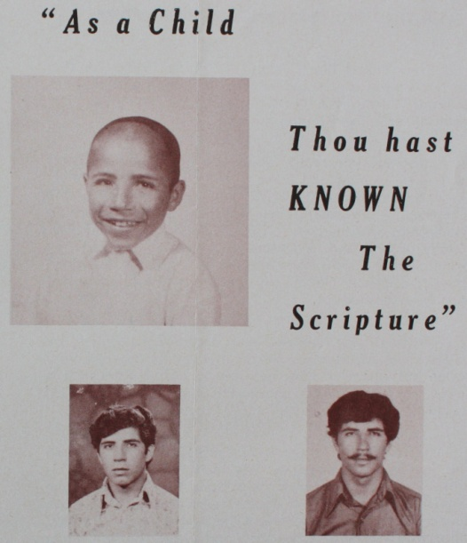
Jesus Espinosa, “El Pelon” From an earlier newsletter,
dated Oct. 1974, excerpted below

Pelon’s father was killed by lightening when he was very small. One of the nice things Pelon said was,”If I could have had a father, or if I could have been the son of a millionaire, I would not have had a happier childhood than I had on the Rancho.”
NO WAY PLACES CHAPTER 23
(No Chapter 22)

Tears of Joy

Jesus (Chuey) Ruiz was Alvaro’s (El Salvaje’s) brother. Chuey lived in Guadalajara with his mother who had financial ways and means of providing for him, but whose many marriages had caused her life to be difficult. Chuey, like Alvaro, did not feel at home when home. He went to work very young and tells drastic stories of long hours of toil and no pay. He finally decided to hitchhike to Monterrey to search for Alvaro. He had heard that Alvaro was on a Ranch with some missionaries and that he was content.
Chuey was battling, not only with his insecure family life, but with his health. He had a walnut size tumor growing on his face beneath his left eye which caused pain and discomfort.
When Chuey arrived in Monterrey, he felt at a loss because he had forgotten the name of the Ranch where his brother was! He wandered around the city, looked for odd jobs, slept on benches or in the empty lots until the little bit of money he had with him dwindled to almost nothing., He thought he might have to hitchhike back to Guadalajara without seeing Alvaro. Then suddenly, like a flash in the dark, the name RANCHO DEL REY came to him! He had heard Alvaro talk about the Ranch, but still he had no idea where the Ranch was, nor on which highway it was located.
Once again, a thought seemed to come out of nowhere, “Go to the bus stations and ask each of the drivers if they pass by a Rancho del Rey!” He found a driver who knew! That very day he took a bus for El Alamo.
But when Chuey got to El Alamo, he looked around and saw everything but a Ranch. He had not understood that the Ranch was a mile further down the road. Discouraged, he was about to turn back when God intervened for this needy young man who seemed at the end of the rope in so many ways. A boy from the village happened to see Chuey, and because Chuey and Alvaro look very much alike, he mistook him for Alvaro. He said, just as Chuey was ready to get back on another bus, “Hi, Alvaro!”
Chuey was overjoyed! This boy knew Alvaro! He talked to him at once and found out that the boy knew where the Ranch was and would take him to it. God made a WAY!
Since Chuey was old enough to go to work and could no longer go to school, we couldn’t officially receive him on the Ranch. Yet he had nowhere to go. Jobs were hard to find. He had the problem of the tumor which drained his vitality, though he was very ambitious and always willing to lend a hand at any job. He stayed around as a helper.
Benjamin alerted us to the seriousness of the tumor on Chuey’s face. “He will lose the sight of his eye if it is not removed,” he said.
This caused me to think harder. Could we accept this responsibility? Once again we remembered Dr. Pedro Rodriguez who had always been such a good friend of the Ranch. We went to him and he advised us that it would not be simple, that there was a lot of involvement in this. He wrote out a note of recommendation to a doctor in the Civil Hospital.
Day after day, Chuey and I went to the hospital. The clock seemed to stand still on all other duties. We sat in long lines and waited. There were tests and more tests. We wondered how long it was going to take and how much it would cost in the end and if the Rancho could possibly survive the expense.
But Chuey and I had happy times, in spite of the ordeal of waiting. He talked to me for hours while we waited: about his life in Guadalajara, his jobs down there, about the time the house caught on fire and he lost everything he had been working for for months.
We forgot about the things we hadn’t done on the Ranch. We talked about the Lord, the Bible, his namesake, Jesus, the Only Way of Life. Chuey accepted Christ and later he was baptized and gave his testimony. I still remember what he said. “I love the Lord, and will love Him until I die.”
Finally, we were through with the waiting lines and it was time for the operation. He lost all his upper teeth because the tumor was entwined in the roots. The cut was made inside his mouth and outside there was not a scar. There were tubes coming out his nose for days.
The boys on the Ranch prayed! And soon he was back home with us again. The operation was a success, praise God! He had an upper plate of teeth made by Dr. Mejia of Monterrey, our faithful and trusted Christian dentist. He looked so handsome and so whole! God was so good!
And we will never get done telling about how much it cost! God must have touched the doctors’ hearts! Somewhere down the line, we never knew who they were, angels must have worked for us. The whole operation and hospital bill was free! We only had to pay a small fee for the tests.
After that, Chuey stayed on the Ranch until he regained strength. Later, he went to Monterrey and worked for a gas meter manufacturing company. Hank was able to help him find the job through a friend of his. He advanced and got a better job with the Federal Electric Commission, where he still works.
Chuey married a girl by the name of Vicky from Monterrey, and they have six children. They come out to see us in their car every time they have a chance. They look so well cared for, so loved. It is always a joy to me to teach their children about Jonah or some other Bible story that they love.

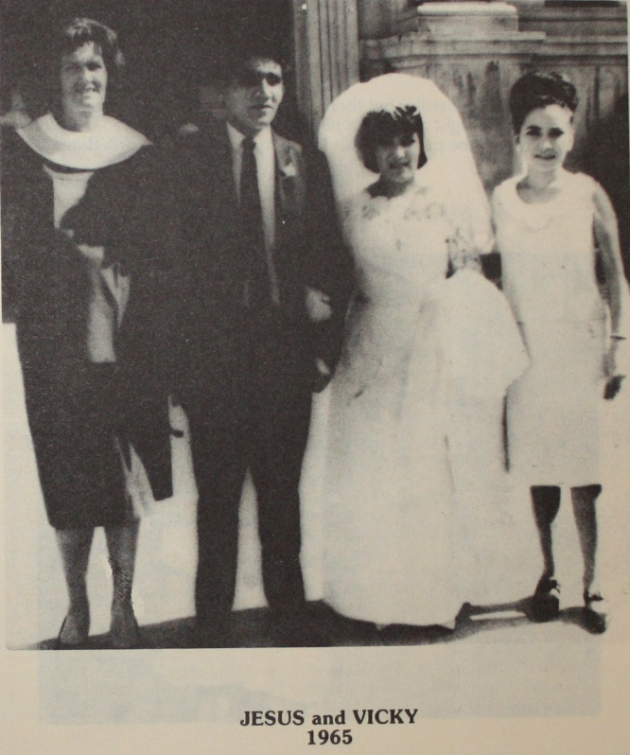
One of the happiest days of my whole life was the day I went to Chuey’s daughter’s Quinceanera (15 year old birthday coming out party. In Mexico it is the 15th, not the 16th year that is the big event). There was an orchestra and mariachis and the biggest cake I have ever seen with a fountain in the middle.
Chuey looked handsome and young as he had years ago after he got well on the Ranch. He stood so proud by his beautiful daughter.
My mind flashed back to the youth from Guadelajara with the tumor on his face who had been lost and alone in Monterrey for days until he remembered the name RANCHO DEL REY. And of his finding the bus line and the Alamo boy who called him Alvaro. It was all in the plan of God who makes the WAY.
I will always remember the things Chuey said that night to one of the Monterrey business men about the Rancho del Rey. He was filled with praise and love. He talked about the hundreds of orphan boys who had been provided for here through the years, of his own experiences with us, and of Hank’s air flights to bring in supplies. He seemed so happy and grateful that we were able to share this important event in their lives with them.
I did not weep outwardly, but there were tears of joy, of rejoicing flowing over my heart that night as I drove home to the Ranch. I said, “Thank you, Lord, for letting me be part of all this that you are doing through Rancho del Rey.”

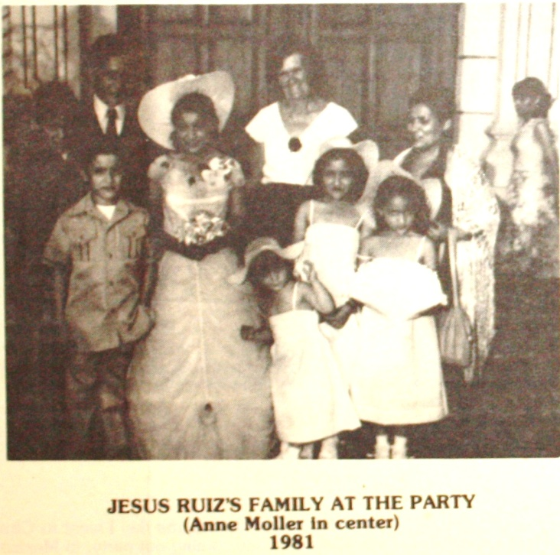

NO WAY PLACES CHAPTER 24

Chiapas

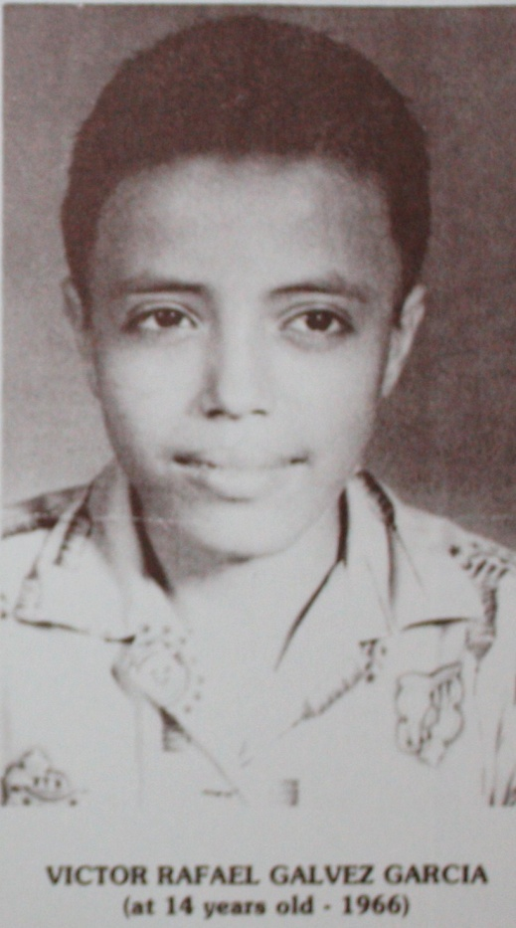

Victor Rafael Galvez Garcia was from the State of Chiapas in southern Mexico so the boys on the Rancho nicknamed him “Chiapas.”
Victor Rafael was in the same group of boys with “Pelon.” The year they graduated with Juan Aurelio, Abram, Carlos and Roberto Paz was one of our most outstanding and gratifying years.
From the beginning of the Rancho until this particular year we had had to deal with diamonds in the rough and there had been some real battles. However, with this group taking the lead, we realized that our oldest boys were trying to walk with the Lord and they were setting the example for the rest.
In Mexico, it is the law of the older brother; it is he who gives the last word. What he says goes, and all down the line each one submits and runs the errands for the one who is next in line older than he. This has been a system we have fought against many times, especially when it meant the youngest carrying a heavy load. However, it did give us a beautiful advantage to have so many older boys who were willing to listen to the preaching of the Word with great respect and interest. They were so willing to get up before the group to sing choruses and hymns with real feeling and love. It had a good effect on the younger boys.
That year we often had happy times having the older boys over to our house after the evening services for a special social time. We served refreshments, sang to guitar music and listened to their tall tales about chile hunts, tree climbs and ball games they had won.
“Chiapas” did not seem outstanding when he was on the Rancho. In fact, we never discovered that he had a beautiful voice. He sang with the group and he never seemed to demand special attention. He was content to be one of the crowd.
I remember several occasions when he and I had a difference of opinion. Once he thought it wasn’t right to be outspoken and to tell someone that they were wrong. He felt that God might punish you instead of the person who was wrong. I thought about that for a minute in the light of the Word and then I remembered Jonah. I reminded him that God reprimanded Jonah for NOT telling Ninevah that they were wrong. Chiapas listened to what I had to say and seemed to ponder it thoughtfully. I wondered what he was thinking but he never said. I think I found out in an indirect way years later.
Another occasion that still stands out was the time he wouldn’t go to school because he had no shirt for his uniform. I knew that all the high school boys had shirts and felt that his must be somewhere around. We went to the clothes room and searched together. We found his shirt and yet this did not seem to make Chiapas happy. He really felt his shirt looked worn out and had hoped for a new one. But that was hardly possible since funds were low. The pump needed repairs and everything we had was hard to come by. Having a large crowd of up-and-coming High School kids to try to please wasn’t easy on them or on us. We all needed lots of love and understanding.
But in spite of all the little frustrations, Chiapas and our other graduates that year were honor students. They were grateful and appreciative. They took a bold Christian stand among the other boys in their school. We thought they looked so handsome in their khaki uniforms and black ties. They were muscular and suntanned.
After Chiapas graduated from Secondary School he went to the Nueva Esperanza Bible School to study the Word. What joy to realize that he felt a desire for a deeper knowledge of the Scripture. There was no way for us to know that the call of God was so great upon him.
It was not until several years later, when he came with a combo of young fellows to sing and preach for us that we realized that Chiapas was on fire for God!
The musicians who traveled with him had the kind of equipment that appealed to the young: drums, electric guitars and a loud speaker.
Chiapas, as lead soloist, sang all the latest and most beautiful gospel songs. His voice never seemed to tire. He had perfect pitch. How surprised we were! We wondered how it was that WE had never discovered his talent!
One of the songs that Chiapas became famous for was “Sodom and Gomorrah.” He made records that were being sold all over Mexico, Latin America and the States. The group of musicians that he sang and traveled with became well known by the young people in evangelical circles as “La Generacion de Jesus (The Generation of Jesus).”
Because of the way he sang “Sodom and Gomorrah”, I realize now that Chiapas had changed his ideas since that little discussion he and I had over the counter in the dining hall. He, himself, was now warning people in his songs and his messages to flee from judgment. It was RIGHT to tell people that sin was wrong, that they needed to repent and come to Christ!
I wish I could end this chapter by saying that Chiapas is still singing and doing great things for God. I am sure that he is still singing, but his songs are raised with the hosts of Heavenly Choruses instead of here on earth.
You can imagine how shocked we all were to hear of Chiapas’ sudden death along with the death of one of the other musicians in a car wreck on their way to the States for concert appearances.
It was a blow to the Generacion de Jesus, to the young people who loved him, and to his young wife. It was a blow to his Rancho del Rey colleagues who were happy for his triumphs and saddened by his being called away from us.
Yet, as we think of his youthful zeal and his surrender to God, we rejoice to realize that not only are his records still speaking to the young, but his life still reminds us all that “Only one life, ‘twill soon be past, only what’s done for Christ will last.”
Chiapas lives on in his songs, in the hearts of his Rancho del Rey companions, and in the many souls he won for Christ. He has multiplied himself many times more than most people do in a long lifetime.
We were told that his funeral procession in Monterrey was twenty blocks long; just a motherless Rancho del Rey lad, who came from remote Chiapas and grew up with orphan boys. Yet in a few short years he had won great fame, was greatly loved and greatly mourned.

I have no greater joy than to hear that my children walk in truth. (3 John: 4)

NO WAY PLACES CHAPTER 25



David’s Sons

When the final count is taken and the effectiveness of El Rancho del Rey is assessed, a lot of credit for whatever mark it made on people for eternity will have to go to those who faithfully “tarried by the stuff (1 Sam. 30:24)” and supplied what was needed to keep the work going. A special group of co-laborers are those visitors who have sacrificially worked to help make El Rancho del Rey a happy place for the children. They came given of their time, strength, talents, ideas and resources. On their vacations, or during retirement trips, they enjoy sampling missionary life, as well as pitching in to help with building, painting, repairs, plumbing or even cleaning sewers.
One couple has been coming to share the load for a time each winter for at least half of the twenty five years that the Ranch has been operating. Fay and Bill Belli of Pennsylvania have been a blessing while helping in the mundane daily tasks or the gospel meetings amongst the boys or in the villages.
Bill works harder here, we think, than on his own remodeling business. He enjoys building house parents quarters, paints with a brush in each hand and is always ready with hammer and saw to make things to make things to improve the boys’ dorms.
Fay shares cooking and other work and has helped with the painting too. For years, she has depended on the Lord for guidance. Those who know her will recall her saying “Commit it, Commit it to the Lord. Let Him lead.” She seems to really have learned to do that in her own life.

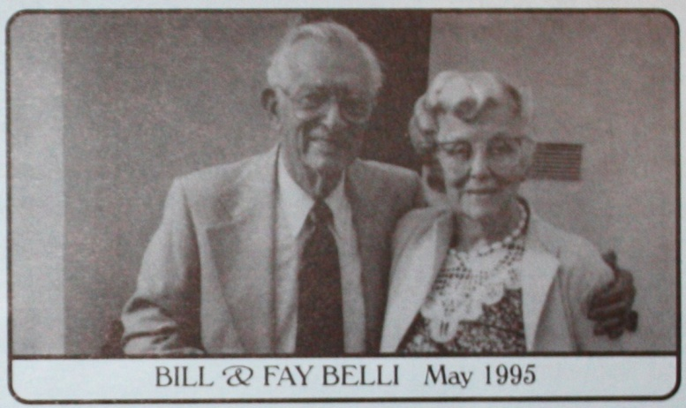

About 10 years ago, during one of those visits, we had an interesting experience that I would like to share with you.
Two of our former boys, Carlos and Pablo were hitchhiking out to the Ranch. On the highway they were picked up by two Jewish tourists from New York who were vacationing in Mexico. The Jewish boys could speak some Spanish and conversed freely with Pablo and Carlos as they rode along. During the ride, Pablo and Carlos invited the Jewish boys to stop off at the Ranch.
When Hank was introduced to the young college students, he learned that they were from New York and felt led to offer them our hospitality for a few days, which they accepted. They ate in the dining room with the boys, slept in the guest house and seemed to be quite content.
Fay and Bill were quick to be friendly and took advantage of the opportunity to witness for the Lord. The boys were polite and good listeners. In spite of their Jewish background they were receptive to the gospel.
I felt the Spirit leading me to talk with them too. I felt that others could do a better job of explaining the way of salvation than I could, yet there was this tug within telling me that I must obey the Lord’s leading.
During their visit Hank had a kidney stone attack and had to be taken to the hospital in Montemorelos. The visits to the hospital and the concern for Hank took up my time and thought.
The day for the Jewish boys’ departure had arrived and I still had not spoken to them about the Lord. If I did not speak to them before four in the afternoon, we would be leaving for the hospital again and the boys would be gone when we got back. I must talk to them now!
But I felt insufficient. I did not know how to approach a Jew. It was easy to deal with the Mexicans who already believe that Christ is the Son of God, but how could you talk to a Jew about Jesus being God and their Savior and Messiah. They reject this.
Remembering that Fay had said she had brought along some Jewish tracts, I asked her if I could read one. The tract gave a beautiful list of proofs from the Old Testament Scripture that Jesus was the Christ, the Promised Redeemer of Israel.
I was gaining confidence and now felt that I could deal with them. But I did not know where the Jewish boys had gone at the moment and time was almost up. They were not in their room and could not be seen outdoors.
Some of our boys were around and they always know where everybody is! So down the lane I went following their directions to the open spaces in the orchard where there was an abundant growth of tall soft grass yellowing from the frost and the sun.
I found the Jewish boys and went right to the point. “I have come to talk to you about this before you leave!” I held up the little tract. “It is beautiful!”
As I started to read it to them, they seemed to know what it was talking about. Ruth and Boaz were talking in the fields. Boaz had been chosen to show again the Kinsman-Redeemer relationship of Christ. As the tract story unfolded, we could almost feel Ruth and Boaz right there with us. I could feel the presence of the Lord.
I somehow wondered if what was happening there to us was not just as eternal as what happened to Ruth and Boaz. The Jewish boys listened as though they were in a wonder world. I was listening too, because the Spirit was speaking to us from the little tract.
Then came Esther, the little Jewish girl, who became queen in Shushan, capital of a foreign land. She had to deliver her people from the cruel Haman. She knew that it might mean having to give her life, but she was willing. “If I perish, I perish!” The Jewish boys were proud of Esther; they loved the story. And she, like Christ, saved her people! She was a type. Did they see this beautiful list of heroes as all portraying the One who was promised and who had come to them?
When we finished the tract, it was time to leave but we prayed first in Jesus’ name and heaven seemed to radiate light and love around us out there in the field.
I will never forget that day! I was able to witness to these young men freely when I had thought there was no way that I knew of to approach them.
“The tract was perfect,” I told Fay on the way to the hospital. “How is it you had Jewish tracts along with you?”
She said she had asked herself that question as she put the tracts in her bag. “What am I doing taking Jewish tracts in English to Mexico?” She had felt led of the Lord.
God was making a way for two Jewish boys to hear about their Savior just as he had led Ruth to Bethlehem to the fields of Boaz, and just as he had placed Esther in the royal court.

How wonderful to be led of the Lord!

NO WAY PLACES CHAPTER 26



The Wide Wide World

As a child, my favorite books were “The Wide, Wide World,” Streams in the Desert,” and the Bible. “Barley Loaves” also stands out in my memory as a story which impressed me very much.
“Barley Loaves” was a story about an invalid girl. She found great pleasure in spending her small allowance on tracts. Her loved ones would wheel her to the bedroom window on the second floor where she would watch for passersby. She waited until they were close and then would drop a tract from the window. The little papers would be caught or recovered by all sorts of people as they saw them fluttering toward them from above.
The writer of “Barley Loaves” went on to tell about the results of this invalid girl’s window ministry. Many a weary traveler found peace and rest. Many a hardened sinner found forgiveness and cleansing. The little invalid girl herself was richly blessed because she had found a way to venture forth into the highways and the byways from her window, scattering the Precious Seed far and wide.
I think my whole life may have been influenced by “Barley Loaves.” At any rate, I have always loved giving out tracts, and here in Mexico tracts are accepted very graciously by almost everyone. Giving tracts is the sort of thing anyone can do. It may not require any special talent, yet there are lots more Barley Loaves available than there are “invalid girls” with hearts to share them.
Giving out tracts is the extra mile sort of thing. It is the “beyond the call of duty” to some. It is off the beaten trail where no one who seeks glory goes.
Even though I enjoy this lowly task, there are often many seemingly legitimate excuses for putting it off until later. There are the village classes, the Ranch services, the caring for the children, and the errands to be run. Usually I am in a hurry coming and going.
Sometimes I am in too much of a hurry to remember to take along some tracts, yet I know that handing out the gospel during free times or while I am on my way to do something else, is often a greater pleasure than I have words to tell.
Swimming is one of my favorite sports and for years we have taken the boys all jam packed the pickup to the swimming pools in El Alamo. This was their Saturday treat. The boys dive from high platforms, play in the creeks among the swirling waters and the rocks, and by His great grace, they have been preserved from accidents or disasters.
Scripture teaches bodily exercise profits a little, and I am very well aware that I need more than this to make my day in the beautiful outdoors complete. So when we go to swim, it seems right to take along my Bible, the guitar and tracts.
I can remember many wonderful times strumming the guitar, singing hymns; sometimes alone, reading the Word and meditating on some devotional thought from “Daily Bread” or “Today.” After singing or meditating on the Word, I would feel the urge to share it with the people around us by means of giving out tracts.
At the pools, the people were relaxed and friendly. They were enjoying the rest, cooking meals over outdoor fires, bathing in the water and the sun. No one was in a hurry and everyone had time to listen or to share. It was an ideal place to scatter the Precious Seed. “La Biblia” is respected by the Mexican people and they honor Jesus as Son of God, although they do not have the assurance of salvation or of knowing Him as their own personal Savior.
This is where the need for tracts and the gospel of the grace of God comes in.
How many happy moments I have spent talking with the people there at the pools I will perhaps only be able to recall in eternity.
Swimming in the beautiful crystal clear water and resting in the verdant grass was nothing compared with the unspeakable joy of telling the story of His love and making His promises clear to these dear people who were so willing to listen and to accept the Word.
On one of these occasions, I felt that I would not be able to witness as I had had a bad experience in the village trying to witness the day before.
I had given a tract to a lady at her door and she had said, “No, thank you. I cannot accept it.” When I asked her “Why?” she informed me that she did not know how to read.
This aroused my sympathy and gave me a great desire to explain the Word of God to her and make clear the plan of salvation. Perhaps she had never heard, and since she could not read the message, she would have to have someone tell her the gospel story.
She seemed to be drinking in the Word, but yet she seemed nervous and kept staring hard over my shoulder. In back of me was another doorway. I did not know why at first, but suddenly, I had lost her. She was no longer listening to what I had to say. There was fear written clearly on her face. Then a booming voice shouted out behind me, “Get out of here with those papers.”
After a futile attempt at trying to take the fury out of this angry husband’s attitude I left, feeling very rejected. And I think I trembled a little when I offered a tract to the next person that I saw coming down the dirt road on my way back to the pickup. There were no more unfriendly encounters that afternoon, but for some reason this hostile encounter seemed to linger in my thoughts and the next day at the pool I made up excuses for not giving out my tracts.
Fear of rejection had temporarily overpowered me. Strumming the guitar, I tried singing some old hymns and passed away the time ordinarily used for witnessing.
But God was very gracious. He wanted to reach out to others and He wanted to help me to overcome my fear. A lady passed by and smiled. She spoke to me and then said, “I liked your songs. What kind of songs are they?”
“They are gospel hymns,” I said.
She had never heard such beautiful words and said they were so full of peace and joy. We talked about an hour. I gave her my New Testament. I had a happy time explaining about the Lord Jesus Christ who is everything in life and who is coming back again for those who trust Him.
She was the wife of a director of a commercial school in Monterrey and invited me to her home. She seemed very anxious to know more about this matter.
Although I have never had the opportunity to see this dear lady again, God used her to dissipate my fears at that crucial time, and to spur me on with my “Barley Loaves.” I forgot about the man with the booming voice of yesterday and went off with my tracts around the pool. My joy was restored. I could give out the little papers again that told of God’s great love and they would be accepted by many graciously.
The “Barley Loaves” were fluttering in the breeze again; the same way they did for the little invalid girl in the window whose greatest joy was to sow the Precious Seed. Little did she know how far it would go in the Wide Wide World.

NO WAY PLACES CHAPTER 27

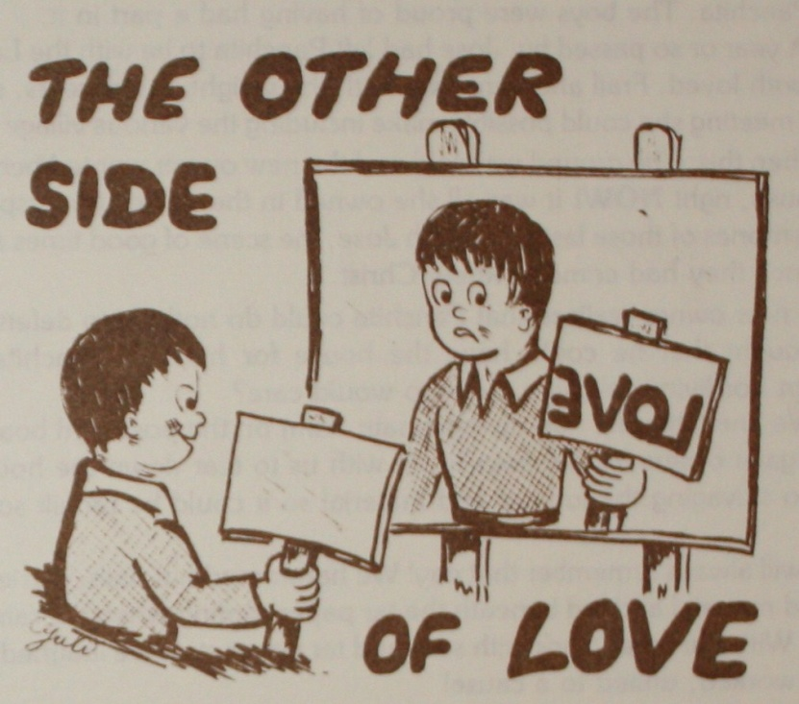

As a missionary, one is called to love. Often as we see the reaction of young people visiting Mexico for the first time we are reminded of the love that drew us and kept us here throughout the years. Almost invariably, the visitor becomes enamored with the people, especially the Rancho del Rey boys. However, we have found that love is not nebulous emotional attachments nor euphoric mouthing of the word no matter how often repeated.
At times we have seen real love turned into practical channels. Pastor Don Lyon and his youth group for North Stonington, Connecticut, were outstanding examples. They came with Love and purposed to SERVE.
Several months before they came to visit, the world suddenly darkened for frail little Panchita. She was above seventy years of age, a widow who lived nearby in a simple board house.
When Panchita and her husband had been dispossessed from the land they had been working for an absent landowner, a neighbor said they could live on a little plot of ground that he had. When Hank heard that their little collection of old boards, posts and tar paper roofing sheets was not going to be enough to make even a simple shack, he told our son Clifford to go to the lumber yard in a nearby town and get what was needed to provide them some shelter.
All the boys were assigned to work with Clifford and soon a simple little house took shape. It wasn’t much by American standards, but it thrilled Jose and Panchita. The boys were proud of having had a part in it.
A year or so passed by. Jose had left Panchita to be with the Lord whom they both loved. Frail and bent over with the weight of her years, she was at every meeting she could possibly make including the various village meetings.
Then this: The ground was sold and the new owner wanted her to vacate the house, right NOW! It was all she owned in the world: the repository of her memories of those last years with Jose; the scene of good times and blessings since they had come to know Christ.
The new owner realized that Panchita could do nothing to defend herself. He thought that he could have the house for himself. Panchita had no children nor living relatives. So who would care?
We knew that he had no legitimate claim on the post-and-board house. Hank gave orders for the boys to go with us to tear down the house with a view to salvaging the lumber and material so it could be rebuilt somewhere else.
I will always remember that day! We hammered out nails, carried boards, stacked material and hid beneath the tar paper roofing when the rain showers came. With our faces black with soot and tar paper stain we laughed and sang as we worked, united to a cause!
Suddenly, most of us stopped working. Down the dirt road came the landowner in his horse drawn carriage. He stopped and stared! He told the boys he wanted to talk to Hank. Hank heard the boys, said there was nothing to talk about, while hammering and pulling nails with a determined look on his face that I had seen before. The angry landowner scowled, then rode off in haste.
I thought of the love we had for Panchita and “her world.” But love is RISKY. No one loves without taking a chance. Now my heart beat rapidly. Was this what love did to you? THIS WAS THE OTHER SIDE OF LOVE! To the landowner we were “ugly Americans” getting in his way. I prayed that God would not let the man’s anger cause hurt to the boys or the work of the Ranch, and it never did. Rather, God worked in a manner we had not anticipated by sending Don and his group down that same spring.
As soon as they settled in they let it be known that they had come to fellowship in love thru working. They came to SERVE and would be content with nothing less.
By now Panchita was the adopted grandmother for the boys and was living in the staff house on the Ranch. However, another believer, Cuca, who had several children, badly needed a house. Panchita, in love, offered her stored materials. El Rancho added some more, a neighbor shared his plot of ground, and the visitors contributed HEAVILY as the project to build a house in 5½ days started rolling.
Those days also stand out in our memory. Throughout that time love flowed from each one as post holes were dug, beams set, lumber carried up the hill; everyone helping wherever needed. We kept thinking of little old Panchita’s boards and of Cuca, the lady with the children who needed a house. It was a joy to know that their need was being met as we watched the Lord making a way again.
Less than two hours before the charter bus came to take the group to the airport for the flight back to the States, the last nail was driven and the house dedicated by prayer. It was the talk of the town and a beautiful testimony of Christian Love.
I have thought a lot about LOVE and the OTHER side of love and would like to share this incident.
Two of our boys had been given permission to go to visit Ledesma’s sister in Monterrey, Ledesma had invited Cesar to go with him. Cesar needed a change as his relatives live far away in Oaxaca and he does not have the opportunity during the school year to visit with them. The two boys went off smiling and happy! But sad to say, they returned a few days later fighting and angry.
I discovered that the reason for this was due to the fact that Ledesma had a problem. Ledesma is a bed wetter at the age of 10 and has to be gotten up several times thru the night. Apparently there was no one at his sister’s to take this precaution and he met with rebukes from his sister for his failure.
Cesar, on the other hand, who is well mannered, capable of being a perfect gentleman, received praise and honor. Because of this, the two boys returned with a lot of hard feelings between them. There were tears and unkind remarks.
With my arm around both of them, I assured Ledesma that his sister really loved him very much. The fact that she had rebuked him and praised Cesar did not disprove her love. She was provoking Ledesma to JEALOUSY to challenge him into growing up!
We encouraged Cesar not to be angry with Ledesma, but to realize that he was hurting and ashamed; that he felt cheated because he had tried to show him kindness and it seemed like Cesar had walked off with what Ledesma held dear – his sister’s love.
This was the other side of love for both of them. Ledesma was finding out that friendship was not just a light casual thing; in word only, it was costing more than he had bargained for, but he could profit by the hurt he felt if he would ask God to help him overcome his fault. Cesar was finding that loving meant more than accepting someone’s kindness. It meant seeing way down deep inside of that person and understanding him in spite of the pain he felt because now that person was lashing out at him.
Too, Ledesma needed to see beyond his sister’s sharp words: praise for Cesar, rebukes for him. Why? Why? Why? Didn’t she LOVE him anymore? Did she love Cesar now instead of him? Wasn’t that enough to make a little boy living in an orphanage without his mother at his side cry his heart out? Yes!
But NO! Not when you saw the OTHER side of love. Love is not in WORD only, but in DEED and in TRUTH. His sister really loved HIM, Ledesma, very much. Her rebuke for Ledesma was more sparked by LOVE than her praise for Cesar. She was looking down the road and wanted Ledesma to LEARN! Soft words weren’t going to reach down inside of him!
We have had to play the part of Ledesma”s sister many times through the years on El Rancho del Rey. Perhaps people who come to visit for a day or two misunderstand. We may seem unreasonable and unkind. Visitors see the surface of what is happening just as a casual person would have listened to the Ledesma/Cesar quarrel. They would have thought “What a NICE boy that Cesar is!” But Ledesma’s heartache would not have surfaced and would have remained unhealed. As it was, both boys prayed for each other and wept together and once more they are friends.
The casual visitor is impressed greatly with our boys who are outstanding in many ways: in sports, in getting a job done, in school, in friendliness. It is EASY for a visitor to reach out to them in love. But there is still the everyday grind for all the rest of us: the routine slacking off by the boys unless someone is there to keep after them; the “I don’t care” attitude that we have to contend with every day; the bedwetters, who have to be gotten out of bed against their will when they would rather die than hear your voice in the middle of the night. A SOFT voice may turn away wrath, but it will not get a sleepy boy out of bed nor make them leave the TV to study or pick up orange peels off the floor, nor settle their disputes and feuds.
Many of our young visitors do not understand this. When they come, they feel love for our boys and express it softly and tenderly. Our boys are enthralled. It is a momentary source of inspiration and does them good. But on the other side of love, our boys are often found weeping after the visitors have left, and begin to fight among themselves over mementos left behind. There is unrest and confusion until the spirit of this kind of love subsides.
For days afterward, I am called upon to translate and type an avalanche of letters from boys to their American friends who have come and gone leaving happy memories. Mostly all will never return, although they well-meaningly said they would.
This is one kind of love. Perhaps it has its place, but it is the Ledesma’s sister’s love that comes closer, I believe, to God’s love. His love can cause discomfort, but blessing follows.

For God so Loved the World

Like sheep without a Shepherd,
That dark and tragic day,
The disciples were so frightened,
That they turned and ran away!

Before that in the courtyard,
“I don’t know Him!” Peter said.
And Judas counted silver,
While the others fled.

Although he was forsaken
By those He held so dear,
There were…the “daughters of Jerusalem”
Still lingering near!

There were the Mary’s and the Magdalenas
And keeping Him in sight
Were Arimathea’s Joseph and Nicodemus
Who came to Him by night!

Like the “Daughters of Jerusalem,” Lord,
Who followed you with tears,
May our love for you be GREATER
…Than our fears.

TRANSFORM US LIKE YOU DID WITH PETER WHO LATER DIED FOR YOU.
FILL US WITH YOUR SPIRIT,
AND MAKE US TRUE!

…Anne L. Moller

For God so loved the world that He gave His only Son, that whosoever believeth in Him should not perish but have everlasting life. (John 3:16)

NO WAY PLACES CHAPTER 28

Let’s Fly!

It would be hard to put into one short chapter all there is to be said about the airplane ministry that Hank has had during our years in Mexico.
To be very honest, I must confess that I have not always encouraged Hank’s flying career. Yet, as the years pass, and I have surveyed from the sidelines the results of having an airplane at our disposal, I must admit it is the LORD’S doing and one of His ways of making a way.
As I watch the children and the women coming down the dusty paths to our village services week after week, I realize that the airplane has played an important part in their having open hearts to the gospel. When you fish you must have bait. When you fish for souls you must also have something to initially attract them. From whence come the boxes of clothes that we have to share with them? Were they not sent to us by people who loved and cared? Had not the airplane brought them to the Ranch?
Are not the Mexican people grateful for this flow of blessing from the sky? Have not some said, “I could never afford to buy clothes like these for our family. I praise the Lord. He has provided!”
Jesus said we were not to love in word only, but in deed and truth. We have been able to do this week by week because of the love in the hearts of his children.
With the availability of the aircraft to transport the gifts we are able to share something each time with the poor. These gifts include needles, thread, needle threaders, sponges, soap, shampoos, potholders, combs, and many other items along with lovely pretty colored clothes for the mothers who gather for our Bible Classes in the nearby villages in the plazas and in their homes.
Ours is the joy of bringing your gifts to them in the name of the Lord. If a cup of cold water has its reward, then these gifts are not given in vain, nor will His Word, shared, return void.
It seems in order to give a brief history of Hank and his airplanes. His interest in planes goes back to when Lindbergh crossed the Atlantic. Hank was only seven then, but remembers that was when he first assembled a little model airplane kit and started to dream of someday becoming a pilot.
Hank studied airplane mechanics in high school, had a few flying lessons in 1939, then was an airplane mechanic in the Marines during World War II. He finally got his pilot’s license in 1947 on the G.I. Bill. I remember the day I first flew with him from the Doylestown, Pennsylvania, airport, soon after he got his license. I was young and reckless then, but still quite scared. I got airsick in that little yellow Piper Cub and he finished the flight with a bouncy landing.
This training was undertaken with the hope of using this skill in the mission field. While the Lord was preparing him for missionary work, it was hard to foresee that this talent would be used to spread the Word thru dropping hundreds of thousands of gospel tracts in remote areas in Mexico, and by supplying some of the needs of hundreds of orphan boys, while helping to spread the gospel message to many villages by means of transporting gifts and supplies to back up the words we were saying about God is Love.
In Mexico, the first plane that Hank got to fly was for a nearby Bible school. After a couple of planes and a couple of years of literature dropping and transporting student gospel teams etc., the Lord moved on the scene and provided a plane for El Rancho del Rey in 1960.
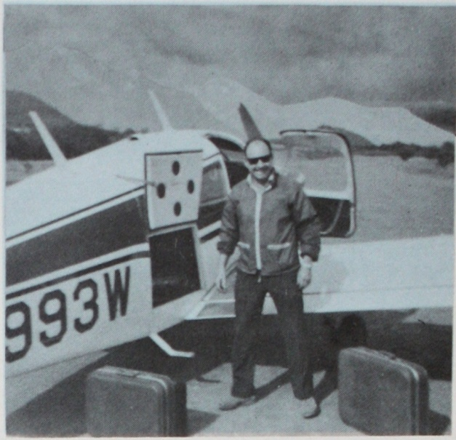

The Lord had already prepared for this addition to Ranch equipment, for in providing the site for the orphanage in our mountain valley, he saw to it that one side was long enough for an 1800 ft. airstrip. Many visiting pilots shake their heads when they see our landing strip on the top of two knolls with a thirty foot dip in the middle of the strip. However, Hank has used it successfully for many years. The Lord has brought him in and out safely, thru crosswinds, heat turbulence and bad weather.
I still have not completely conquered my fear of flying, in spite of the many flights I have made with Hank. He has often reassured me, as we have flown together in bad weather that the airplane doesn’t know if it is in the clouds or in the sunshine or whether it’s dry or pouring rain. It just depends on the “nut that holds the wheel” to push or pull the correct things. So, don’t bother looking at all those dark clouds. Just watch the instruments. However, to me, it is a really strange sensation as he makes an instrument approach, to be going down, down, down, and not to be able to see the ground.
Hank has had what I call a few hair raising experiences during his years of flying (However, he won’t call them “hair raising” but quips, “if they are hair raising why don’t I have more hair?”). The Lord has kept him thru all these times of trial.
One that I remember being in was a landing in Columbus, Ohio in a Cessna 180 when the brake on my side began to smoke and came loose. It dragged on the wheel, and the pavement providing enough sparklers for a fourth of July parade (one that I would just as soon have missed!). A new wheel and brake fixed that after a day or so of waiting for parts.
Another time, another plane, another place, but still the same good Lord watching over us: We had flown Linda to Costa Rica where she was teaching at the University. This afforded us a chance for a change of pace and an opportunity to give out hundreds of gospel portions along the way. On a photography mission along the isolated Pacific Coast beaches with Linda as passenger and photographer, one take off attempt ended with the nose wheel striking a soft spot causing the plane to try to bury its nose in the sand as the flight came to an abrupt halt. He said he had found the only soft spot on 30 miles of hard packed volcanic sand. There were no personal injuries.
That morning in our devotions we had read “I am the Bread of Life.” It struck us as very significant, since the pilot that came to the rescue, ferrying Linda back to us, notifying the authorities, arranging for mechanics and flying Linda, Danny and myself back to the capital at San Jose, was named “Señor Paniagua,” which translates, “Mr. Bread and Water.” It was a difficult time for all of us, but God was there and sent such a kind person whose very name reminded us of Himself.
Hank stayed with the plane to await the repair crew and parts. He spent the night in a nearby village where the only room available was in the rear of a “Cantina” and Dance Hall. They treated him royally, helping in every way they could, but did not spare his eardrums by lowering the music even one decibel. From his description of the windowless, sparsely furnished, single bed cubby hole, it was evident that its purpose was more amorous than for sheltering downed “gringo” missionary pilots.
Some years later on a routine flight to Texas for Rancho del Rey mail and supplies, Hank crossed the mountain range between the Ranch and the Monterrey airport. While descending near San Roque, just 10 miles from the airport, the engine quit. It could not be restarted. He radioed a MAYDAY (S.O.S.) call and prepared to glide into some tall brushy trees as no open field was near enough to reach.
The landing, in spite of being cushioned by the brush, was hard enough to pitch him forward. He cut his forehead and lower lip on the instrument panel. Although he was bleeding, he praised the Lord that he was still alive.
The tower operator at Monterrey diverted a business plane to look for him and soon a twin engine Cessna 401 circled overhead and radioed the location to the authorities.
Returning from a search for water, Hank spotted a helicopter coming. How good it was to be lifted out of the woods, but it took a lot of faith for him to believe that God would make a way for his crippled Navion that he had to leave. It was like leaving a part of himself behind!
There were months of discouragement that followed when Hank was without his wings. The plane had to be disassembled and a road cut into the crash site before the parts could be hauled out on a truck. Permits had to be obtained to export it to the States for repairs.
Our village supplies dwindled and there was a shortage of things for the boys while our transportation problems increased. After a year and a half of waiting and praying, it seemed unlikely that the repairs would soon be finished. Even though the Lord’s people were generous with their help, parts for such an old airplane often had to be scrounged.
Then the Lord brought about a blessing exceedingly abundantly above what Hank could ask or even think about. A friend of our work provided funds to purchase an excellent late model Piper Cherokee. The 31 year old Navion was sold and the proceeds used to support and maintain the Cherokee.
I believe one of Hank’s talents is flying, though I often decline going with him when the weather is bad. He doesn’t want to be called a courageous pilot, just a careful one who knows the plane’s and his own limitations. He wants his talent to count for the Lord. I have written a poem that might express some of Hank’s feelings as he takes wing with his Heavenly Father at his side:

Come, son, let’s fly together,
Let’s rise and climb and soar…
Let’s not mind the weather,
Nor heed the wind’s rough roar.

Remember, when it’s stormy
And raindrops beat and pound,
Your PILOT’S there to guide you...
HE knows the way around.

Come! Fly away from earth things!
Come! Fly away from care!
You’ll catch a glimpse of GLORY
When you’re with ME up there!
Anne L. Moller

“Hold thou me up and I shall be safe.” Psalm 119:117

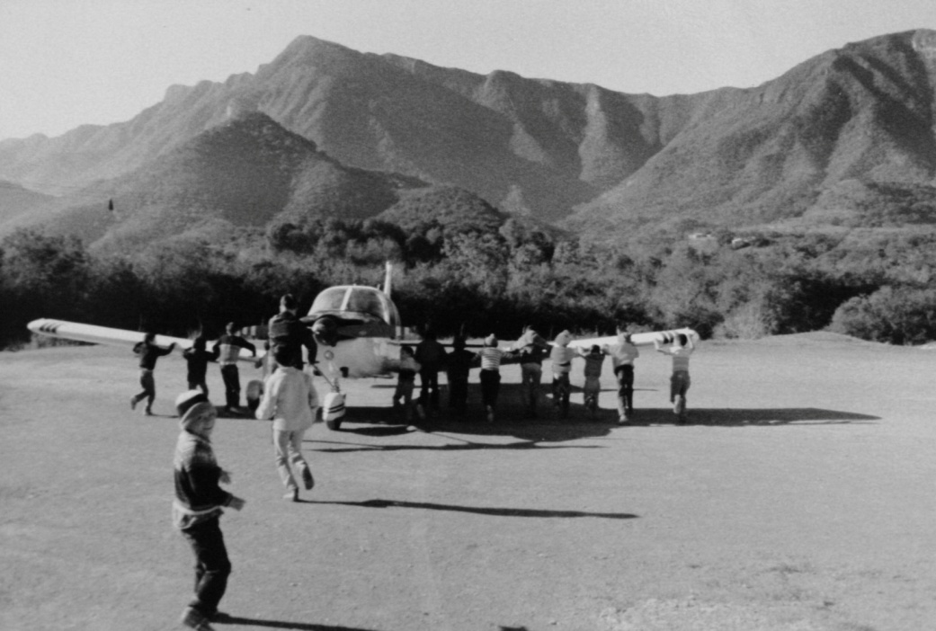
The boys helping to push the plane into position for take-off
at El Rancho del Rey

NO WAY PLACES CHAPTER 29

“...Thou Shalt Laugh…”

There was one summer that I thought I would not itinerate, but rather take a little break from ranch activities between school terms to just rest and relax. However, Linda had been hopefully planning to itinerate that summer with me. That following fall she would be transferring from Prairie Bible Institute in Canada to East Texas Baptist College so that her teacher’s certificate would be accredited and recognized in the States. She felt that she wanted to share in this phase of the work of telling about God’s goodness amidst the work in Mexico and of her experiences. Realizing that perhaps this was possibly one of the last opportunities we might have to travel together, I decided, for her sake, to go.
Along with Danny, who was quite small, we started out. Soon we were in California. We had nice visits with old friends and many opportunities to present the work in Los Angeles, Santa Paula and Santa Rosa. The time passes all too quickly and it wasn’t long before it was time to head home to El Rancho, where Hank was holding the fort.
The way back was something else! It started with a flat tire in Santa Rosa and after that I didn’t know so many things could go wrong with a car. A long hot wearisome trip thru the California desert saw us limping into Sedona, Arizona, barely on time for our service. We had a motor job done there and were delayed several days.
When we left Sedona, we drove over a hundred miles in the scorching Arizona heat thru mountain roads of which a large section was under construction. It was bumper to bumper stop and go thru the worst , while dust blew and motor temperatures soared. Replenishing the water as possible, we limped along. Finally after one last boil over, we had to stop for more repairs. There went the motor job!
I have forgotten the names of all the towns along the way where we were delayed for this or that repair. In my whole life I never had so many breakdowns, and we have had some very eventful trips in old cars going east and going west.
I began to question what was wrong. Were we out of the will of the Lord? Was this trip really not to have been?
The days were speeding by and we were still on the road trying to get home. Finally, passing El Paso eastbound, we decided not to stop overnight again until reaching McAllen near the Mexican border in Southeast Texas. Just another 825 miles to go as the sun lowered in the sky behind us.
Several days previously, I had felt led to suggest to Linda what she should do in the event that she should have to make a quick turn. She must not overcorrect too quickly as she might turn over. I realized that she was relatively in-experienced and there were many situations out on the road she had not yet me up with.
I had driven most of the day, and now as night came on, I surrendered the wheel to Linda. The miles were being put behind us as the road was wide open and rather flat. Linda was driving along at a good pace when suddenly in the headlights she saw an animal lying right in our path. Linda swerved the car then overcorrected! We were rolling! In those split seconds I thought that we all would be killed out there on that lonely road somewhere west of the Pecos.
But lo and behold! We were down and then up! We had rolled in to a sheep fence! A post cracked the windshield, but the sheep fence cradled us, restrained us from further rolling, and set us upright again with a plop.
Danny had been sound asleep but woke up with a scary cry. Linda consoled him in her arms while I pushed my way behind the wheel. The motor had died but it turned over, coughed itself clear and caught. With a scraping noise of sheep fence and barbed wire against the roof and right side of the car, we pulled out of there and we were on our way again!
The car handled poorly and seemed to have low tire pressure. As we came into the outskirts of Alpine we spotted a small all night gas station where they started to fix the tires which were now almost flat. There was dry grass and small stones between the tires and the rims, causing the leaks.
With the tires now fixed, we stopped off in a little rickety old hotel. Stumbling up the stairs and into our room we practically fell onto the beds. Exhausted and discouraged, we prayed and praised, but in trembling, timid tones.
Linda, glad to be able to stretch out and rest after the horrendous experiences of the day, soon fell asleep. For me, there was no sleep nor stopping the replay of events in my minds. Of course, Satan was pushing a confusing array of negativism my way. Hadn’t the Lord gone off somewhere and forgotten us? He did seem far away. Hadn’t everything gone wrong that could go wrong? It did seem that way, but I had to allow that it could have been worse.
Enough of that Satan! I needed to hear from the Lord! My Bible was somewhere amongst the tumbled about things in the car, so I was deeply grateful to see one lying on the little night stand by the bed. It was an old Bible, but its age yellowed pages seemed to me like sheets of gold.
“Lord! Please tell me if I am out of your will! Please be with us! We can’t go on without you!”
The Bible opened at Job 5: 22-26; a portion I did not remember having ever read before, but every word was speaking to me now… “at destruction and famine shalt thou laugh. Neither shalt thou be afraid of the beasts of the earth. For thou shalt be in league with the stones of the field. And the beasts of the field shall be at peace with thee. Thou shalt know that thy tabernacle shall be in peace and thou shalt visit thy habitation and shalt not sin. Thou shalt know also that thy seed shall be great and thine offspring as the grass of the earth. Thou shalt come to the grave in a full age, like as a shock of corn cometh in his season.”
To me this meant: Destruction had not been able to touch us, though we had been rolling at high speed. Even the stones in our tire rims was a sign of God’s power to overrule and preserve us. It made us stop for repairs and reconsider trying to make all those miles without rest. It had taken the repair time for fatigue and reason to take over. The sheep in the middle of the road (beast of the field) in the end had not harmed us. It was their fence that spared us bodily harm. Now that’s a league of cooperation! We would come safely to our habitation and our children would be blessed and our seed (spiritually) would be as the grass of the earth! The Lord was with us, our children, and the Rancho del Rey. He saw. He cared. He had lifted us up Praise His name!
We finally arrived in McAllen where Hank had come to wait for us and told him all the experiences. After arriving in McAllen we could not get the car to run again and finally sold it for parts to a gas station owner so that we could get it off the motel parking lot. As it was towed away, I sadly thought of the $1,100 we had paid for it plus all the extra repairs and the bills from the trip that would arrive over the next few months.
We mentioned some of the above experiences in our newsletter and requested prayer for a replacement vehicle as we were without a car at the ranch. The newsletter traveled all over the States to all the different interested readers who have helped to pray for El Rancho del Rey throughout the years. Perhaps some of the letters were lightly read and put aside but many friends were praying.
One of the letters found its way to Babylon, New York, and was placed along with other mail on the desk of Pastor Richard Cotter. Shortly thereafter, a member of his church walked into the office with a question:
“Pastor, do you know of anyone who needs a car?” she asked. “Someone in the Lord’s work; a pastor or missionary,” Mrs. Monges continued.
Pastor Cotter reflected and said, “No, I don’t have anyone in mind…but wait! I have a letter here from Mexico. Let’s take a look at that.”
After reading the letter, he looked up and said to Evelyn Monges, “This is unbelievable. The Mollers in Mexico need a car!"
The Monges’ were pleased that their vehicle would be used for the Lord in Mexico as Dr. Monges had been born and reared there.
We have had other cars given to us before and since then in times of need by sacrificing friends of the work. But the beautiful green Rambler station wagon that Hank drove back from New York will always be something joyously special in my memories. To me, it was the culmination of the summer’s encounters; of the experience of having the Lord assure me from His word after a night when destruction seemed so imminent; replacing my despair and sorrow when He intervened; for had not He said… “thou shalt laugh!”

NO WAY PLACES CHAPTER 30

Kings and Queens

When Danny was coming along, I prayed that he would be like the Daniel of the Lion’s Den. Perhaps because of a great sense of insufficiency, I longed for a son who would someday take the role of “big brother” among the Mexican boys. Mexican boys always look up to their big brothers and obey them even more so than they obey their mothers or their “maestros.”
Through the years I struggled with a sense of guilt when our boys were not getting good grades, if they were caught stealing, smoking or giving their teachers a bad time. Yet when I have been most depressed and inclined to feel all was in vain is when someone would invariably knock on the door and beg us to receive a child who was such a dire case that I would forget my despair and realize that we were meeting a need in spite of our imperfections. God understood and wanted to encourage us to continue.
But the battles kept on being waged. We tried to teach Christian principles which seemed so unreal to these boys off the street…”Giving is better than receiving…forgiving is better than revenge…friendship is worth more than things.”
We struggled with our own pride. We wanted to be gracious and unassuming. We did not want the boys to think we needed their “Thank You’s” for the things we were doing for them. Yet…they needed to learn to say “Thank You” and “Please,” not for our sake, but for theirs. If they did not begin to say it to us, then they might never say it at all.
We, ourselves were still in the learning process. The day Martin, a village boy who had a chronic sickness, got kicked by Victor, one of our Rancho boys, seemed like a big crisis. However, it was really just another Rancho del Rey day and I should have put it into the Lord’s hands at once and trusted Him.
I had been to Monterrey that morning buying groceries, and also had to appear at the police station in regards to a theft which had taken place at the Rancho. It had been an exhausting day in the hot city, and being informed of the Victor-Martin problem as soon as I arrived on the Rancho seemed like too much punishment for one day. I was listening to remarks about a possible operation being needed for Martin, which would cost 3,000 pesos. To make matters worse, Hank was in New York due to his mother’s being ill, and I felt very much alone and frightened.
I had to go to the border for mail the next day and rashly decided to go at once to escape the problem. I would just disappear clear out of sight and let this simmer down! Panchita, my little old Rancho grandmother, who had been faithfully by my side as companion and friend, agreed with me. She was afraid I was going to get into trouble without Hank around to help me and she wanted me out of here!
But Benjamin, who has been cook and Rancho del Rey pillar through the years, disagreed. “You should go to see Martin’s parents before you leave,” he said. “You owe it to them. The people respect us. They would not respect you if you ran away from guilt.”
In spite of my fears, I realized that Benjamin was right. It was true that Victor’s guilt was my responsibility whether I liked it or not. I was angry with Victor for his misbehavior; yet, I must take the blame before the people along with him, or bring reproach on the Ranch and on the Lord.
Contrary to what I had expected, his parents were kind and talked over the problem with me graciously. They had every reason to have made the complaint.
Victor admitted he was at fault and asked for forgiveness. I agreed to share the medical expense as best we could. I still remember the peace that flooded my heart as I shook hands with Martin’s mother after our talk with her and I am sure that Victor, too, felt relieved that the feud was over and the wrong made right.
We prayed about the problems, and God worked it out so that the operation was not needed, and the boy who was hurt was not seriously injured, and our friendship with these people to this day has been a good one.
Because of the many discipline problems with the boys, I always cried to the Lord for someone who could help them. While Danny was on the way, I got a promise from the Lord that I didn’t understand, “Kings shall be thy nursing fathers and Queens thy nursing mothers…” I didn’t understand this, but believe now that for me it meant that there would be “Kings” and “Queens” (spiritually speaking), in Danny’s life; great people in the Lord, who would pray for Danny and would nourish him spiritually and would be concerned for his growth in the Lord. And indeed, God has given Danny friends in Christ who have been “Kings” and “Queens.”
One day, when Danny was about six, he said, “I like to be poor.” When I asked him why, he said, “Because I like to be like the boys on the Ranch.”
That was the beginning of his showing a deep interest and love for the Rancho and for the boys. Since then, God has caused him to share in the work of helping with the garden work with the boys, with the kitchen work, in counseling, teaching English, and in getting to the bottom of some of the discipline problems, and keeping the dormitories clean. When Danny sings in the services or itinerates, I thank the Lord for the love in his heart for the work of the Ranch and for every “King” and “Queen” who has prayed for him. I give heartfelt thanks for each one.
Danny’s desire as a child to be like the boys reminded me in a small way of Jesus who became like us.
All the while He walked the dusty streets of Nazareth, He was rich. He owned the whole world. As He hammered nails, he was the One who was holding the universe together.
He did not mind spending hours teaching and preaching to people who would later want him crucified.
He was willing to sit with sinners and eat with them, while perfect Celestial Beings, whose minds had not been warped by sin, waited to commune with Him again.
All those long nights that He had no place to lay his head, He could have had angels carrying Him through clouds of glory with shouts of joy.
While His life’s blood poured out, and He hung upon the Cross, He could have had ten thousand angels at his side to destroy the world and set Him free.
But there was no way for him to escape all this because He wanted to be one with us.
So it is. There was no way for me to run away from Victor’s guilt. It was mine too. As I faced it together with him, it was just as though it had never been. There is no way for Danny to help the boys unless he is there where they are. While he is one with them, he can understand and help them.
We covet the prayers of all the “Kings and Queens” on Danny’s behalf; that Danny will have the spirit of this One who walked the dusty roads of Galilee and gave Himself.

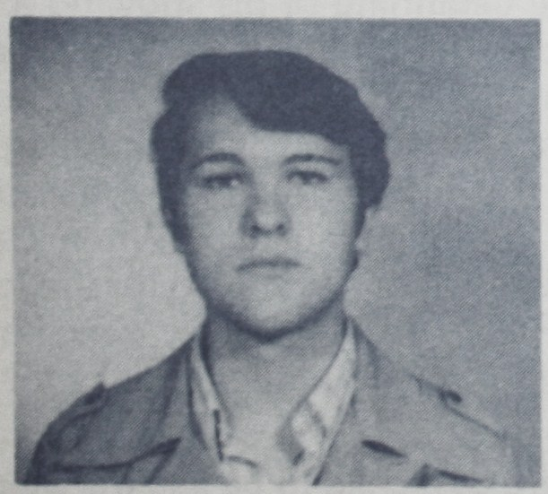
[Danny Moller, in 1982]

NO WAY PLACES CHAPTER 31

(A 1982 Interlude)

“OPEN DOORS…?”

Years ago, in Mexicali, God had spoken to us thru His Word and had said, “I have set before you an ‘open door’ which no man can close.” There had been occasions when we wondered if, after all, the door was closing. Would we be forced to leave this land that we love so much, that had become home to us and our children? Most of all, we wondered if the Rancho Del Rey would be a thing of the past.
We had cause, too, in recent months to view some of the events that have occurred with real concern for the future. We had planned Vacation Bible School in the villages and invited friends down to share in this. Several planned to help: one in particular wrote saying she had obtained hundreds of Bibles and was looking forward to this time of getting out the Word while working with the people.
In June, as the time grew near for VBS, we received a letter from this friend saying that she had heard that certain Mexican missionaries had been warned that in September the doors to Mexico would be closed.
Even without such warnings, we already realized that things were tightening up and that the time was short. We knew that we must do our best to proclaim the gospel before it was too late, but this seemed so decisive, so abrupt!
We wanted with all of our hearts to work harder than ever, but we were handicapped somewhat. Right about then, the enemy came in like a flood and Hank landed in the hospital with diverticulitis. He had only gotten one box of the Bibles flown in before he took sick, and it would probably be a while before he could fly the rest of the Bibles to us. They were sitting in a storeroom on the other side of the border. Now why would God provide all those Spanish Bibles and then close the door on them?
I recalled the promise, “I have set before you an open door that no man can close.” We got as busy as we could under the circumstances with two more young ladies joining us to help. We distributed carefully the Bibles we had, witnessed, held Bible classes, and gave out the Word in the villages like it might be our last chance.
In a week, Hank made a marvelous recovery, thanks to prayers. We dismissed the boys for summer vacation, left for the East for a few weeks change while visiting family and co-laborers.
When we returned near the end of August, politically that which we had feared had seemingly come upon us. Things had degenerated rapidly in Mexico. The value of the peso floated from 70 to 100 pesos to the dollar while prices soared.
In September, yes! Everybody seemed to be expecting trouble. There was talk everywhere of a possible “golpe de estado” – an overthrow of the government. But the president arose, presenting himself before the people with the Mexican army supporting him and this idea vanished. The president’s decree closed the doors to foreign spending. Banks were nationalized, dollar accounts cancelled out and changed into pesos. The exchange granted was 30 pesos below the exchange value in the States.
To make matters more impressionable for us, we heard through friends that the missionaries who had been warned that their time in Mexico was coming to an end and that the doors were closing, had already left the country.
My heart prayed silent prayers. My lips did not want to voice them. “Lord, what about us? Are the doors closing for us too?”
When we flew into Mexico, after our trip east, things seemed strange to me (perhaps because of having been away for a while, or perhaps because of fear). We wondered if Customs would be difficult, but all went along smoothly. We had no problems getting back into the country.
On the fly-by check of our airstrip before landing, we noted how sun scorched the fields were. There had been so little rain that even the weeds hadn’t grown up on the airstrip. The lake behind the nearby dam was extremely low. Monterrey would also be suffering water shortages. We would need to pray for rain, but everything else at the Rancho seemed fine. Benjamin had stayed by the stuff faithfully as always.
In a few days, the boys were back and school started again. The swimming pool people were noticeably friendly and kind (they wondered where we had gone and seemed to have missed us!). Considering the fact that they let us swim in their lovely pools without charge, and that they have made life a joy for all of our boys, they have been instruments of the Lord to help our boys stay healthy and active and to have the opportunity to learn to swim. We marveled at their extra-mile brotherly kindness in that they even missed us when we were not around!
“Señora Moller!” the owner’s wife said one day, “How do you manage your boys? They are so well behaved. They come right away when you call them and when you are ready to leave. Other groups who come have so much trouble. Their children fuss so when it is time to go.”
“It’s just the Lord,” I told her. “We pray about everything. He helps us when we don’t even notice in little things that we are not aware of. He has helped us a whole lot through you and your husband by making it possible for our boys to enjoy this lovely place. It is such a blessing!”
On my way back to the Rancho, in the pickup loaded with boys, I thanked the Lord for this open door, and sang a little song of praise for a pickup full of contented “muchachos.”
Then there was the church in San Jose – all of our classes had begun and were going along well again, but the San Jose group was outstanding. All of the benches were filled with children and mothers. They were not waiting for the sound of the music to come to the service as they had before, but were there waiting for us each time when we arrived. What happened?
What had really happened was that God had worked in mysterious ways to perform His wonders. It was nothing that we had done.
I had been praying for more of the presence of the Spirit in our ministry. God heard and answered in His own way. He allowed a disaster to bring a lady to Himself, and that turned the tide in San Jose for God.
The lady I refer to lived near the little church but never came to services. One day, while she was out on an errand, her house burned down to the ground. She had nothing left! Her house and clothes, everything was gone. The church people let her stay in the church. When we returned from our trip we found the church had a bed in it with a bright bedspread. There were curtains on the windows and everything was dusted and cheerful.
Victoria was so happy that we were agreeable to her taking refuge in the Lord’s House that she, like the Samaritan woman at the well, invited all her friends to the services, and she herself is always there accepting the Word and receiving us with joy each time we go. Her house was burned down, I am convinced, so that she might have an eternal house in the heavens.
So there was another door more open than it had ever been before in San Jose!
“Golpes de Estado,” decrees of presidents, doors closing to foreign spending, 100 percent inflation, the Apostle Paul would have said, “None of these things move me. For me to live is Christ.”
One thing is for sure: September has come and gone. We are still here in Mexico and the Bibles are here. I somehow have in my spirit a feeling of destiny; that now is the Golden Opportunity to reap a harvest. The people need help and reassurance. Their hearts are OPEN DOORS!

NO WAY PLACES CHAPTER 32

Image of God or??

Several years ago, we told the story of the “Eight Valientes,” and it is worthy of being retold and included among our “No Way” Stories.
There wasn’t much chance for the classmates of the Valientes to be exposed to the truth of Man’s creation in the image of God, because their “Maestra” was so completely dedicated to teaching the theory of evolution.
But the Valientes found a way. They spoke up and declared “We are not descended from apes!”
“Then where did we come from?” the Maestra asked.
One of the little Valientes had a brilliant thought. “We are made from the dust in the image of God!” he said.
“Who says so?” challenged the teacher.
“The Bible!” declared one of the eight, and the rest backed him up. Having eight little Rancho del Rey Bible believers in one class was a disadvantage for a teacher who tried pushing evolution on her scholars.
“The Bible is just a book with pages,” she fired back at them. “It is not true!”
“The Bible is true,” the boys insisted. “The story about apes isn’t! No way!”
The rest of the class laughed the eight to scorn, but the eight were a fearless bunch, and they stuck together. They were not about to retreat into a corner or apologize.
The teacher got on the defensive. She was afraid there might be trouble later on outside the school. “No fights!” she warned, or it would be just too bad for the Eight.
The Eight came home to the Rancho and shared what had taken place. Like good soldiers of the cross they did not seem to be worried. Being made fun of did not bother them. They knew they were made in the image of God, and that was better than being descendants of apes!
The Lord blessed the Eight Valientes after they confessed Him before their class. Juan Rivera, whose mother and father had been drowned in Tampico, made a wonderful friend who invited him to spend Christmas with him in his home. He seems to have the ability to make friends. He has a tender spot in his heart for the Rancho and for the Lord. He now has hopes of arranging his legal birth certificate, which he needs for the future. This will be difficult as he has no family contacts.
Wichi, a few days after the episode, received mail and a gift for Christmas, and Oscar also was blessed in the same way.
Hugo, Pedro and Cesar also visit on occasion, and sometimes stay for our Sunday Night Services. We have not kept track of all the Valientes in recent years, but we trust they are still as bold and as willing to stand for the truth as they were then.
Years later, God allowed the children of this same Maestra to attend some of the village Bible classes (God has ways of getting to us!). I got such a thrill when I saw her daughter’s face light up and glow when I shared the promises from the Word and the wonderful new creation that God has planned for those who trust the Savior. When we bowed our head to pray and accept Christ, she joined us. I trust that one day that Maestra herself will come to a knowledge of the Truth. God is longsuffering and not willing that any should perish!
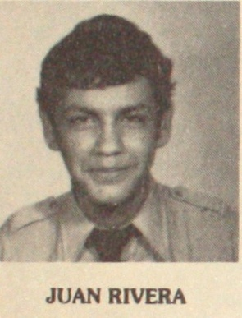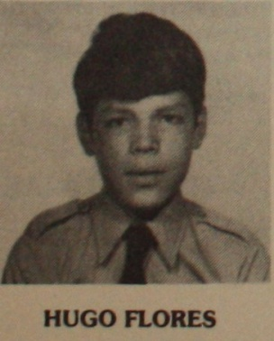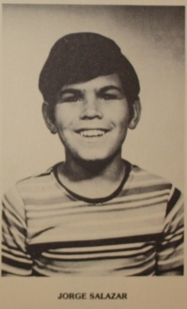
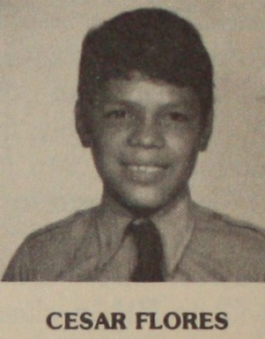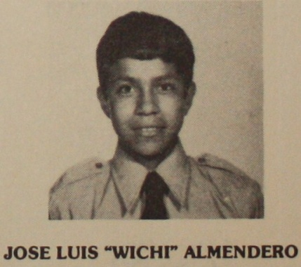
Five of the
“Eight Valientes”

NO WAY PLACES CHAPTER 33

Worshippers

Throughout our Rancho del Rey years we have had the privilege of baptizing those of our boys and the villagers who have taken Christ as Savior. It is always a joy to see them take the first steps of worship by obeying the Lord thru identifying themselves with Him in His death, burial and resurrection.
We have had baptismal services in placid pools under the luxuriant foliage of tree lined tropical streams, muddy ponds, swimming pools and even a cattle watering trough.
The cattle trough was a 10 ft. by 3 ft. concrete tank here on the Ranch that could be filled to about 28” deep. At one particular time the scene around this tank climaxed a glorious week with a visiting minister who dealt with the boys and led many of them to Christ. What joy filled our hearts as we walked down the lane in the orange grove, singing His praises, on the way to the Baptism service.
It took me back in time to a similar experience when I was a young girl. I had been a Christian only a short while and was exuberant in my first love for Christ. Everything the Lord said in His word seemed so exciting. I followed Him in baptism just as soon as I could.
However, the baptism that impressed me most took place a short while later. It was held at a pool in a beautiful garden. The air was scented with spring flowers. The trees, tall and graceful, shaded the pool’s crystal clear waters. There was a reverence in nature all about us that eloquently spoke of God’s greatness in a unique way.
The group standing around the pool raised their voices in song:

“Thousand, thousand praises be…
Lord of Glory, unto Thee…”

There were those there that day that were not with our group, but they stood quietly by, reverently listening.
The preacher was a little man but he was big spiritually. His message made him tall. As his voice rose and fell, it was like ripples of glory to those of us who followed every word. Even now I remember how he preached on Phillip and the Ethiopian.
He reminded us that God told Phillip to leave Samaria to go down to the southern desert. Phillip was led there to an Ethiopian eunuch, treasurer of the court of the Queen of Ethiopia. He had been to Jerusalem to worship but was returning unfulfilled. He had not yet found the One to worship. But God was moving in the affairs of this man as He always does whenever He finds a hungry heart.
The Ethiopian was reading a portion of Isaiah but not understanding of whom it spoke. The Holy Spirit said to His Messenger, “Go near and join thyself to this chariot.” So Phillip ran!
The Scripture he was reading was speaking of the suffering, silent Savior and Phillip was able to win the courtier’s heart to Him. The Ethiopian came to a knowledge of Christ as Savior and was baptized. He went on his journey now with his mission fulfilled. He had at last learned how and who to worship!
Carmelita was another one who had no way to worship. When we first met her, several years ago, she wasn’t even involved in the religion of the land that she had grown up in. The church played very little part in her everyday life. Her husband, their three children, her cows and a bunch of dogs were her world.
She despised housework, but she knew how to handle cows. With them she supplements her husband’s small income.
Carmen was very receptive from the first time I visited with her. She invited me to have a cup of coffee topped with creamy milk fresh from her own cow.
I felt a deep desire to reach her for Christ, but felt so insufficient. Her world seemed so far removed from mine, but I left tracts and spoke a few words which I hoped to follow up on later.
Little by little, this neighbor’s world and ours began to merge. Carmen’s cows needed pasture. El Rancho del Rey had some unused fields and allowed her to use them freely. Carmen was grateful. Then, too, our pickup truck was seemingly always running back and forth on errands. Sometimes we happened to be going to the village just when Carmen would be needing a ride. When we built the log cabin camp and the swimming pool, Fidel, Carmen’s husband, worked faithfully with our boys until this project was complete.
As a result of our paths crossing frequently, a Thursday afternoon Bible class emerged. Carmen began to study the Word with me. Week after week we read through the book of John and then Acts. Carmen found it as easy to accept Christ as the Ethiopian eunuch had, once she understood the Word. She wanted her children to learn the Word too and has been inviting her sisters to the class.
We are amazed at the way God helps us as He did Phillip and the Ethiopian to see Christ on every page.
Sometimes we have to skip our Thursday class if I happen to go with Hank to McAllen on his weekly flight. When we do, Carmen says she really misses our time together meditating on the Scripture. She feels that these times are the highlights of her week. She is convinced that the Word of God is truth. Her prayers have been getting answered and God has revealed Himself to her in many special ways, confirming to her that she has found the right way. Knowing and understanding the Scripture is something that she had never experienced before. She considers the Bible her greatest treasure.
Like the Ethiopian eunuch, Carmen has found the way to worship.

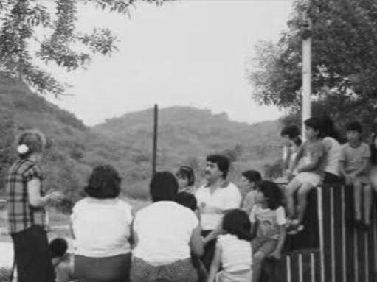
[Anne Moller and the Village Ministry]



NO WAY PLACES CHAPTER 34

A Song

The two weeks’ “Time out” from El Rancho as my sister’s guest on an airstream trailer caravan trip in Mexico was a great experience. To me it was an additional eye-opener to the beauties of the country that I love but needed to know better.
I still feel a wanderlust when I recall the fantastic sight of dozens of silver trailers winding down the road from Reynosa to Victoria then down the coast to Tampico, Tuxpan, and Vera Cruz. The caravan continued on to Campeche and then to Yucatan Peninsula, home of the ancient Maya Indian civilization. Alas, my time was limited so I could only stay with them as far as Vera Cruz. Meeting so many caravaners and sharing our pleasures over what we were seeing was fun.
Palm trees, banana trees and little children all waved as we traveled along. Soft breezes sang their greeting to us from off the Gulf of Mexico. We felt welcomed by God and man.
Ciudad (City) Victoria was our first stop. We stayed there two nights while the days were filled with sightseeing and tours. This gave me a chance to go off from the Caravan to buy some tortillas and chile and to hand out Gospel portions. People were friendly and receptive. If a tract dropped to the ground, someone would stoop down to recover it. A group of children playing in a garden agreed to meet me later that evening to listen to a Bible story. They were told that they could invite their friends.
The boys never tire of knocking on the silver Airstream trailer door, because they know that they will be greeted by smiles and love, and they will go away with some “goody” besides.
At night, while Jocelyn and Arden are parked in their trailer on El Rancho, the light in their kitchen shines out of the window and lightens the path from our house to the dining hall. One night, the week before their last visit, as I walked in the dark over to the shop where Hank was working, I stumbled and fell over a hose. It was nice to have the light of their trailer shining out during their stay.
Like the boys, I enjoy knocking on their door because I know I, too, will be greeted with a smile and love.
I give thanks for the privilege of praising God. There is a little song that we sing here that says, “Las alabanzas de Dios cambian las cosas,” “The praises of God change things.” The song goes on to say, “Walls have fallen down, armies have been defeated, and prisoners have been set free when they PRAISE God.”
And we could add, the praises of God made a way for us and our Rancho del Rey children to find a place in these Airstreamers’ hearts.

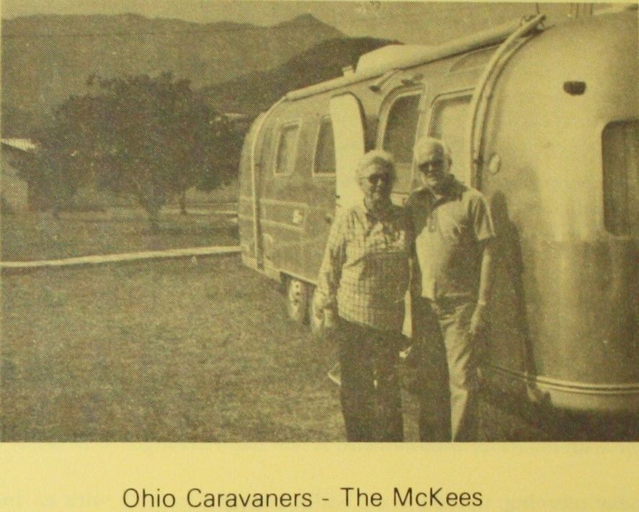

NO WAY PLACES CHAPTER 35

Another Chance

After their trip to Yucatan, the Airstream Caravaners came back out of Mexico through Monterrey. Some of them came to visit nearby Horsetail Falls and El Rancho del Rey. Once again I was in contact with them. They invited me to join the Caravaners in Harlingen, Texas, for the final events before the Caravaners disbanded. There would be s skit night and a banquet night. Danny and I were happy to have this privilege of being part of the caravan for a few days before the disbanding.

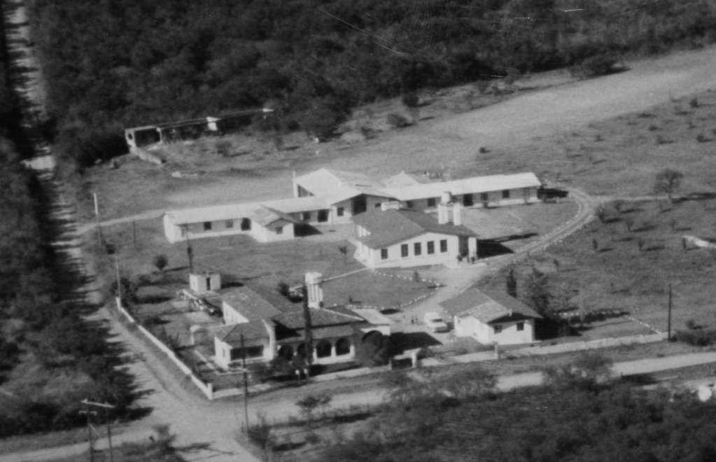
El Rancho del Rey From the Air

As they were planning the skit program, my sister suggested that I sing a song in Spanish. The lady in charge thought the idea acceptable and agreed. On the night of the program, just as it was to begin, she asked me what song I would be singing. I said, “It’s a hymn.”
“Oh,” she said, apologetically. “I’m sorry, but we can’t have you do a hymn.” We can’t have anything religious on skit night. Can’t you sing a popular Mexican song instead?”
I had to admit, I couldn’t. I only knew choruses and hymns.
My sister suggested, “It doesn’t matter whether it is a hymn or not. It is in Spanish. These Americans won’t know the difference.”
“Well, yes, I suppose that’s true,” the lady in charge agreed. “Just go ahead and do it.”
I had been given permission, but something inside of me backed down. I began to think of these American Caravaners as very important and dignified people whose trust I valued. Perhaps they would not be pleased with me if I tried to be sanctimonious on skit night. It just didn’t seem to be in tune with their activities and I didn’t want to look foolish.
All I needed was the courage to forget myself, and lift up Jesus. But my fears won and I decided not to sing my little song of praise.
After the program, my conscience bothered me all night. Sleep was hard to come by. I had been given an opportunity to serve the Lord and I had refused. I felt like a traitor. I had denied my Lord!
What bothered me more than anything else was the feeling that there was no way I could tell the village people back in Mexico that they should be faithful to the Lord and never be ashamed to confess Him before others. After telling them this so many times, I had been guilty of that very thing. How was it that I had the courage to confess Him, to sing His praises among the poor in Mexico, and yet I did not have the courage to do the same thing before these more affluent Americans? Did I think God was only good enough for the poor? Wasn’t He sufficient for the Caravaners too?
Repenting for what I had done, I decided to ask the banquet committee if I could sing a Spanish hymn as part of the program in the banquet. To my amazement, the answer was “Yes”. I was to sing my hymn as the parting benediction.
If it would have been difficult for me to sing on skit night, it was now twice as difficult for me to face the caravaners in this formal affair. Everything and everybody looked super elegant. I felt so inadequate!
However, I now had something going for me much more so than I had the night of the skit. On skit night I wanted to sing with the secret hope that I would get a chance to present the work of El Rancho del Rey. As it ended up, I lacked the courage to go through with it. Now all I wanted was another chance to confess the Lord before these people. He was there to give me strength.
At the last minute, I decided not to do the hymn I had practiced. A little gospel chorus kept going around in my mind. The tune was lively enough for the occasion, and expressed my spiritual desire for these caravaners to whom I would be bidding farewell.

“Quedate Señor, quedate Señor
Quedate Señor, en cada Corazón
Quedate Señor, quedate Señor
Quedate Señor, en mi…

Cristo mío haz en mi alma
Un altar para adorarte
Con devoción, para beber
Así saciar mi pobre Corazón!”

“Tarry with us, Lord
Tarry with us, Lord
Tarry with us, Lord, in every heart…
Tarry with us, Lord,
Tarry Lord, with me…

Oh Lord, make an altar in my soul
So I can worship you with devotion,
So that I can drink of the water of Life,
And thus satisfy my poor thirsty heart!”

Some of the caravaners must have understood because they seemed pleased even before I translated the little song and sang it again. My testimony came out with joy. All fear was gone.
And what was more important, the guilt I had felt the night before was no more. I had peace and communion now with my Greatest Friend.
I can only praise God for what happened afterward. The people were so kind. They pressed upon me their Mexican pesos left over from their trip, then they took up a collection besides. Danny and I were both given a bike to take back to the Ranch.
However, there was still one more problem. How would I get the bikes into Mexico?
I thought that perhaps Hank could disassemble them and take them in by airplane, but after talking that over with him, that was out. They would fit better in a trailer.
Had not God given us the bikes? Would He not make a way?
My sister and her husband had decided to come back into Mexico and visit with us for a few weeks before going home. When we crossed the border with the bikes inside the house trailer, none of the inspectors questioned us about them. So many trailerites carry supplemental transportation that they caused no concern.
Eight years have come and gone since then. The bikes are still in use. They have been broken down and repaired many times. Every time I see a boy racing along on the one I used for a while to distribute tracts in the villages, I am reminded of the caravan and the time God gave me “Another chance.”

NO WAY PLACES CHAPTER 36

The Kingdom

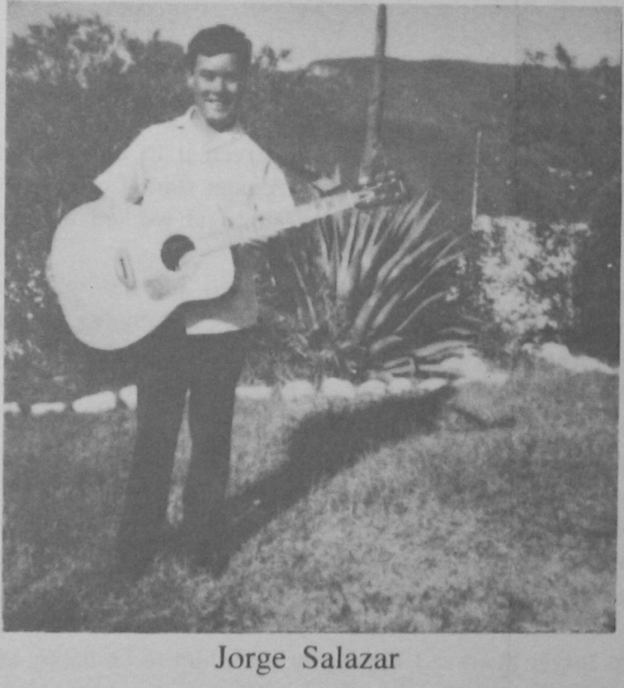

Jorge Salazar lives in the village of San Pedro, just up the road from El Rancho del Rey. He has attended our services for years.
As a small child, Jorge nearly drowned. As a result of oxygen starvation and brain damage, he could not learn in school. His parents made repeated attempts to send him because in some ways he is very normal, even clever.
One of the areas in which Jorge is outstanding, is in musical ability. He first began to show this talent years ago by playing a mouth organ. He got great pleasure out of playing along in the services. Later, someone from the States sent him a nice new harmonica, which he treasured for a long time.
Soon after he mastered the harmonica, he began to strum the guitar. It wasn’t long before the others wished that they could do as well. He was the envy of all.
After mastering the guitar, he had his eye on Benjamin’s big accordion. It was a joy for him to accompany the accordion with the guitar especially when the singers were his favorites. He loves harmony and seems enabled by the Lord to hit the right chords. He plays best when people sing confidently.
In spite of his desire to play the accordion, no one seemed to believe that he was capable of doing it. After a considerable length of time, we were surprised one night when he walked into one of our services with a small accordion. Someone in the village had given it to him, and he had been practicing. He sat down and to our amazement started to play as though he had always done it. The Lord had provided and worked for him again!
Jorge’s family has not been in favor of his interest in our evangelical activities. They tried many times to discourage him from visiting us and attending our meetings. They worked on “encouraging” him to attend their church. They were very upset, when on his own, he refused to conform to the confirmation and other church rituals. There was no way for him to make them understand how much the gospel meant to him.
On one occasion, when Jorge was refusing to be forced into church attendance, his mother became hostile. I felt led of the Lord to go to her and to have a talk.
“You love Jorge, Señora, I know you want him to be happy and you want him to be accepted and blessed by God. You are afraid that God will punish him for not conforming to the church.”
“Yes,” she admitted. That was true.
“You must believe that God, who created Jorge, understands and loves him just as much as you do.” She was willing to go along with that.
“He loves Jorge so much that He sent His own Son to this world to seek him and to die for him, so that Jorge could be accepted and belong to God. Jorge has accepted the work of Christ as His Savior as the Word of God says we should. The Bible says that Jorge is HIS child through faith in Christ.”
“God accepts Jorge on the basis of what HIS own son, Jesus, has done for Jorge. If that is true, then Jorge doesn’t need the church to make him right with God. Jesus is at the right hand of God Himself interceding for Jorge day and night.”
I believe the Spirit helped her to understand. I think she saw that if God accepted Jorge without the church, she, his mother, could accept him too.
After that, Jorge was allowed to continue to join us in our services, and no one seemed to worry any more about his conforming to the church’s rituals. He went on playing his accordion and his guitar to his heart’s content.
Jorge’s brothers are very handsome, intelligent young men who have good jobs and live normal lives with their families and children. Jorge is the only loner and still lives at home. In a way, one feels that he has more than the others, though he has nothing and they have everything, because he is an instrument in the hands of the Lord to remind people of their need to worship God. His childlike faith in Christ and his sincere desire to worship Him are an inspiration and a challenge.
One of his unfailing requests in our services is that his family will one day believe the gospel and accept Christ. I believe God will answer Jorge’s prayers.
Jorge is always willing to be helpful and he has a wonderful spirit of gratitude. He never seems to expect special attention and he is always grateful for any little attention that he does get.
He loves to use the few English words that he has learned, especially when we have American visitors. One of the expressions that he has learned perfectly in English, due no doubt to his grateful spirit, is “Thank you very much.”
It is amusing, also very heartwarming, to hear him say, when he is doing someone a favor, “Thank you very much!” He will say this with a happy grin right after he has just carried a pile of clothes over for you, or right after he has gotten back from a jolting ride over bumpy roads, and patiently stayed with you through three or four services, always ready with the guitar or accordion when you needed accompaniment. He has in his simplicity and willingness to serve, caught the secret of greatness. He counts it a privilege, not a bother, to carry the milk to the kitchen from the pickup. He loves to help with your bags and things and he’ll thank YOU for the privilege.
More so than most normal Christians, Jorge, in serving others and living to praise and worship God, has unconsciously discovered what it means to “Seek ye first the Kingdom of God.” The result has been that he is blessed; a light shines on his face and a childlike thankful spirit rules his life.

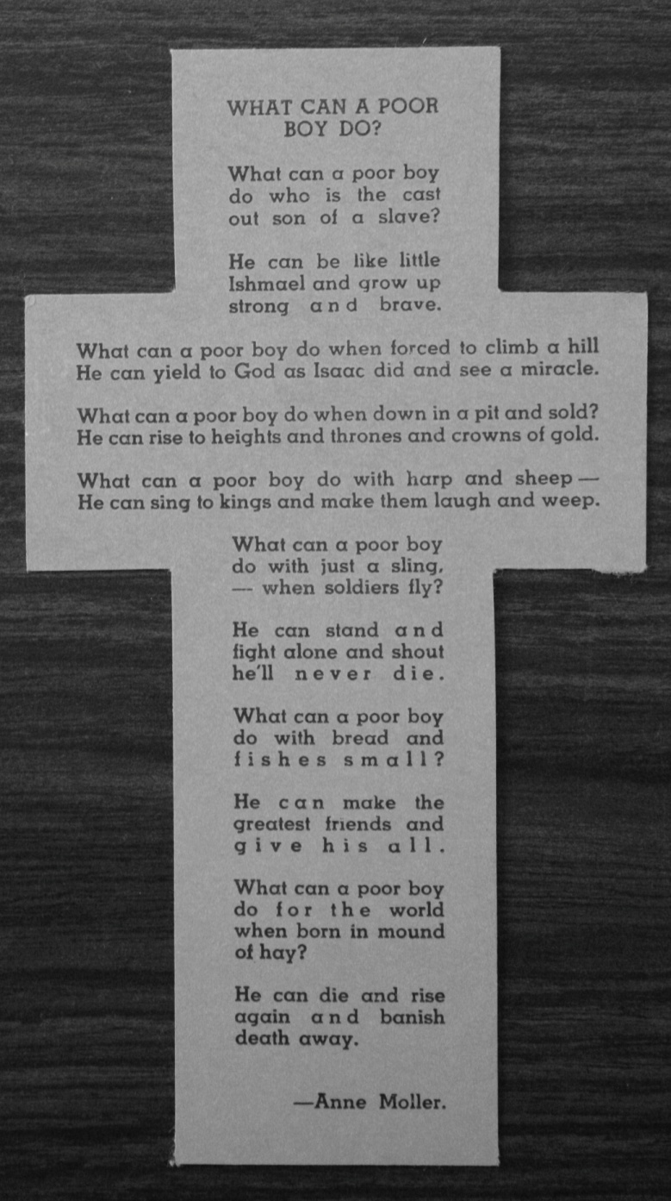

NO WAY PLACES CHAPTER 37

Fishing

Pedro and Wichi were brought to us when they were six and five years old respectively. After their arrival, as their mother left to walk back to take a bus into Monterrey, they cried broken heartedly. I can still picture them taking off their shoes and throwing them out through the gate as though they were trying to reach her with their shoes.
One can really sympathize with a child who feels that their little world is tumbling down around them. Emotionally tossed about like a ship at sea in a storm, they view even the people who are trying to console them as a threat. They often are left feeling more alone, frightened and hostile.
Not all children react this way. Sometimes those who seem the most tempest-tossed are the ones who adjust more quickly.
This was true of Pedro and Wichi (Jose Luis). They became very attached to Rancho del Rey. After their first shock of being left by their mother, they adapted easily to our way of life. They liked the regular delicious meals, the animals and the nearby creek. They soon made friends on the Rancho and at the village school.
They loved the wide open spaces, the orange trees and the chile hunts. They soon were gathering the wild chiles and selling them in the village in little plastic bags. Sometimes they would sell them to passersby along the highway. They use the money they earned to buy little snacks for themselves and their friends.
Pedro loved to communicate. He was very talkative! He liked to tell you about all the things he was doing and what he was going to do. Whenever he was on a work detail, like cleaning trees, he would stop to talk about this and that until you got the impression that he would rather talk than work.
But persistence is a winner. As the years went by we noticed that Pedro became a very good worker and seemed to build self confidence by his attainments. He would be relied upon to help whenever a hand was needed to unload the pickup or in other tasks. He was cheerful, helpful and appreciative.
Pedro is now a full grown man with a family of his own. He visits occasionally. He is always happy to recollect those Rancho del Rey days when he was growing up: the times in the village school, the happy times he spent with us in our Bible times learning the Scriptures, singing choruses and listening to the Word of God. He recalls the many hours he spent along with the other boys out on the airstrip playing soccer or baseball, the times when they went swimming down in the creek or at the nearby swimming pools.
One thing always brings a happy grin to Pedro’s face as he remembers and discusses those childhood days. That happy memory is his fishing times, for he was the best fisherman of them all.
Pedro did not use pole or net, nor did he even have a hook and line. He preferred to use his bare hands or an old gallon size tin can. He always came back with fish. Of course an eight incher was a whopper in our creek, but to our boys it was a real accomplishment to bring back these trophies. Pedro was our achiever as he slowly moved his bare hands under the creek bank or rock overhangs. He could grab a fish or maneuver it into the supposed safety of his tin can.
Pedro’s joy was in the catching, not in the eating, as he never ate any of his prize catches. He would say, “No me gusta comerlos.” “I don’t like to eat them.” He would grin and watch the other boys enjoy the fish he had caught. He wanted to make his friends happy. He enjoyed catching and giving.
JESUS said, “Follow ME and I will make you fishers of men.” As we go into the villages to be fishers of men and women, boys and girls, I would like to be as good at fishing as Pedro was. He didn’t have to have a lot of expensive equipment to catch fish. He loved fishing so much that he just went off and fished without anything except himself, his bare hands and his rusty little old tin can. It was his enthusiasm for fishing that made him come back every time with fish.
Pedro didn’t have a lot of accessories, just a tin can. When we go into the villages, we don’t have a lot of expensive equipment to fish for souls…sometimes when we are standing out in the open air by a pile of rocks preaching to a crowd of children with their mothers, we feel like Pedro must have when he went fishing with his bare hands. But we LOVE it! There is a thrill about looking up into the clear blue sky and feeling so close to God that you can touch Him, feeling as though the words you are saying are being breathed into you by the Spirit.
Sometimes there is no one else to go along to help with the music and the singing. When you are standing there alone, you need to remember what Pedro did. He knew that he could do it with just his little tin can.
A lot of people might have thought the tin can wasn’t worth much, but Pedro knew it was. Perhaps there are a lot of things we do not have, but there is one thing we DO have and it is very wonderful for catching and holding the fish: the Word of God! The more we use it, the more we realize just how effective it can be; the more we realize that other things are superfluous.
I am convinced that what we need to catch more fish is more of the Word of God and a love in our hearts, like Pedro had for fishing.
How important it is too, to remember not to be fishing for ourselves, but for OTHERS and for The LORD.

Who Told the Wise Men?

Who told the Wise Men
About the little King
Who came from Heaven
And made Angels sing?

Who told the Wise Men
The meaning of the Star
That sent them climbing mountains
On a journey far?

They must have read the Scriptures
(Those who read are wise)
“A Star shall come out of Israel…
A scepter shall arise”…

Arriving in Jerusalem,
They asked “where shall we go?...”
To see the little Newborn King”
(…No one seemed to know!)

Again they searched the Scripture…
“In Bethlehem!!” it said.
The Wise Men paid attention
And followed what was read.

…While other men were sleeping
Wise Men from afar
Found JESUS in a MANGER
Beneath a Shining STAR!

God who told the wise men
Still speaks to men today
To those who seek the savior…
The Scripture points the way.

…Anne Moller

NO WAY PLACES CHAPTER 38

Pioneer

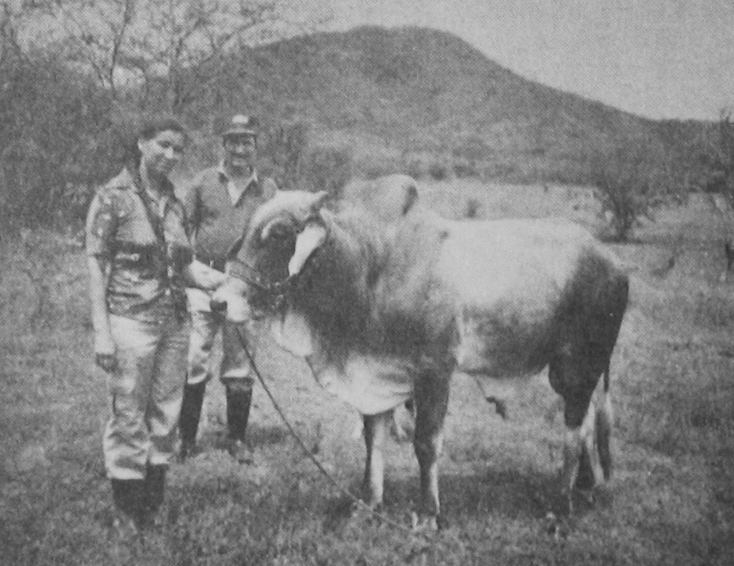
Carmen & Fidel Silva

As well as serving the boys, El Rancho del Rey reaches out to the neighborhood about us. Our fields are loaned out to some for their cows; our doors open to their problems, our vitamin closet their source of help, our meetings open for them to attend and our God always ready to show Himself strong on their behalf.
A couple of hundred yards down the road from the Ranch House live Carmen and Fidel. Fidel is an excellent block mason, while Carmen minds the house, the children and the livestock in reverse order.
On Sunday nights Carmen is usually in the gospel service in the Ranch dining hall. She’s accompanied by some of her children and often by her husband Fidel. Carmen especially enjoys the meetings when we have visitors from the States who have messages that really touch the heart.
Carmen continues to come out to the other meetings. She enjoys the Lord’s Supper and private Bible studies on Thursdays. We have been having wonderful experiences reading the Word and discussing it together.
She likes to bring her three children along with her so that they too will learn the Word of the Lord. It is during these times that we talk about the things of the Lord and share together the different experiences we have had through the week.
She has testified that one time she was quite ill but the doctor’s medications had not produced any improvement. She was very discouraged and could hardly take care of her cows. She grew up working with animals on her father’s small ranch, learning to milk and to take care of them. This, to her, is a great joy and she much prefers working with her cows in the outdoors than doing housework. She laughs about this but has no intentions of changing her way of life. Fidel sometimes would make remarks about the housework not getting done but seems to be reconciled to his fate and resigned to this wife’s career as an excellent cow girl and not so excellent housekeeper.
On this particular occasion, when Carmen was ill, she became unable to take care of her cows or anything else. This made Fidel’s days very difficult. Both he and Carmen needed much prayer and quick answers.
About that time, Pastor Shoffner, from Carthage, Texas, came down to visit and to hold services. One evening Carmen asked for prayer. God answered and Carmen began to recover. As she grew stronger, her faith strengthened also.
As a result of this experience, Carmen began to talk more and more about how that the gospel which we were teaching was widely apart from what she had grown up with. She became more involved in reading the Word and began talking about it to her sisters and family.
Carmen has a brother who has a drinking problem. It has always been her deep desire that he would overcome this problem. Her parents have tried so hard to make him change his ways, but to no avail. Felipe continued with his drinking habits and with his companions who encouraged him in this.
Carmen had harbored the expectation that Bill Belli of Pennsylvania would be able to witness to Felipe and help him to really understand. Bill and Fay are friends of the work who return winter after winter to help with the painting and maintenance. Carmen felt that Bill would have an effect on her brother for Bill himself had had a great transformation by the Gospel.
When Bill and Fay returned, Carmen was enthused. She insisted that we all visit Felipe. We decided to go in the evening hoping that he would be home. He was!
We had a thrilling time as first one and then another shared with Felipe as the Lord gave us words. All of us were working together as in Bible days when a team of friends removed a roof to bring a friend to Christ. We were of one accord; we wanted to help Felipe.
In the midst of sharing our experiences, Carmen began to share hers. It was a revelation to see how deep had been her soul searching and long the investigation in her mind. She told how she had enjoyed the Word and was thrilled with the gospel. However, she sometimes wondered if she was doing the right thing to leave her traditions and the religion of her fathers.
She had studied about Paul. He had had the same problem. He devoted his life to upholding the traditions and religion of his forbearers. But one day, he met Christ on the Damascus Road. He had been blind in his zeal and shortly was made to see. The religion of his fathers was not set aside but, rather, made clear. Now he understood what the law and the prophets were all about. Now he understood of whom the Scriptures were speaking. Carmen was beginning to really understand who this Jesus was that she had heard about.
Carmen told the group of her continuing struggle; of the old fear of being a traitor to her family traditions. All of this haunted her and she wasn’t SURE…
Then, as her story continued, something happened in her life that helped her know without a shadow of a doubt that she was on the right track.
God, who made the animals, loved her and would use her love for animals to enable her to know and trust him more.
One of her bulls had been put out in our orchard to graze. He had swallowed a large orange and was choking. She worked with it trying to dislodge the orange but he was swelling up and would soon die. She was very upset as her cattle mean so much to her. She had worked hard with them and they help sustain the family. Now they would be losing one. It would be a heartbreaking loss for Carmen.
Carmen relates that suddenly she thought to pray. The prayer that fell from her lips was not something she had premeditated, it just poured forth from her heart.
“Lord, please let me know if I am doing the right thing believing the Bible and leaving the teachings of my family. If I am doing right, help the bull to live. If I’m doing wrong, then let the bull die.”
Carmen testified that just a short time later the bull coughed and expelled the orange.
Then she KNEW! She knew that she was on the right path. God was there in the orchard. HE had seen her searching heart and had heard her prayer. He had answered her in a way that would assure her that the Bible was the Word of God, that Jesus was a personal Savior who was interested in her problems.
For Carmen, that was the turning point. She knew that walking with her Savior and accepting the Word of God as truth was not being a traitor to her family. She was being a spiritual pioneer; leading the way for them to also know the truth, helping them to find their way, through personal faith in Christ, through the Portals of Eternal Life.

NO WAY PLACES CHAPTER 39

Bread Upon the Waters

Porfirio is the son of the farmer who worked for us during the early days of El Rancho del Rey. To the best of my recollection he was born on the property. As he grew up, he often helped his father with the chores and particularly with the milk cows during the time that we tried to supply our own milk needs. Years later, after futile efforts to make the farming venture pay its own way, we abandoned the idea. Our ground was just too poor and mostly shale. In our semi-desert area it takes ten or more acres to adequately support each head of cattle. Jose and his family left for other employment. They still respond pleasantly when we greet them in the village. They seem to have good memories of their Rancho del Rey days.
At the particular time about which I am writing, Porfirio was in his late adolescent years and was suffering from a festering open wound on one foot that would not heal. It threatened his well being and made it impossible for him to work or to meet the challenges of every day rural life.
Desperately in need, and not knowing what to do, he came to El Rancho del Rey for help. He remembered how we had often prayed about impossible situations - real no way out places - and had seen God do many marvelous things in answer to the boy’s and the staff prayers.
However, we knew that if we got involved with Porfirio’s problem it would mean taking on the responsibility for his medical care. We could not pray and then send him away without taking his need upon ourselves. Our faith, without works, would be dead. We were already struggling with the daily demands made upon our time and meager resources. Could we dare to try to take another mountain?
Porfirio needed our friendship and perhaps his healing depended on our decision to extend ourselves in his hour of need. Would we excuse ourselves and worm out? Was the Lord able to meet the need? Should we dare? We decided that God could and we would!
We prayed with Porfirio while seeking to help him medically. The doctors in the mission hospital in Montemorelos, a nearby town, said that an operation would be necessary. Part of the diseased bone was removed and he began to heal nicely. The wound closed and he was released from the hospital. He was warned that he would have to be very careful about cleanliness and keeping on with the treatments that they prescribed.
Perhaps because Porfirio comes from a background where poverty had been an overwhelming part of life and rules for cleanliness and personal hygiene are not easy to follow, Porfirio soon forgot his instructions. Re-infection followed.
He came back to the Rancho and was hurried off again to the hospital as an outpatient. An effort was made to halt the infection, but to no avail. He would do well for a few days then a reversal would set in. The doctors felt they were fighting a losing battle and feared for the whole leg. They decided that the foot would have to be cut off.
This was a real blow to Porfirio and to all of us who had been praying for his healing. We were believing that the Lord would undertake, but now clouds of doubt crested our horizon.
Porfirio’s faith seemed inspired as we drove home from the hospital, even though within a few days he was to lose his foot. We were very concerned that one so young should experience so great a handicap.
We all prayed earnestly and asked for divine guidance. We looked to Him to help. We did not want to be responsible for influencing Porfirio not to be operated on if the result that might follow delay would mean a greater loss, but we felt that he needed to look for healing from another avenue.
God led! A doctor in Monterrey was willing to scrape the bone some more and used medication not previously used. The wound healed. The foot was spared. We have no doubt that God worked on Porfirio’s behalf.
To this very day, when I see Porfirio walking around in the village, cheerfully waving as we pass, I remember what might have been. He might have been on crutches or an artificial leg. God overruled a, perhaps too hasty, decision of one medical team and directed the person seeking healing to another for help. The doctors can alleviate and treat pain but the ultimate source of all healing is God.
The Bible says, “Cast thy bread upon the waters and after many days it shall return unto you [Ecclesiastes 11:1].”
Years later, we had good friends visiting with us from Ohio. Tired and thirsty, we walked into a roadside restaurant after our village services. It was a Sunday afternoon when the Don Julian Restaurant is always crowded with people from Monterrey who are seeking to escape from the hot city. There were no tables or chairs available for us and we thought perhaps we would forget the cool drink and go on home to El Rancho.
Just then a young man greeted us, face all smiles. He got up from his table quickly and gracefully offered us his chairs. He had his wife and little baby with him. He seemed so proud and happy. Porfirio wanted to be sure we would be taken care of, even though it meant surrendering his own place.
It was a joy to see them, so young, so full of life, so willing to show their friendship and their love. The “bread” of friendship was coming back to us again.

Do This In Remembrance of Me

Jesus said, “This do…
This is my Body…
Broken for YOU!

Remember, when you drink the wine
How I poured out my life’s blood
To make you MINE!”

Does Jesus remind me
Because He knows how
My wayward heart
Can forget the part
I had in his broken body
And bleeding brow?

“This do in remembrance of Me”
Is His gentle plea,
“The bread and the wine are a token
Of my shed blood and body broken
To make you ONE with Me!”

“I have desired to eat this feast
With you,” Jesus said.
His disciples watched Him
As He broke the bread.

“Beloved ones, the time has come
When I must die, you see…
And as you eat this broken bread
By faith, partake of ME”

“My body shall be broken now
My blood be poured out too…
I take this blood red cup
And pass it on to you…”

“My broken body and shed blood
Will give New Life to thee,
Take, eat my body, drink my blood,
And be made one with ME”

…Anne L. Moller

NO WAY PLACES CHAPTER 40

Father’s Business

As missionaries, we are often asked to do things which we would rather not have to do. Many times we feel duty bound to comply with the requests because of our desire to befriend the people for the gospel’s sake.
At times we have to drop the activity that is important to us, and to the Ranch, for something urgent like taking a neighbor to the next town to a doctor, or something as mundane as helping a poor person move their belongings and furniture with our pickup truck.
When Cuca asked me if we would take her to the airport to pick up her daughter who was flying in from Dallas, I have to admit I was perturbed. The airport is about 40 miles away and Mexican airlines have a way of their own about arriving. The scheduled arrival was at an inconvenient time on a most inconvenient day.
Friday is my day in the City of Monterrey. It is the day I usually shop for the major purchases of foods, fruit and vegetables for the Ranch at the large open air market and other places. Usually a couple of boys accompany me to help with the packages. Afterwards, the boys and I have lunch at a pizza parlor for a treat. They love it and so do I. Then we go to a Bible study class in the basement of the Union Church in the stately old Colonia Chepe Vera before returning to the Ranch for supper and our Friday Night Service. As I said, Friday is my day and it is something I always look forward to.
Taking Cuca to the airport would mean skipping everything after the shopping and hurrying out to the airport to meet the flight. However, I decided that it was the right thing to do to try to help her out as there was no one else she could count on.
The day arrived. We left a little early to take care of the shopping. Cuca had her nine year old son along with her. It might have been a long afternoon for Luis except he found his own amusement.
We usually give out gospel literature in the poorer neighborhoods and among the village people. We wondered how the airport set, these well dressed wealthy people, some rushing, some waiting, would receive them. We passed out some tracts which, mostly, were politely received. Luis helped.
After a little while, we went to the airport restaurant for a cup of coffee. After his soda, Luis wanted a few more tracts to give out. He kept coming back to our table for more tracts. He was elated and smiling because some of the people apparently appreciated his determined venture. Perhaps being moved by his humble attire and not too well groomed appearance, they began to give him small coins. Being a poor boy and having lived all his days where money was a scarcity, he was all the more encouraged to keep sharing his precious papers.

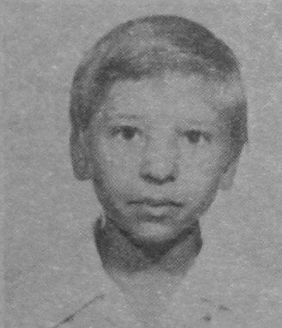

After three hours of waiting, the plane’s arrival time was still indefinite, so we wandered back to the restaurant again for a bowl of soup. Since prices in the airport restaurant are high, I thought soup would be within our budget.
While sitting there, still killing time, Luis decided he wanted more tracts. We noticed some Americans sitting nearby. They had also been in the restaurant several hours back, but they had seemed to be unaware of us. This time they asked if we spoke English.
It was thrilling t learn that these folks were Christians enroute to Mazatlan on the Pacific coast to preach the gospel. They were from Odessa, Texas, and promised to visit El Rancho del Rey in the future.
They called Luis over during our conversation, and told him how much they appreciated what they had seen him doing: sharing the Word of God with the people. Then one of the men handed Luis a bill. He was so overwhelmed he forgot to say “gracias”. It was a whole one hundred pesos.
The Americans joined us at our table and we had happy fellowship sharing our experiences while serving the Lord in Mexico. Time now no longer dragged. The atmosphere changed from one of impatience to one charged with joy and meaning.
Flight arrivals were announced. We all realized that our planes were about to arrive and we would have to bid farewell to these other laborers in Father’s vineyard: these who also knew the love of Christ and rejoiced in His mercies as we did.
As they were leaving, one of the Americans stopped back to inform us that they were going to pay for our supper! God was so good! Here we had wondered whether we could afford the soup we had ordered, and now the Lord was providing and paying the bill!
The same gentleman handed me twenty dollars saying he wanted to have a share in our missionary efforts.
So! The Lord fed us, gave us fellowship and paid our way to the airport and back. He always is willing to pay the way when we are going things for Him. He made little Luis happy and spared us what might have been a very frustrating wait. We were glad we had been busy about our Father’s Business. It made our day!

The Father’s Gift

“Before the World was, you loved me,”
Jesus prayed one day.
And yet, because God “so loved us”…
He gave His Son away…

…Away to a world of sadness,
Shackled by sin and shame…
Away to Bethlehem’s Manger…
To and “Old Rugged Cross” He came!

And while a host of Angels
Announced great joy on earth…
Was the Father grieving…
The Night of Jesus’ Birth?

He who was one with the Father
Throughout eternity
Was forsaken now for sinners…
Why was this meant to be?

It was because the Father knew
There was only one thing He could do…
(One way, sinners could be won)
That was when… “God so loved the world…
That He gave His only Son”

…Anne L. Moller

NO WAY PLACES CHAPTER 41

Morning Glories…
Or Entanglements?

Back in the States, we called them Morning Glories, but here in Mexico the people call them “enredederos” – “entanglements.”
Several years ago, we learned the reason why they were called “entanglements.” Suddenly, Morning Glories” began to grow wild in our orange orchard. At first we thought they were so pretty, until we noticed that, little by little, those beautiful flowers were twining round and round the limbs and boughs of the orange trees, slowly choking out their lives. Left there long enough, the tree withers us and dies.
There was no way to keep those beautiful flowers and also save the trees. It would have to be the temporary delight in the Morning Glory or the enduring repetitive fruiting of the orange tree.
The boys pitched in and helped as we tackled the problem. We plucked the vines from the trees, tearing them down and pulling them up by the roots. It seemed a shame to sacrifice such a beautiful flower! However, a choice had to be made: it was either the passing Morning Glory or the tree.

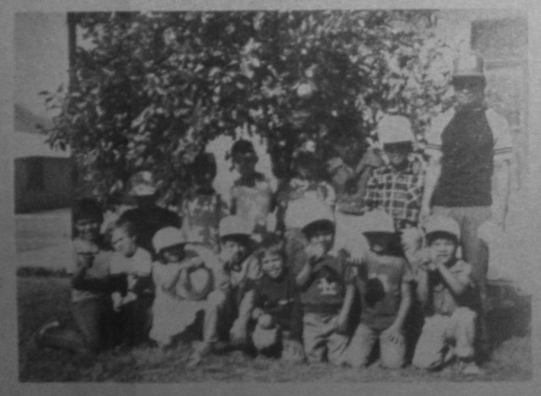
[God’s Pruners]

Pretty soon the orange trees were bursting forth with blossoms perfuming the air and delighting the senses with the promise of delicious fruit. These blossoms had a purpose that the Morning Glories did not have. The blossoms would soon turn into little pea sized green balls that in eight or nine months would develop into full round, juicy fruit providing vitamins and substance for the children.
While the Morning Glories were allowed to grow, there was not a chance that one could sit beneath the trees and enjoy the shade. Now that they were cut down and the weeds hoed out, there was room for the children to play or rest and it would be easy for them to pick the fruit.
Morning Glories are all so often typical of the passing pleasures and attractions in our lives. They seem so pleasant and beautiful. Why would anyone want to deny us these things? The flowers appear so innocent, so innocuous.
Why should there be a chopping and uprooting of our pretty flowers? Our little secret sins, our pride, our selfish plans…all spoiled…our self esteemed beauty and over estimated greatness cut down…rooted out. Who did it? Who cuts down all those Morning Glories?
God Does it!
God cuts them down because He wants us to be strong fruitful trees. He does not want us to be adorned by beautiful little entanglements to our destruction. He wants Christ in us to grow and to bring comfort and food, rest and protection to the weary and the hungry about us!
As we go to the villages, our hearts are burdened as we see the needs among the people. Some are sick, some are lonely, some are being destroyed by little nagging sins. We see the young whose eyes shine with expectation, but we watch them in a few short years as the light of their faces dies out as the entanglements of sin overwhelm them.
But there are those who come to hear the Gospel. Some of those who listen and believe allow the Holy Spirit to remove the Morning Glories, the entanglements from their lives. They begin to be like trees planted by the River and give fruit in their season. Things they do begin to prosper. Their fruit is not withered. There is a beauty about their lives. They are vibrant, strong and a blessing to others.
Come along and meet the believers of the Church in San Jose. A few years ago, we met beneath a tree in this little town. Now we are meeting in a small rustic tin-roofed building. The walls are of rough bark slabs; leftovers from the squaring of the logs at a nearby sawmill. It is a humble place and the people are poor, but they have learned to GIVE. They are finding out what a privilege it is to live and grow in the Lord and to bless others. They are giving to the poor all around them, and God is causing the village of San Jose to be lit up with the Gospel because of His Trees who have had the Morning Glories cut down from around them.
The prunings of God are done with purpose and in love. He does not wish our growth to be stifled with the entanglements we foolishly wrap ourselves in. He knows all about the grass that withereth and the shortness of the glory of the Morning Glories. So He tears all of these things away from us sometimes leaving us feeling barren for a season. Does it not seem like all the beautiful things have been taken away?
Ah, but not so! In a little while we feel a new surge of life flowing through us. The dead Morning Glories can no longer sap our strength. We no longer struggle to stay alive spiritually. We are not being bowed down by earth things. We are lifted up to praise Him! We feel a new freedom, a glorious reason to be alive. The Glory now is HIS!
Whereas before it was the Morning Glory that everyone could see, now it is the Tree. The blossoms fill the air with fragrance; the fruit brought forth is HIS.
Yes, Lord! Cut the Morning Glories down!

Travail

A cry of pain…what can it be?
This sound of restless agony?
Another cry…the night wears on
And then, the JOY! A Son is born!

My God why hast thou forsaken me?
Jesus cried from Calvary,
The heavens were dark, creation wailed
When Christ, the Son of God travailed!!

No one else could enter death like He
And rise to set the sinner free.
No one else could bear the shame,
The curse, the loneliness, the pain…

But “He shall see the travail of His soul”…
While countless years and ages roll…
Alive and reigning up on high
Are sinners who had been cursed to die!!

…Anne L. Moller

NO WAY PLACES CHAPTER 42

“Stay the Course”

We circled around once before making our landing.
The wind had blown out of the north very strongly all morning. It pushed our little plane rapidly along on its south bound flight as we returned from Dallas.
After clearing customs at Del Norte Airport in Monterrey, we were just minutes from landing at El Rancho del Rey.
There was just one mountain range to cross. But because of the fierce winds, another thousand feet of altitude was needed to avoid turbulence above the mountain pass. With just a few miles to go down the valley to our airstrip, the extra altitude plus the pushing winds would call for an excessively steep and fast descent or a wide, sweeping, circling, 360 degree turn to allow us to lose altitude at a more comfortable rate.
It so happened that our circling was over the little village where in a few minutes we were due to have a service. It attracted attention! Many saw the plane, others heard or were told and started out for the little church.
As we pulled up in the pickup truck, it was a joy for us to see them sitting on the benches ready to worship the Lord and to listen to His Word. This day the place was packed out. It is a privilege to be able to share the goodness of the Lord with them; to encourage them to leave the things of the world behind and to go on with the Savior.
It is always a blessing to be a blessing. Many Americanos have helped us to bless and be blessed in sharing the wonderful clothes that they send to us to meet the needs of the people in these little towns. They are poor folk but rich in gratitude. This year we have rejoiced as we have seen the people themselves learning to give to others who are even less fortunate.
What a thrill it was at Christmas time to take a warm coat, and the money that the believers had given, to the little blind lady who lives near the church. That morning she was sitting close to a fire of little sticks trying to keep warm yet afraid to get too close because of not being able to see and fearful of being burned.
I think also of Juan, who had been having attacks, having also been showered with love gifts, kindness and prayer by the Lord’s children in that little church. Then there is Marti, the little girl who was crippled by an adverse reaction to an inoculation. How they support her by prayer and love. To see the Lord’s children reaching out to others is to see them grow. The joy is akin to watching your own children’s first steps!
In retrospect, I look back on the early days of our gospel efforts in this little town of San Jose de la Montaña over ten years ago. Ernestina was the first to open up her heart and home to the Word of God.
She had been saying “No” to members of a cult. But she wanted to hear the Word. God led us to her and she rejoiced in the new fellowship provided by the Lord. She was so happy and so were we. For a while we preached on her terrazza, then beneath a tree. Others received Jesus as Savior and the little group grew. After a while, a way was opened up to build the little simple church.
The work grew, but not without the enemy’s attacks. There were discouraging times when things looked dark and bleak. There were mockers and trouble keeping order. Young people would come to play, talk, and socialize. There were mixed up lives and poor testimonies. It was hard for the people to break away from their ignorance of God’s Word.
Gradually, the bigger storms subsided and barriers were broken down. They loved to sing the beautiful, meaningful choruses and hymns. They learned from these scriptural songs and from the Scriptures themselves.
They were quick to memorize the Word. We would be inspired ourselves as we listened to the children, the young people and the grown-ups quote verse after verse and sometimes whole chapters. They learned to bring their requests and make them known to God. God answered prayers. Now at last they were learning, not just to receive, but to give. God is good! His Word does not return void.
I thought of the recent time when Hank was counseling Danny about the dark stormy times he would certainly face while away at Bible school.
Hank said that when he is flying on instruments and the clouds get black and bumpy, it’s probably a storm cell he’s entered. But one doesn’t usually turn back and you CAN’T quit. Stay on course!
He said, “You don’t turn back; it can only last so long. If you try to turn back in the turbulence, it’s doubly hard to keep the airplane under control. You may tumble your gyroscopic instruments and end up totally disoriented, not knowing up from down.”
Continuing, he explained, “Also you are not getting anywhere. It took you X number of minutes to get to where you are and it will take you at least another full minute to make a safe 180 degree turn, if you can, and you’re still nowhere but directly opposite where you started the turn. You still have to go back the amount time it took to get there. Proceed straight ahead on course and you’ll soon break out of the storm.”
“Don’t give up! Go through the experience with the Lord’s help. You’ll learn about yourself and about the Lord’s faithfulness.”
That is good advice for life; especially for missionary life. When it looks like there is no way through the storm it’s best to keep on going. You’ll soon break out into clearer skies!

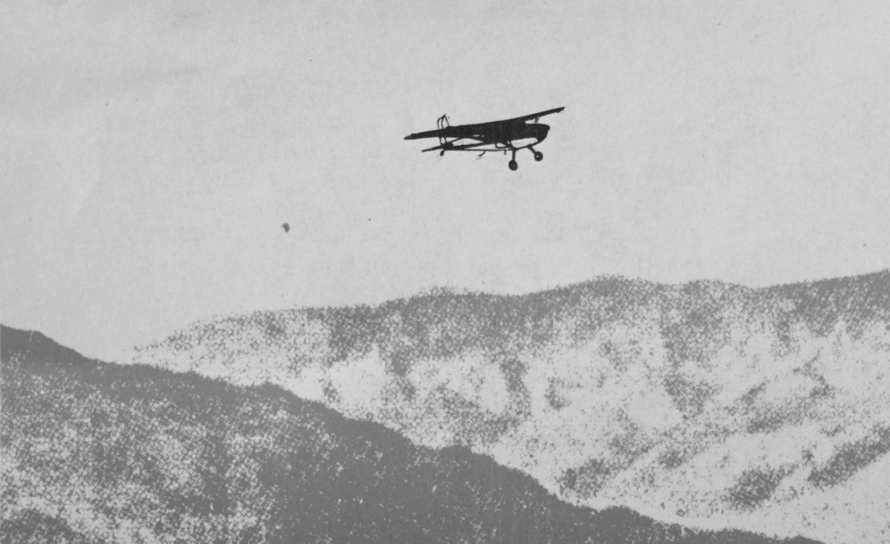

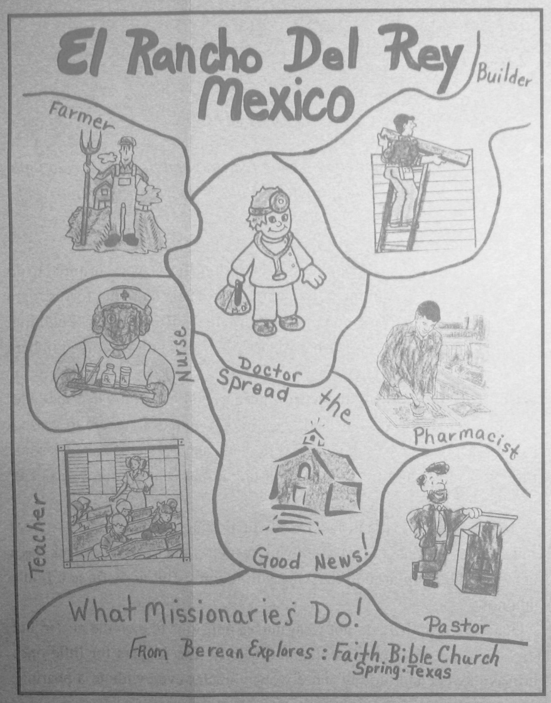
“What Missionaries Do”
[Poster created by a Sunday School Class at
Faith Bible Church in 2004, from Way Places 196]

Epilogue

We have concluded Anne Moller’s history, somewhat arbitrarily, with “No Way” Places, Chapter 42, the issue of February 1984. Anne would continue to write “No Way” Places from that date until April 1994, primarily as a newsletter, rather than strictly a history of the missionary work in Mexico as it was originally intended. In May 1994, the title became, just Way Places. Explaining the change in title, Anne wrote that [Ed.]:

With this issue we are revising our cover page title to widen our scope of subject matter and more accurately reflect our experiences. The Lord will always be our GOD OF THE IMPOSSIBLE, THE MIGHTY ONE of our NO WAY PLACES and of the WAY PLACES of our journey with Him!

Within these first 42 chapters of “No Way” Places, most of the major historical events of the first 28 years of El Rancho del Rey history had been written. Although after that, “No Way” Places, and subsequently Way Places, continued to contain occasional historical tidbits, they became primarily newsletters. However, that is not to diminish the importance of the events that are covered in those newsletters; Anne always considered the work of the Lord in peoples’ lives far more worthy of her literary efforts than mere temporal history. Of course she is right, but with Chapter 42 her early history of the mission of El Rancho del Rey, as it was originally intended to be, is mostly complete, and this book is brought to a conclusion.
Anne L. Moller passed into Glory on January 31, 2010. As her physical abilities waned in her later years, she had to give up most of her village ministry, and found it difficult to participate in the daily activities of El Rancho del Rey itself. However, she continued to write the Way Places each month until the last few years of her life, when her very capable son, Danny, took over the writing and continued with the themes and in the style of his mother. Anne never wrote an epilogue to the story of their missionary work, but this editor has had the temerity to choose some of Anne’s writing, subsequent to “No Way” Places, Chapter 42, that she might have considered worthy of that purpose. But first is a testimony of one of the graduates of El Rancho del Rey about what El Rancho del Rey meant to him. It is consistent with many of the stories told by former “Sons of the Street” returning to El Rancho as adults [Ed.]:

Dear Mothers,

For Mothers’ Day I cannot send flowers to my mother because she died when I was six years old.
It was a great lack not having my mother when I was small. I lived in the street. I ate what I found or stole. I slept anywhere.
The memory and vision of my mother disappeared little by little. But I remember how I felt angry when I saw boys with their mothers. They had everything. I felt a pain and a desire that did not go away even when I went to the movies. I felt alone.
When I arrived on the Rancho del Rey at eleven years of age, Sister Moller embraced me, and I thought about my mother again. I soon learned about Christ and salvation.
I am twenty years old now and the sadness and the loneliness which I felt when I was a small boy is gone, but I still remember and feel stricken for the rest of the boys when I see them all dirty with their hair uncombed, asking for help, fighting in the streets. For this reason, I love the Rancho, because for these boys to come to the Rancho, is like coming out of the dark to the light.
I wish that I could tell you in America how grateful I feel for those who help the Rancho and are like mothers and fathers to the boys who have no parents.
I would like to send you all flowers, but I cannot, and the boys and I from El Rancho del Rey send you this petal from the red rose with all affection, hoping that you will always remember the boys here.

Love in Christ,
Tomas

Proverbs 22:2 [“Rich and poor have this in common: The Lord is the Maker of them all.” -NIV]

In Chapter 21, Anne wrote about the boy nicknamed “El Pelon”. Next is a follow-up to that story [Ed.]:

They called him “Pelon”- “Baldy” after he first arrived on the Rancho because he had gotten a baldy haircut and “Pelon” was his nickname for the nine years after that while he lived on the Rancho.
His name was really “Jesus” and many of our friends will recall having met Jesus. When Jesus was twelve he and Abram visited with Danny and I in many of the churches in the east. They went to Camp Lou San in Harrisburg and churches in New York, Pennsylvania, New Jersey, Connecticut and Massachusetts and N.C. [North Carolina]. They sang choruses and played the “balero” for the American boys and girls. Pelon says he would like to be twelve and itinerate again.
Pelon is now nineteen years old and studying to be a doctor in Monterrey. We do not get to see him very often, but when he does come out to visit El Rancho it is a joy for us to hear him share with us the things that God is doing in his life.
For one thing, he served the Lord faithfully all through his first year of medicine. He feels that he passed his first year by prayer and help from the Lord, since the students were given stiff exams that were meant to wash out as many as possible before they got started. He feels that with the help of the Lord and prayer he will make it through.
Pelon came out to the Rancho recently and preached for us. It was a profound message filled with thoughts from the Word that were delightful to hear. He spoke to the boys’ hearts as one of them. He remembered very well what it felt like to be where they are, yet now he can see things clearly because he is surrendered to the truth that he had been only listening to back then. Now he was proving it to be real.
Pelon sat down with us and sang hymns that were old and new. First one, then another, and another. How did he know all those beautiful old hymns? How did he know so much Scripture? He said he had really “stayed with it” and kept close to the Lord ever since he had left the Rancho.
He challenged the boys to never doubt their salvation that was purchased for them by the blood of Christ and to surrender themselves completely to Him if they wanted to get the most out of life. Anything less than complete submission was failure.
After he preached Pelon sang, “Then Jesus Came,” and it felt as though a rosy light from heaven was shining down upon us and our hearts rejoiced. Ah, Yes! It was worth it all! All the heartaches, all the struggles, all the tears.
Oh Yes! There have been boys who have NOT gone on with God. There have been disappointments! There have been dark moments of despair when there seemed to be NO WAY. But God has always come on the scene at times like that and He has always shaken us out of our despondency by reminding us of the job there was still to be done. And he has made us feel if we didn’t do it nobody else would.
For instance, there is a mental strain when you find yourself cleaning up a dirty room after a worker has gone home sick, or gone away on a vacation, or stayed home to take care of a baby. There are lonely moments when you feel really let down and you feel confused and weary and you wonder where to turn, and yet you dig in and get up a little earlier and extend yourself a little farther and you rearrange your day and there are times when you feel you have NO more strength nor time, and yet the demands never cease and you think this is IT, but it isn’t…And then that is when it happens, God comes to the rescue and you sit down in a service and Pelon SINGS. And you feel NEW LIFE flowing through you and you are strong and whole and rested.
And then you think you could take care of a thousand million more little sons of the street and never mind a bit all the interruptions, the blame, the rebukes, the FAILURES, because you feel that in the END they will grow up to be like Pelon.
YES, deep within your heart you tell yourself that you BELIEVE that they will all be like JESUS someday.
Pelon’s father was killed by lightning when he was very small. One of the nice things Pelon said was, “If I could have had a father, or if I could have been the son of a millionaire I would not have had a happier childhood than I had on the Rancho.”
And Pelon says that someday when he becomes a doctor he will like to live down the road from here.
Pelon says the reason why he has been able to keep faithful to the Lord through everything is his knowledge of the Word. “As a CHILD thou hast known the Scriptures which are able to make thee WISE unto Salvation.”

…Anne Moller

It becomes abundantly clear, reading the compiled writings of Anne Moller, that the highest calling that she could attain to in life was to be a Christian missionary, following the call of Christ to go and make disciples of all nations. She was certainly a gifted writer and poet, but she used those skills in no other way than to further the Gospel of Jesus Christ. To her, there was no other purpose in life that even came close to serving her Savior and Master. It was her life, her breath, and her all-consuming passion. Again in her words [Ed.]:

The Scripture says it was Ruth’s “hap” to light on the part of the field that belonged to Boaz. It was not just a “happening” or a coincidence. Ruth had gone to the field to provide for Naomi. In fact she had come all the way from Moab to Belen to care for Naomi and God was honoring her for it. He was making every move she made to count for her good and His glory.
She never dreamed as she gleaned among the sheaves, that one day she would become an heir to those broad fields. She only knew and said what was on her heart, “Entreat me not to leave you! Where you go, I will go, where you lodge, I will lodge. Your people shall be my people and your God my God. Where you die, I will die. And there will I be buried.” And how could she know, that she being a stranger and a foreigner, would have the honored privilege of being in the Royal family of the Promised Redeemer?
Little did Hank and I ever dream when we waved goodbye to loved ones and friends in Pennsylvania in August 1953 that we were taking off on that long journey which led us to Mexico, that our “hap” would be the “broad fields” of Rancho del Rey and villages all around.
Little did we dream that the sons of the street that God allowed to find refuge with us and the village people who have trusted Christ would become co-heirs with us of the broad fields of Eternal Life. Little did we know that though we were strangers and foreigners in Mexico, the Mexicans would accept us from their hearts and say “mi casa es su casa,” and we would know and marvel of the grace of God that allowed us to share Christ and make Him dear to these beloved Mexican children and friends.
Like Ruth, we are glad we said from our hearts almost 49 years ago, “Let me now go to the field.”
…Anne Moller

Finally, Anne looked back over nearly 40 of ministry in Way Places, Chapter 139, reminiscing wistfully about the rewards of a life fully surrendered to the Glory of God in His work at El Rancho del Rey. She never took credit for anything she did; she always rejoiced that she was allowed to participate in the work her Lord was doing in Monterrey Mexico. Her joy in that fact was complete, and God’s fulfilling reward for a life well lived [Ed.]:

Rancho del Rey’s original building is still standing proud. It is an adobe hacienda, built by an “aduana” (a Mexican custom’s man) who was killed out in the orange grove field when his tractor tipped over and he was pinned underneath.

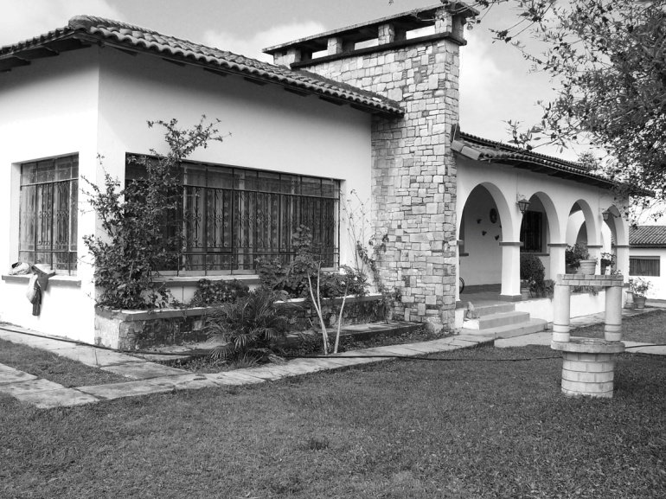

The house and the wide open spaces seemed like an ideal place for a home for needy Mexican children. It was far enough away from the big industrial city of Monterrey to be free from contamination and yet close enough to be convenient. There were 28 of us living in the big ranch type house: family, boys, and staff members.
After two years of renting the Rancho and caring for our little “muchachos”, we were convinced that it was right for us to try to buy the property. Raising the money was the problem. God worked a miracle and supplied the down payment, and in two years after that, we were talking about the need to build a dining room and dormitories. The hacienda was overcrowded with our growing group of boys. It was difficult to house them and feed them and hold our worship time all in the one building with only one bath. It was especially hard in the winter time when it got dark early and there was no electricity and we had to stumble around in the dark or use oil lamps to tuck the children in bed.
One of the most frustrating things for me was when the children would wake up at the crack of dawn and their voices would seem to be bouncing off our bedroom wall.
We often reminisce…about the time Guillermo got malaria and Jesus had to have a tumor cut out of his cheek and Angel nearly died with a tumor on his liver caused by amoebas. The amazing part of this story was the “Doctor” who came in the night and touched Angel and said he was going to be alright and the pain went away. Who was this strange “Doctor” who suddenly appeared to help Angel since there was no doctor in that little village hospital on duty in the middle of the night?
In our reminiscing, the house…the “Hacienda” stands out. Everything really started there. Since then, we have built the dining room and the dorms and the house parent’s quarters. We have our meals in the dining room, which is spacious and sufficient for our needs. We hold our services there as well and fiestas. But the HOUSE…the visitors who come from near and far still find refuge there.
I thought back about the time Danny had whooping cough when he was only three months old, and I remembered the time he had a high fever and was dehydrated, and the frantic trips we made in the middle of night to try to find help for him. The House seemed so cold and damp then in the winter. But during the long, hot summers, its adobe walls were cool and inviting.
Reminiscing brought familiar smiling faces before me. I could see them coming in and out of the Hacienda. They were visitors who had labored with us faithfully during the years. Their names are written down in glory. When they reach their Heavenly Hacienda, they will hear “Well done.” Just recently, some of these visitors, like busy bees, were trying to make the Hacienda look warm and cozy and bright and clean. All of the coldness and drabness disappeared. The House seemed to be smiling at us when we opened the terraza door. The mowed grass and the clean grounds shouted out loud and clear, “There’s a welcome here!”
Coming home in the pickup the other evening, just as the sun was setting, the sky was beautiful red and gold. The Hacienda seemed to stand out more proud than ever. It seemed to be saying, “Here I am!...If my walls could speak they would tell a thousand tales…The No Way Places that have never been written down…The tears…the hopes…the prayers…
So many No Way Places that have become Way Places. Hector told us one we had almost forgotten. He came several years ago and wanted to see the bedroom in the Hacienda where he had been born. Hector is a preacher now and he cried tears of gratitude when he said, “Thank you, Thank you so much for letting my Mom stay here when she was expecting me. She didn’t have any place else to go (She was an unwed mother-to-be. Her dad didn’t want her at home. Rancho del Rey took her in and showed her love.). Is this really the room where I was born? Praise God? Praise God! This is one story the Hacienda walls knew very well, but never told.
As I write this, the children are home from school and are having their evening meal in the dining room. It is a simple meal of beans, sweet potatoes, with tortillas, and chile. They give thanks before they start to eat. We are thankful for their healthy appetites, their smiles, their love. It is a privilege to be able to share in their lives. Thanks to YOU we have been able to do this.
Leaving the dining room and heading back to the office, again I noticed the Hacienda. It was standing there alone. It always looks lonely when there are no visitors. It was meant to have its doors open, to embrace the poor…people who are hurting…people who want to help. It is no longer just an adobe Hacienda. To me, it is home. And it has been home for hundreds.

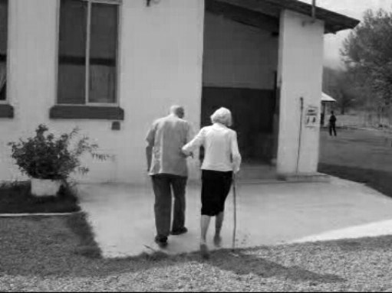
“Well done, thou good and faithful servant[s]: thou hast been faithful over a few things, I will make thee ruler over many things: enter thou into the joy of thy lord.”
(Matthew 25:21)

Anne L. Moller, A Star a Sceptre, A Stable a Cross, An Empty Tomb (a collection of poems by the author, privately published abt. 2006), pp. 54-55.
Anne L. Moller, A Star, A Sceptre, A Stable, A Cross, an Empty Tomb, pp. 34-35.
The Bible, King James Version; Hebrews 11: 32-35.
Anne L. Moller, A Star, A Sceptre, A Stable, A Cross, an Empty Tomb, pp. 48-49.
Anne L. Moller, A Star, A Sceptre, A Stable, A Cross, an Empty Tomb, pp. 32-33.
Anne L. Moller, A Star, A Sceptre, A Stable, A Cross, an Empty Tomb, pp.44-47.
Anne L. Moller, A Star, A Sceptre, A Stable, A Cross, an Empty Tomb, pp. 12-13.
Anne L. Moller, A Star, A Sceptre, A Stable, A Cross, an Empty Tomb, pp. 14-15.
This letter from Tomas Garza was translated from Spanish and used in a Mothers’ Day greeting to American supporters sometime during the mid-1980’s. It was undated. The postscript, “Proverbs 22:2” is original to the letter.
2 Timothy 3:15, KJV
Undated newsletter, probably about 1990.
From Way Places, Chapter 196, February 2002.
See Chapter 12, El Medico, p. 50.
From Way Places, Chapter 139, February 1995.

